09 antecedent_Models

Jake Cavaiani

9/2/2022

The purpose of this script is to model HI/FI against fixed and random effects and perform model selection techniques to see which model is best fit

Input: Antecedent moisture conditions with HI_FI_BETA and catchment characteristics! Step 1) import full file Step 2) standardize and center the data Step 3) add fixed (storm total, intensity, week precip, month precip, 3month precip and doy) and random effects (catchments) Output: linear model plot

# Read in data #   
  
AMC <- read.csv(here("Output_from_analysis", "07_Combine_HI_BETA_FI", "antecedent_HI_FI_AllYears.csv"))  
  
AMC <- AMC[c("Hyst_index", "HI_ymin", "HI_ymax", "site.ID", "storm.ID", "month.x", "day.x", "response_var", "Flush_index", "FI_ymin", "FI_ymax", "year", "Parameter", "Beta_index", "SE", "CI", "Beta_ymin", "Beta_ymax", "t", "df", "p", "precip", "temp", "precip.week", "precip.month", "ThreeMonth", "temp.week", "TOTAL.TIME", "Intensity", "doy", "burn", "pf", "date", "TimeSinceChena")] # selecting the columns that I want  
  
  
colNames <- c("Hyst_index", "HI_ymin", "HI_ymax", "site.ID", "storm.ID", "month", "day", "response_var", "Flush_index", "FI_ymin", "FI_ymax", "year", "Parameter", "Beta_index", "SE", "CI", "Beta_ymin", "Beta_ymax", "t", "df", "p", "StormPrecip", "StormTemp", "PrecipWeek", "PrecipMonth", "ThreeMonth", "TempWeek", "Duration", "Intensity", "doy", "burn", "pf", "date", "TimeSinceChena")  
  
names(AMC)<- colNames # renaming columns   
  
  
##subsetting by solute   
# NO3 #  
HI_FI_NO3 = subset(AMC, response_var == "NO3")  
# fDOM #  
HI_FI_fDOM = subset(AMC, response_var == "fDOM")  
# SPC #  
HI_FI_SPC = subset(AMC, response_var == "SPC")  
# turb #  
HI_FI_turb = subset(AMC, response_var == "turb")

### Scaling and normalizing data

### HI

# NO3

#### Correlation   
NO3_data <- HI_FI_NO3[,c("Hyst_index", "site.ID", "StormPrecip", "PrecipWeek", "PrecipMonth", "ThreeMonth", "Intensity", "TimeSinceChena", "pf", "burn", "year")]  
NO3_data <- na.omit(NO3_data) # 244 to 236 rows   
  
ggpairs(NO3_data,  
 columns = c("Hyst_index", "StormPrecip", "PrecipWeek", "PrecipMonth","ThreeMonth", "Intensity", "TimeSinceChena"),  
 ggplot2::aes(color = site.ID))+  
 scale_color_manual(values = c("#3288BD", "#FF7F00","#A6761D", "#6A3D9A", "#66C2A5", "#E7298A"))

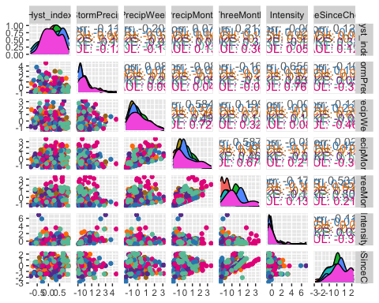

ggsave("NO3_pairs.pdf",  
 path = here("Output_from_analysis", "09_Antecedent_Conditions_models", "plots"),  
 width = 10, height = 10)

1. StormTemp is heavily correlated with TempWeek leading up to a storm (0.778) but TempWeek is slightly more correlated with HI (-.05 to -.03)
2. StormTemp is also correlated with time since chena (-0.735) but time since chena is more correlated with HI (0.251 vs. -0.173) so this makes me want to keep Time since Chena and temperature a week before considering that is a more marginal comparison with HI and the temperature predictors.

3)Precip week is correlated with precip month (0.511) but precip week is more correlated with HI than precip month (-0.242 vs. 0.048)

4)Precip month is correlated with three month precip (0.591) but three month precip is more correlated with HI (0.220 vs. 0.048)

1. Three month is correlated with Time since Chena (0.619) but time since chena is more correlated with HI (0.251 vs. 0.220)

* to sum up this makes me want to drop storm temperature and three month precipitation…..but lets run the model with all of the candidate predictors first and go from there

HI_FI_NO3_MOOS <- subset(HI_FI_NO3, site.ID == "MOOS")  
HI_FI_NO3_FRCH <- subset(HI_FI_NO3, site.ID == "FRCH")  
HI_FI_NO3_CARI <- subset(HI_FI_NO3, site.ID == "CARI")  
HI_FI_NO3_POKE <- subset(HI_FI_NO3, site.ID == "POKE")  
HI_FI_NO3_VAUL <- subset(HI_FI_NO3, site.ID == "VAUL")  
HI_FI_NO3_STRT <- subset(HI_FI_NO3, site.ID == "STRT")

ggpairs(HI_FI_NO3_MOOS,  
 columns = c("Hyst_index", "StormPrecip", "PrecipWeek", "PrecipMonth","ThreeMonth", "Intensity", "TimeSinceChena"),  
 ggplot2::aes(color = site.ID))+  
 scale_color_manual(values = c("#A6761D"))

## Warning in ggally_statistic(data = data, mapping = mapping, na.rm = na.rm, :  
## Removing 1 row that contained a missing value  
  
## Warning in ggally_statistic(data = data, mapping = mapping, na.rm = na.rm, :  
## Removing 1 row that contained a missing value  
  
## Warning in ggally_statistic(data = data, mapping = mapping, na.rm = na.rm, :  
## Removing 1 row that contained a missing value  
  
## Warning in ggally_statistic(data = data, mapping = mapping, na.rm = na.rm, :  
## Removing 1 row that contained a missing value  
  
## Warning in ggally_statistic(data = data, mapping = mapping, na.rm = na.rm, :  
## Removing 1 row that contained a missing value  
  
## Warning in ggally_statistic(data = data, mapping = mapping, na.rm = na.rm, :  
## Removing 1 row that contained a missing value

## Warning: Removed 1 rows containing non-finite values (stat_density).

## Warning: Removed 1 rows containing missing values (geom_point).  
## Removed 1 rows containing missing values (geom_point).  
## Removed 1 rows containing missing values (geom_point).  
## Removed 1 rows containing missing values (geom_point).  
## Removed 1 rows containing missing values (geom_point).  
## Removed 1 rows containing missing values (geom_point).

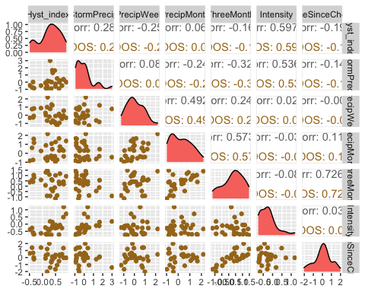

ggsave("NO3_pairs_MOOS.pdf",  
 path = here("Output_from_analysis", "09_Antecedent_Conditions_models", "plots"),  
 width = 10, height = 10)

## Warning: Removed 1 rows containing non-finite values (stat_density).  
## Removed 1 rows containing missing values (geom_point).  
## Removed 1 rows containing missing values (geom_point).  
## Removed 1 rows containing missing values (geom_point).  
## Removed 1 rows containing missing values (geom_point).  
## Removed 1 rows containing missing values (geom_point).  
## Removed 1 rows containing missing values (geom_point).

MOOS.model <- lm(Hyst_index ~ StormPrecip + PrecipWeek + PrecipMonth + TimeSinceChena, data = HI_FI_NO3_MOOS)  
  
vif(MOOS.model)

## StormPrecip PrecipWeek PrecipMonth TimeSinceChena   
## 1.159617 1.404085 1.480382 1.043649

plot(MOOS.model)

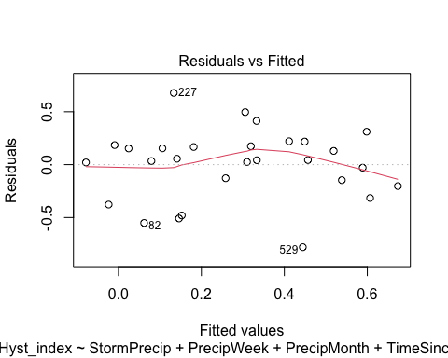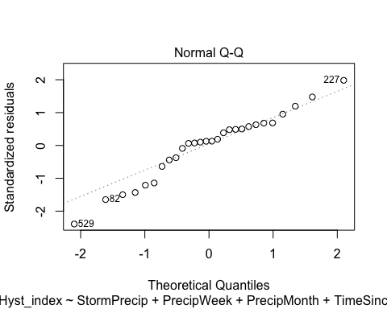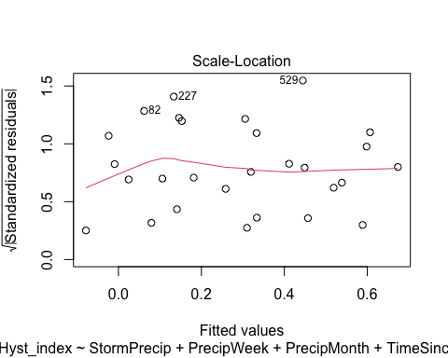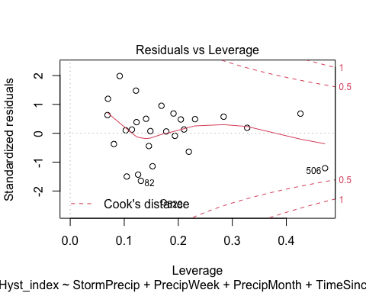

summary(MOOS.model)

##   
## Call:  
## lm(formula = Hyst_index ~ StormPrecip + PrecipWeek + PrecipMonth +   
## TimeSinceChena, data = HI_FI_NO3_MOOS)  
##   
## Residuals:  
## Min 1Q Median 3Q Max   
## -0.78039 -0.16058 0.04243 0.17678 0.67802   
##   
## Coefficients:  
## Estimate Std. Error t value Pr(>|t|)   
## (Intercept) 0.26265 0.07092 3.703 0.00117 **  
## StormPrecip 0.17234 0.08017 2.150 0.04232 *   
## PrecipWeek -0.24053 0.10036 -2.397 0.02506 *   
## PrecipMonth 0.18775 0.09377 2.002 0.05718 .   
## TimeSinceChena -0.06701 0.07485 -0.895 0.37996   
## ---  
## Signif. codes: 0 '***' 0.001 '**' 0.01 '*' 0.05 '.' 0.1 ' ' 1  
##   
## Residual standard error: 0.3587 on 23 degrees of freedom  
## (1 observation deleted due to missingness)  
## Multiple R-squared: 0.2996, Adjusted R-squared: 0.1778   
## F-statistic: 2.46 on 4 and 23 DF, p-value: 0.07402

ggpairs(HI_FI_NO3_FRCH,  
 columns = c("Hyst_index", "StormPrecip", "PrecipWeek", "PrecipMonth","ThreeMonth", "Intensity", "TimeSinceChena"),  
 ggplot2::aes(color = site.ID))+  
 scale_color_manual(values = c("#FF7F00"))

## Warning in ggally_statistic(data = data, mapping = mapping, na.rm = na.rm, :  
## Removed 2 rows containing missing values  
  
## Warning in ggally_statistic(data = data, mapping = mapping, na.rm = na.rm, :  
## Removed 2 rows containing missing values  
  
## Warning in ggally_statistic(data = data, mapping = mapping, na.rm = na.rm, :  
## Removed 2 rows containing missing values  
  
## Warning in ggally_statistic(data = data, mapping = mapping, na.rm = na.rm, :  
## Removed 2 rows containing missing values  
  
## Warning in ggally_statistic(data = data, mapping = mapping, na.rm = na.rm, :  
## Removed 2 rows containing missing values  
  
## Warning in ggally_statistic(data = data, mapping = mapping, na.rm = na.rm, :  
## Removed 2 rows containing missing values  
  
## Warning in ggally_statistic(data = data, mapping = mapping, na.rm = na.rm, :  
## Removed 2 rows containing missing values  
  
## Warning in ggally_statistic(data = data, mapping = mapping, na.rm = na.rm, :  
## Removed 2 rows containing missing values  
  
## Warning in ggally_statistic(data = data, mapping = mapping, na.rm = na.rm, :  
## Removed 2 rows containing missing values  
  
## Warning in ggally_statistic(data = data, mapping = mapping, na.rm = na.rm, :  
## Removed 2 rows containing missing values

## Warning in ggally_statistic(data = data, mapping = mapping, na.rm = na.rm, :  
## Removed 4 rows containing missing values  
  
## Warning in ggally_statistic(data = data, mapping = mapping, na.rm = na.rm, :  
## Removed 4 rows containing missing values  
  
## Warning in ggally_statistic(data = data, mapping = mapping, na.rm = na.rm, :  
## Removed 4 rows containing missing values  
  
## Warning in ggally_statistic(data = data, mapping = mapping, na.rm = na.rm, :  
## Removed 4 rows containing missing values  
  
## Warning in ggally_statistic(data = data, mapping = mapping, na.rm = na.rm, :  
## Removed 4 rows containing missing values

## Warning in ggally_statistic(data = data, mapping = mapping, na.rm = na.rm, :  
## Removed 2 rows containing missing values  
  
## Warning in ggally_statistic(data = data, mapping = mapping, na.rm = na.rm, :  
## Removed 2 rows containing missing values  
  
## Warning in ggally_statistic(data = data, mapping = mapping, na.rm = na.rm, :  
## Removed 2 rows containing missing values  
  
## Warning in ggally_statistic(data = data, mapping = mapping, na.rm = na.rm, :  
## Removed 2 rows containing missing values  
  
## Warning in ggally_statistic(data = data, mapping = mapping, na.rm = na.rm, :  
## Removed 2 rows containing missing values

## Warning in ggally_statistic(data = data, mapping = mapping, na.rm = na.rm, :  
## Removed 4 rows containing missing values

## Warning: Removed 2 rows containing missing values (geom_point).

## Warning: Removed 2 rows containing non-finite values (stat_density).

## Warning: Removed 2 rows containing missing values (geom_point).  
## Removed 2 rows containing missing values (geom_point).

## Warning: Removed 2 rows containing non-finite values (stat_density).

## Warning: Removed 2 rows containing missing values (geom_point).  
## Removed 2 rows containing missing values (geom_point).  
## Removed 2 rows containing missing values (geom_point).

## Warning: Removed 2 rows containing non-finite values (stat_density).

## Warning: Removed 2 rows containing missing values (geom_point).  
## Removed 2 rows containing missing values (geom_point).  
## Removed 2 rows containing missing values (geom_point).  
## Removed 2 rows containing missing values (geom_point).

## Warning: Removed 2 rows containing non-finite values (stat_density).

## Warning: Removed 4 rows containing missing values (geom_point).  
## Removed 4 rows containing missing values (geom_point).  
## Removed 4 rows containing missing values (geom_point).  
## Removed 4 rows containing missing values (geom_point).  
## Removed 4 rows containing missing values (geom_point).

## Warning: Removed 4 rows containing non-finite values (stat_density).

## Warning: Removed 2 rows containing missing values (geom_point).  
## Removed 2 rows containing missing values (geom_point).  
## Removed 2 rows containing missing values (geom_point).  
## Removed 2 rows containing missing values (geom_point).  
## Removed 2 rows containing missing values (geom_point).

## Warning: Removed 4 rows containing missing values (geom_point).

## Warning: Removed 2 rows containing non-finite values (stat_density).

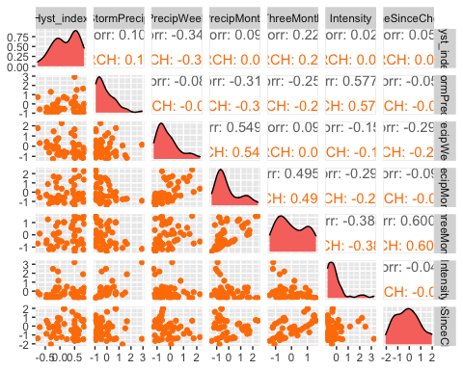

ggsave("NO3_pairs_FRCH.pdf",  
 path = here("Output_from_analysis", "09_Antecedent_Conditions_models", "plots"),  
 width = 10, height = 10)

## Warning: Removed 2 rows containing missing values (geom_point).  
## Removed 2 rows containing non-finite values (stat_density).

## Warning: Removed 2 rows containing missing values (geom_point).  
## Removed 2 rows containing missing values (geom_point).

## Warning: Removed 2 rows containing non-finite values (stat_density).

## Warning: Removed 2 rows containing missing values (geom_point).  
## Removed 2 rows containing missing values (geom_point).  
## Removed 2 rows containing missing values (geom_point).

## Warning: Removed 2 rows containing non-finite values (stat_density).

## Warning: Removed 2 rows containing missing values (geom_point).  
## Removed 2 rows containing missing values (geom_point).  
## Removed 2 rows containing missing values (geom_point).  
## Removed 2 rows containing missing values (geom_point).

## Warning: Removed 2 rows containing non-finite values (stat_density).

## Warning: Removed 4 rows containing missing values (geom_point).  
## Removed 4 rows containing missing values (geom_point).  
## Removed 4 rows containing missing values (geom_point).  
## Removed 4 rows containing missing values (geom_point).  
## Removed 4 rows containing missing values (geom_point).

## Warning: Removed 4 rows containing non-finite values (stat_density).

## Warning: Removed 2 rows containing missing values (geom_point).  
## Removed 2 rows containing missing values (geom_point).  
## Removed 2 rows containing missing values (geom_point).  
## Removed 2 rows containing missing values (geom_point).  
## Removed 2 rows containing missing values (geom_point).

## Warning: Removed 4 rows containing missing values (geom_point).

## Warning: Removed 2 rows containing non-finite values (stat_density).

FRCH.model <- lm(Hyst_index ~ StormPrecip + PrecipWeek + PrecipMonth + TimeSinceChena, data = HI_FI_NO3_FRCH)  
  
vif(FRCH.model)

## StormPrecip PrecipWeek PrecipMonth TimeSinceChena   
## 1.132064 1.577770 1.612711 1.103157

plot(FRCH.model)

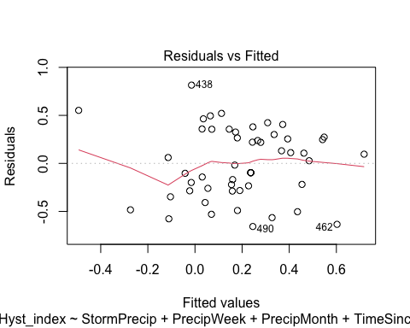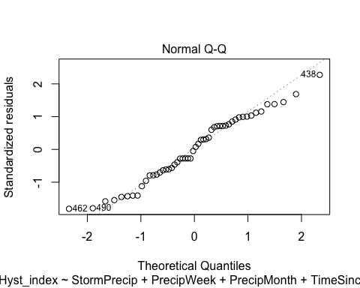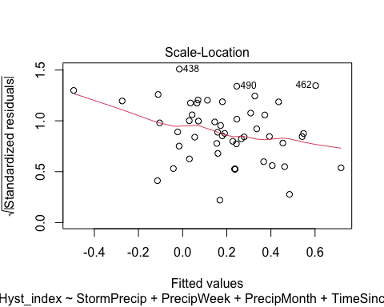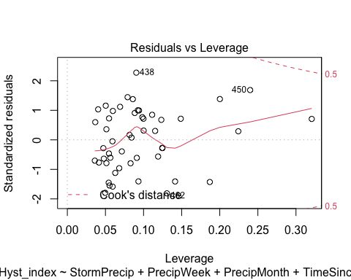

summary(FRCH.model)

##   
## Call:  
## lm(formula = Hyst_index ~ StormPrecip + PrecipWeek + PrecipMonth +   
## TimeSinceChena, data = HI_FI_NO3_FRCH)  
##   
## Residuals:  
## Min 1Q Median 3Q Max   
## -0.6572 -0.2656 0.0049 0.2803 0.8152   
##   
## Coefficients:  
## Estimate Std. Error t value Pr(>|t|)   
## (Intercept) 0.16343 0.05584 2.926 0.005267 **   
## StormPrecip 0.10844 0.06871 1.578 0.121248   
## PrecipWeek -0.31635 0.07990 -3.959 0.000253 ***  
## PrecipMonth 0.21161 0.06696 3.160 0.002758 **   
## TimeSinceChena -0.02776 0.05211 -0.533 0.596761   
## ---  
## Signif. codes: 0 '***' 0.001 '**' 0.01 '*' 0.05 '.' 0.1 ' ' 1  
##   
## Residual standard error: 0.3756 on 47 degrees of freedom  
## (2 observations deleted due to missingness)  
## Multiple R-squared: 0.2767, Adjusted R-squared: 0.2151   
## F-statistic: 4.494 on 4 and 47 DF, p-value: 0.003711

ggpairs(HI_FI_NO3_CARI,  
 columns = c("Hyst_index", "StormPrecip", "PrecipWeek", "PrecipMonth","ThreeMonth", "Intensity", "TimeSinceChena"),  
 ggplot2::aes(color = site.ID))+  
 scale_color_manual(values = c("#3288BD"))

## Warning in ggally_statistic(data = data, mapping = mapping, na.rm = na.rm, :  
## Removed 2 rows containing missing values  
  
## Warning in ggally_statistic(data = data, mapping = mapping, na.rm = na.rm, :  
## Removed 2 rows containing missing values

## Warning in ggally_statistic(data = data, mapping = mapping, na.rm = na.rm, :  
## Removing 1 row that contained a missing value

## Warning in ggally_statistic(data = data, mapping = mapping, na.rm = na.rm, :  
## Removed 2 rows containing missing values

## Warning in ggally_statistic(data = data, mapping = mapping, na.rm = na.rm, :  
## Removing 1 row that contained a missing value  
  
## Warning in ggally_statistic(data = data, mapping = mapping, na.rm = na.rm, :  
## Removing 1 row that contained a missing value

## Warning in ggally_statistic(data = data, mapping = mapping, na.rm = na.rm, :  
## Removed 2 rows containing missing values

## Warning in ggally_statistic(data = data, mapping = mapping, na.rm = na.rm, :  
## Removing 1 row that contained a missing value  
  
## Warning in ggally_statistic(data = data, mapping = mapping, na.rm = na.rm, :  
## Removing 1 row that contained a missing value  
  
## Warning in ggally_statistic(data = data, mapping = mapping, na.rm = na.rm, :  
## Removing 1 row that contained a missing value

## Warning in ggally_statistic(data = data, mapping = mapping, na.rm = na.rm, :  
## Removed 2 rows containing missing values

## Warning in ggally_statistic(data = data, mapping = mapping, na.rm = na.rm, :  
## Removing 1 row that contained a missing value  
  
## Warning in ggally_statistic(data = data, mapping = mapping, na.rm = na.rm, :  
## Removing 1 row that contained a missing value  
  
## Warning in ggally_statistic(data = data, mapping = mapping, na.rm = na.rm, :  
## Removing 1 row that contained a missing value  
  
## Warning in ggally_statistic(data = data, mapping = mapping, na.rm = na.rm, :  
## Removing 1 row that contained a missing value

## Warning in ggally_statistic(data = data, mapping = mapping, na.rm = na.rm, :  
## Removed 2 rows containing missing values

## Warning in ggally_statistic(data = data, mapping = mapping, na.rm = na.rm, :  
## Removing 1 row that contained a missing value  
  
## Warning in ggally_statistic(data = data, mapping = mapping, na.rm = na.rm, :  
## Removing 1 row that contained a missing value  
  
## Warning in ggally_statistic(data = data, mapping = mapping, na.rm = na.rm, :  
## Removing 1 row that contained a missing value  
  
## Warning in ggally_statistic(data = data, mapping = mapping, na.rm = na.rm, :  
## Removing 1 row that contained a missing value  
  
## Warning in ggally_statistic(data = data, mapping = mapping, na.rm = na.rm, :  
## Removing 1 row that contained a missing value

## Warning: Removed 1 rows containing non-finite values (stat_density).

## Warning: Removed 2 rows containing missing values (geom_point).

## Warning: Removed 1 rows containing non-finite values (stat_density).

## Warning: Removed 2 rows containing missing values (geom_point).

## Warning: Removed 1 rows containing missing values (geom_point).

## Warning: Removed 1 rows containing non-finite values (stat_density).

## Warning: Removed 2 rows containing missing values (geom_point).

## Warning: Removed 1 rows containing missing values (geom_point).  
## Removed 1 rows containing missing values (geom_point).

## Warning: Removed 1 rows containing non-finite values (stat_density).

## Warning: Removed 2 rows containing missing values (geom_point).

## Warning: Removed 1 rows containing missing values (geom_point).  
## Removed 1 rows containing missing values (geom_point).  
## Removed 1 rows containing missing values (geom_point).

## Warning: Removed 1 rows containing non-finite values (stat_density).

## Warning: Removed 2 rows containing missing values (geom_point).

## Warning: Removed 1 rows containing missing values (geom_point).  
## Removed 1 rows containing missing values (geom_point).  
## Removed 1 rows containing missing values (geom_point).  
## Removed 1 rows containing missing values (geom_point).

## Warning: Removed 1 rows containing non-finite values (stat_density).

## Warning: Removed 2 rows containing missing values (geom_point).

## Warning: Removed 1 rows containing missing values (geom_point).  
## Removed 1 rows containing missing values (geom_point).  
## Removed 1 rows containing missing values (geom_point).  
## Removed 1 rows containing missing values (geom_point).  
## Removed 1 rows containing missing values (geom_point).

## Warning: Removed 1 rows containing non-finite values (stat_density).

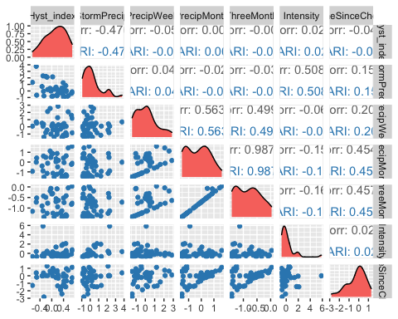

ggsave("NO3_pairs_CARI.pdf",  
 path = here("Output_from_analysis", "09_Antecedent_Conditions_models", "plots"),  
 width = 10, height = 10)

## Warning: Removed 1 rows containing non-finite values (stat_density).

## Warning: Removed 2 rows containing missing values (geom_point).

## Warning: Removed 1 rows containing non-finite values (stat_density).

## Warning: Removed 2 rows containing missing values (geom_point).

## Warning: Removed 1 rows containing missing values (geom_point).

## Warning: Removed 1 rows containing non-finite values (stat_density).

## Warning: Removed 2 rows containing missing values (geom_point).

## Warning: Removed 1 rows containing missing values (geom_point).  
## Removed 1 rows containing missing values (geom_point).

## Warning: Removed 1 rows containing non-finite values (stat_density).

## Warning: Removed 2 rows containing missing values (geom_point).

## Warning: Removed 1 rows containing missing values (geom_point).  
## Removed 1 rows containing missing values (geom_point).  
## Removed 1 rows containing missing values (geom_point).

## Warning: Removed 1 rows containing non-finite values (stat_density).

## Warning: Removed 2 rows containing missing values (geom_point).

## Warning: Removed 1 rows containing missing values (geom_point).  
## Removed 1 rows containing missing values (geom_point).  
## Removed 1 rows containing missing values (geom_point).  
## Removed 1 rows containing missing values (geom_point).

## Warning: Removed 1 rows containing non-finite values (stat_density).

## Warning: Removed 2 rows containing missing values (geom_point).

## Warning: Removed 1 rows containing missing values (geom_point).  
## Removed 1 rows containing missing values (geom_point).  
## Removed 1 rows containing missing values (geom_point).  
## Removed 1 rows containing missing values (geom_point).  
## Removed 1 rows containing missing values (geom_point).

## Warning: Removed 1 rows containing non-finite values (stat_density).

CARI.model <- lm(Hyst_index ~ StormPrecip + PrecipWeek + PrecipMonth + TimeSinceChena, data = HI_FI_NO3_CARI)  
  
vif(CARI.model)

## StormPrecip PrecipWeek PrecipMonth TimeSinceChena   
## 1.040591 1.515896 1.816429 1.295038

plot(CARI.model)

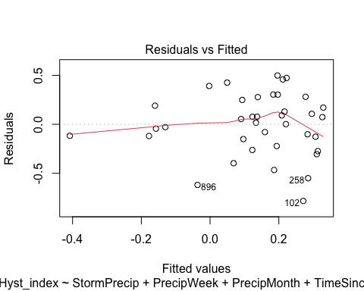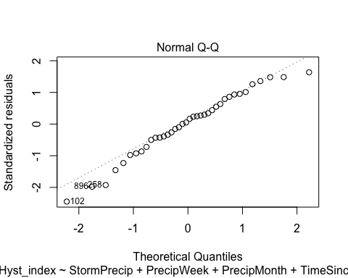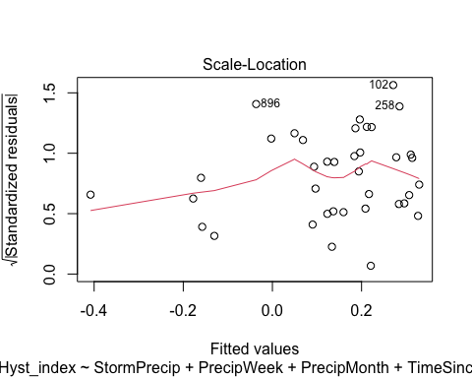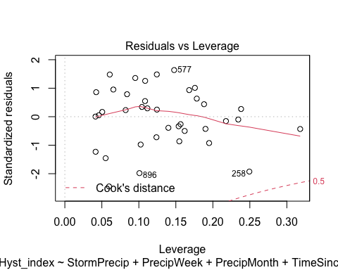

summary(CARI.model)

##   
## Call:  
## lm(formula = Hyst_index ~ StormPrecip + PrecipWeek + PrecipMonth +   
## TimeSinceChena, data = HI_FI_NO3_CARI)  
##   
## Residuals:  
## Min 1Q Median 3Q Max   
## -0.78267 -0.14498 0.03521 0.23424 0.49834   
##   
## Coefficients:  
## Estimate Std. Error t value Pr(>|t|)   
## (Intercept) 0.1787003 0.0587760 3.040 0.00460 **  
## StormPrecip -0.1548437 0.0513981 -3.013 0.00494 **  
## PrecipWeek -0.0102140 0.0590368 -0.173 0.86370   
## PrecipMonth -0.0007459 0.0778874 -0.010 0.99242   
## TimeSinceChena 0.0094600 0.0643518 0.147 0.88402   
## ---  
## Signif. codes: 0 '***' 0.001 '**' 0.01 '*' 0.05 '.' 0.1 ' ' 1  
##   
## Residual standard error: 0.3298 on 33 degrees of freedom  
## (2 observations deleted due to missingness)  
## Multiple R-squared: 0.2225, Adjusted R-squared: 0.1283   
## F-statistic: 2.361 on 4 and 33 DF, p-value: 0.07343

ggpairs(HI_FI_NO3_POKE,  
 columns = c("Hyst_index", "StormPrecip", "PrecipWeek", "PrecipMonth","ThreeMonth", "Intensity", "TimeSinceChena"),  
 ggplot2::aes(color = site.ID))+  
 scale_color_manual(values = c("#6A3D9A"))

## Warning in ggally_statistic(data = data, mapping = mapping, na.rm = na.rm, :  
## Removed 4 rows containing missing values  
  
## Warning in ggally_statistic(data = data, mapping = mapping, na.rm = na.rm, :  
## Removed 4 rows containing missing values  
  
## Warning in ggally_statistic(data = data, mapping = mapping, na.rm = na.rm, :  
## Removed 4 rows containing missing values  
  
## Warning in ggally_statistic(data = data, mapping = mapping, na.rm = na.rm, :  
## Removed 4 rows containing missing values  
  
## Warning in ggally_statistic(data = data, mapping = mapping, na.rm = na.rm, :  
## Removed 4 rows containing missing values  
  
## Warning in ggally_statistic(data = data, mapping = mapping, na.rm = na.rm, :  
## Removed 4 rows containing missing values

## Warning: Removed 4 rows containing missing values (geom_point).  
## Removed 4 rows containing missing values (geom_point).  
## Removed 4 rows containing missing values (geom_point).  
## Removed 4 rows containing missing values (geom_point).  
## Removed 4 rows containing missing values (geom_point).

## Warning: Removed 4 rows containing non-finite values (stat_density).

## Warning: Removed 4 rows containing missing values (geom_point).

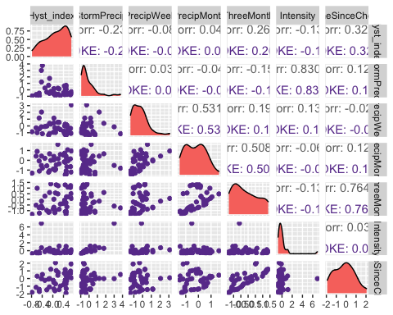

ggsave("NO3_pairs_POKE.pdf",  
 path = here("Output_from_analysis", "09_Antecedent_Conditions_models", "plots"),  
 width = 10, height = 10)

## Warning: Removed 4 rows containing missing values (geom_point).  
## Removed 4 rows containing missing values (geom_point).  
## Removed 4 rows containing missing values (geom_point).  
## Removed 4 rows containing missing values (geom_point).  
## Removed 4 rows containing missing values (geom_point).

## Warning: Removed 4 rows containing non-finite values (stat_density).

## Warning: Removed 4 rows containing missing values (geom_point).

POKE.model <- lm(Hyst_index ~ StormPrecip + PrecipWeek + PrecipMonth + TimeSinceChena, data = HI_FI_NO3_POKE)  
  
vif(POKE.model)

## StormPrecip PrecipWeek PrecipMonth TimeSinceChena   
## 1.026959 1.420011 1.444585 1.047664

plot(POKE.model)

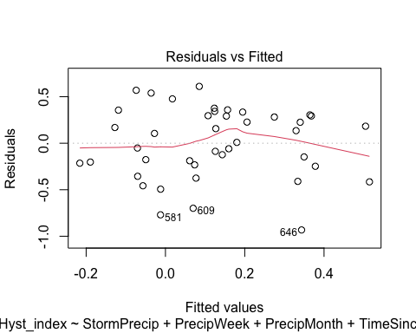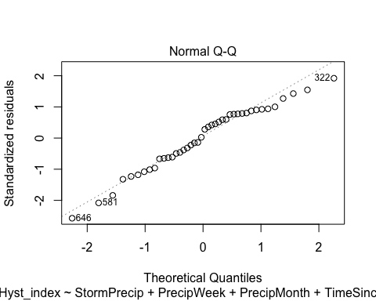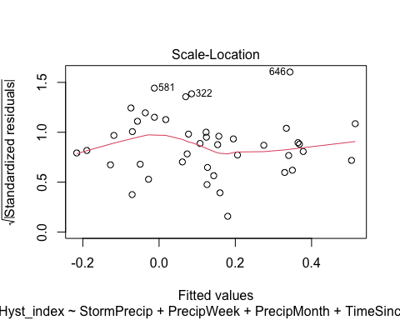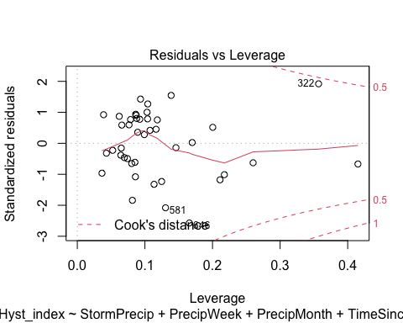

summary(POKE.model)

##   
## Call:  
## lm(formula = Hyst_index ~ StormPrecip + PrecipWeek + PrecipMonth +   
## TimeSinceChena, data = HI_FI_NO3_POKE)  
##   
## Residuals:  
## Min 1Q Median 3Q Max   
## -0.9324 -0.2280 0.0571 0.2953 0.6108   
##   
## Coefficients:  
## Estimate Std. Error t value Pr(>|t|)   
## (Intercept) 0.13632 0.06584 2.070 0.0454 *  
## StormPrecip -0.11513 0.06256 -1.841 0.0737 .  
## PrecipWeek -0.03755 0.07886 -0.476 0.6368   
## PrecipMonth 0.01790 0.09397 0.190 0.8500   
## TimeSinceChena 0.14806 0.06276 2.359 0.0237 *  
## ---  
## Signif. codes: 0 '***' 0.001 '**' 0.01 '*' 0.05 '.' 0.1 ' ' 1  
##   
## Residual standard error: 0.3967 on 37 degrees of freedom  
## Multiple R-squared: 0.1912, Adjusted R-squared: 0.1038   
## F-statistic: 2.187 on 4 and 37 DF, p-value: 0.0895

ggpairs(HI_FI_NO3_VAUL,  
 columns = c("Hyst_index", "StormPrecip", "PrecipWeek", "PrecipMonth","ThreeMonth", "Intensity", "TimeSinceChena"),  
 ggplot2::aes(color = site.ID))+  
 scale_color_manual(values = c("#66C2A5"))

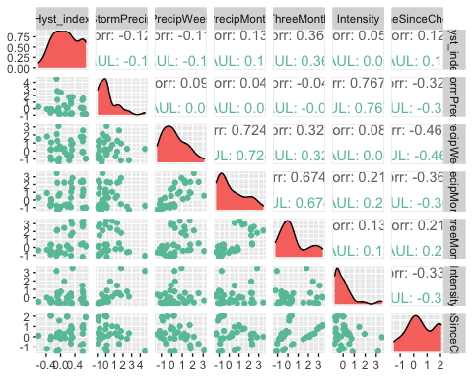

ggsave("NO3_pairs_VAUL.pdf",  
 path = here("Output_from_analysis", "09_Antecedent_Conditions_models", "plots"),  
 width = 10, height = 10)  
  
  
VAUL.model <- lm(Hyst_index ~ StormPrecip + PrecipWeek + PrecipMonth + TimeSinceChena, data = HI_FI_NO3_VAUL)  
  
vif(VAUL.model)

## StormPrecip PrecipWeek PrecipMonth TimeSinceChena   
## 1.126961 2.320792 2.112763 1.418655

plot(VAUL.model)

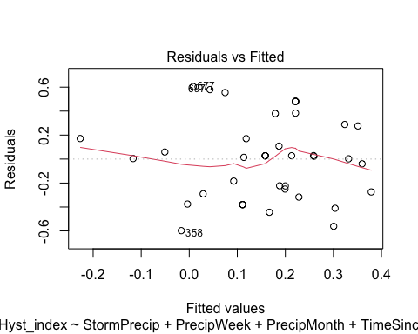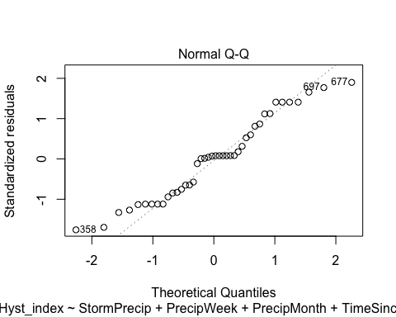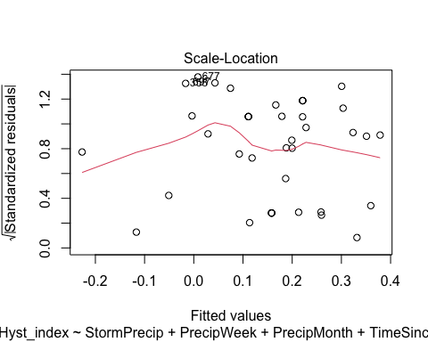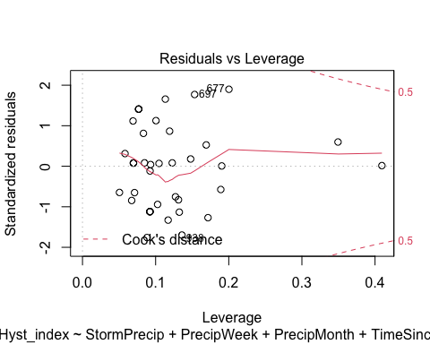

summary(VAUL.model)

##   
## Call:  
## lm(formula = Hyst_index ~ StormPrecip + PrecipWeek + PrecipMonth +   
## TimeSinceChena, data = HI_FI_NO3_VAUL)  
##   
## Residuals:  
## Min 1Q Median 3Q Max   
## -0.59736 -0.28638 0.02535 0.24999 0.60418   
##   
## Coefficients:  
## Estimate Std. Error t value Pr(>|t|)   
## (Intercept) 0.15283 0.07196 2.124 0.0404 *  
## StormPrecip -0.02304 0.05075 -0.454 0.6525   
## PrecipWeek -0.13181 0.07605 -1.733 0.0914 .  
## PrecipMonth 0.12121 0.05913 2.050 0.0475 *  
## TimeSinceChena 0.02533 0.05986 0.423 0.6746   
## ---  
## Signif. codes: 0 '***' 0.001 '**' 0.01 '*' 0.05 '.' 0.1 ' ' 1  
##   
## Residual standard error: 0.3556 on 37 degrees of freedom  
## Multiple R-squared: 0.1268, Adjusted R-squared: 0.03239   
## F-statistic: 1.343 on 4 and 37 DF, p-value: 0.2724

normality doesnt look great….lets try and log transform

HI_FI_NO3_VAUL$logHI <- log(abs(HI_FI_NO3_VAUL$Hyst_index))  
VAUL.model.log <- lm(logHI ~ StormPrecip + PrecipWeek + PrecipMonth + TimeSinceChena, data = HI_FI_NO3_VAUL)  
  
vif(VAUL.model.log)

## StormPrecip PrecipWeek PrecipMonth TimeSinceChena   
## 1.126961 2.320792 2.112763 1.418655

plot(VAUL.model.log)

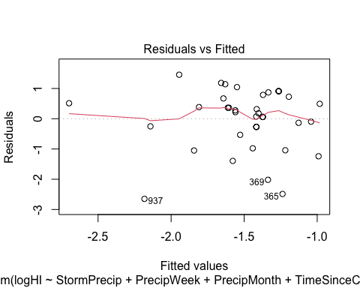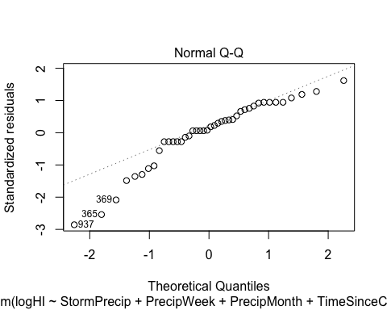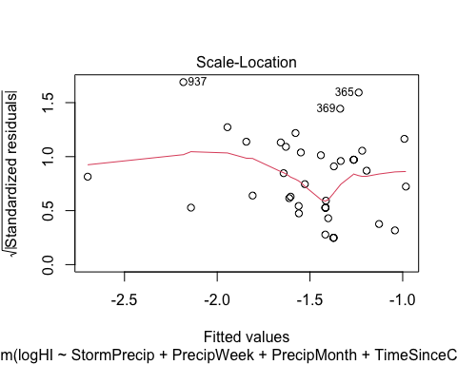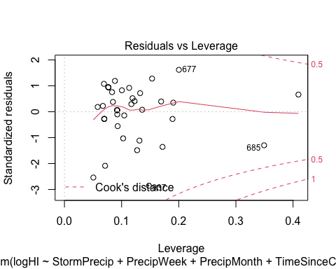 Does this need to be further transformed?

ggpairs(HI_FI_NO3_STRT,  
 columns = c("Hyst_index", "StormPrecip", "PrecipWeek", "PrecipMonth","ThreeMonth", "Intensity", "TimeSinceChena"),  
 ggplot2::aes(color = site.ID))+  
 scale_color_manual(values = c("#E7298A"))

## Warning in ggally_statistic(data = data, mapping = mapping, na.rm = na.rm, :  
## Removing 1 row that contained a missing value  
  
## Warning in ggally_statistic(data = data, mapping = mapping, na.rm = na.rm, :  
## Removing 1 row that contained a missing value  
  
## Warning in ggally_statistic(data = data, mapping = mapping, na.rm = na.rm, :  
## Removing 1 row that contained a missing value  
  
## Warning in ggally_statistic(data = data, mapping = mapping, na.rm = na.rm, :  
## Removing 1 row that contained a missing value  
  
## Warning in ggally_statistic(data = data, mapping = mapping, na.rm = na.rm, :  
## Removing 1 row that contained a missing value  
  
## Warning in ggally_statistic(data = data, mapping = mapping, na.rm = na.rm, :  
## Removing 1 row that contained a missing value

## Warning: Removed 1 rows containing non-finite values (stat_density).

## Warning: Removed 1 rows containing missing values (geom_point).  
## Removed 1 rows containing missing values (geom_point).  
## Removed 1 rows containing missing values (geom_point).  
## Removed 1 rows containing missing values (geom_point).  
## Removed 1 rows containing missing values (geom_point).  
## Removed 1 rows containing missing values (geom_point).

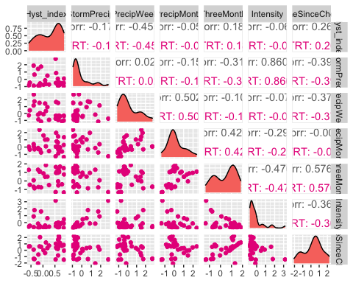

ggsave("NO3_pairs_VAUL.pdf",  
 path = here("Output_from_analysis", "09_Antecedent_Conditions_models", "plots"),  
 width = 10, height = 10)

## Warning: Removed 1 rows containing non-finite values (stat_density).  
## Removed 1 rows containing missing values (geom_point).  
## Removed 1 rows containing missing values (geom_point).  
## Removed 1 rows containing missing values (geom_point).  
## Removed 1 rows containing missing values (geom_point).  
## Removed 1 rows containing missing values (geom_point).  
## Removed 1 rows containing missing values (geom_point).

STRT.model <- lm(Hyst_index ~ StormPrecip + PrecipWeek + PrecipMonth + TimeSinceChena, data = HI_FI_NO3_STRT)  
  
vif(STRT.model)

## StormPrecip PrecipWeek PrecipMonth TimeSinceChena   
## 1.241411 1.691802 1.560647 1.369631

plot(STRT.model)

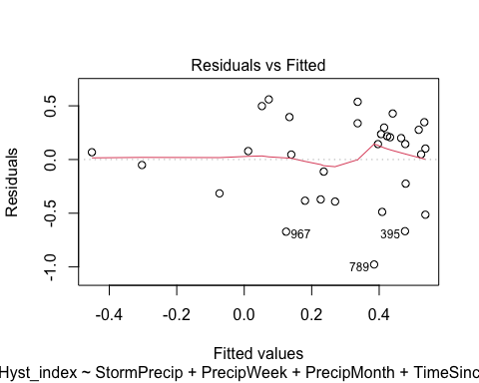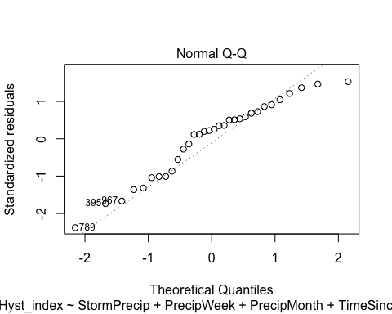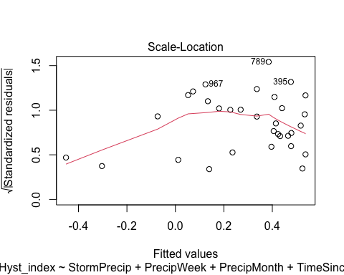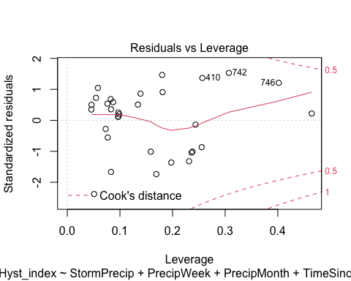

summary(STRT.model)

##   
## Call:  
## lm(formula = Hyst_index ~ StormPrecip + PrecipWeek + PrecipMonth +   
## TimeSinceChena, data = HI_FI_NO3_STRT)  
##   
## Residuals:  
## Min 1Q Median 3Q Max   
## -0.97722 -0.32939 0.09037 0.28177 0.55990   
##   
## Coefficients:  
## Estimate Std. Error t value Pr(>|t|)   
## (Intercept) 0.26045 0.07940 3.280 0.00286 **  
## StormPrecip -0.04341 0.08875 -0.489 0.62874   
## PrecipWeek -0.26617 0.09715 -2.740 0.01076 *   
## PrecipMonth 0.13443 0.10568 1.272 0.21420   
## TimeSinceChena 0.02164 0.08108 0.267 0.79161   
## ---  
## Signif. codes: 0 '***' 0.001 '**' 0.01 '*' 0.05 '.' 0.1 ' ' 1  
##   
## Residual standard error: 0.4216 on 27 degrees of freedom  
## (1 observation deleted due to missingness)  
## Multiple R-squared: 0.2793, Adjusted R-squared: 0.1726   
## F-statistic: 2.616 on 4 and 27 DF, p-value: 0.05728

lets log transform

HI_FI_NO3_STRT$logHI <- log(abs(HI_FI_NO3_STRT$Hyst_index))  
STRT.model.log <- lm(logHI ~ StormPrecip + PrecipWeek + PrecipMonth + TimeSinceChena, data = HI_FI_NO3_STRT)  
  
vif(STRT.model.log)

## StormPrecip PrecipWeek PrecipMonth TimeSinceChena   
## 1.241411 1.691802 1.560647 1.369631

plot(STRT.model.log)

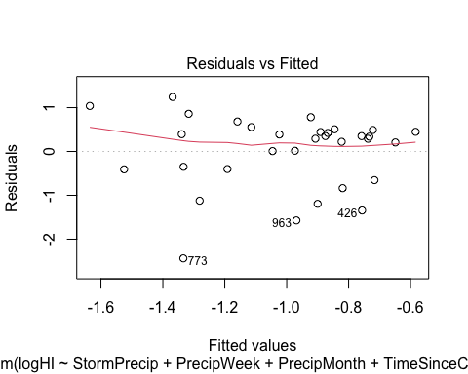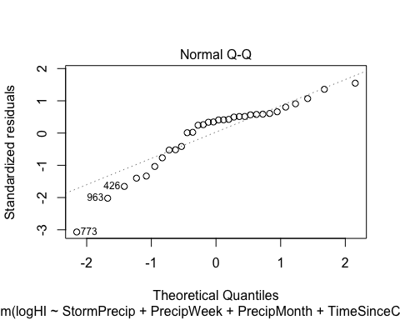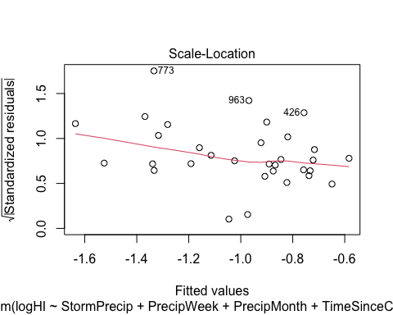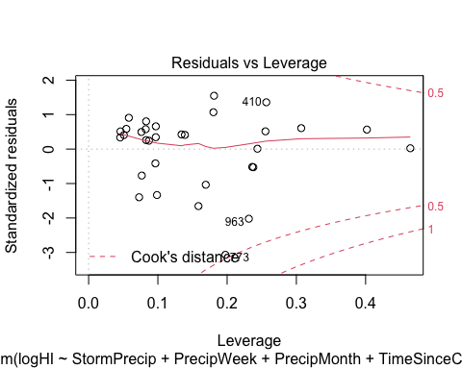 Doesnt look much better - do we need to further transform?

Plot_1 <- plot_summs(MOOS.model, FRCH.model,   
 CARI.model, POKE.model,   
 VAUL.model, STRT.model, scale = TRUE,  
 model.names = c("MOOS", "FRCH", "CARI", "POKE", "VAUL", "STRT"),  
 colors = c("#A6761D", "#FF7F00","#3288BD", "#6A3D9A", "#E7298A", "#66C2A5"))

## Loading required namespace: broom.mixed  
## Loading required namespace: broom.mixed  
## Loading required namespace: broom.mixed  
## Loading required namespace: broom.mixed  
## Loading required namespace: broom.mixed  
## Loading required namespace: broom.mixed

no3_hi <- Plot_1 +   
 xlab("Coefficient estimate") + ylab("") +  
 geom_vline(xintercept = 0,  
 colour = "grey80",  
 linetype = 1) +  
scale_y_discrete(labels= c("Seasonality",   
 "Precipitation Month",   
 "Precipitation Week",  
 "Storm Precipitation")) +  
 theme_bw()   
  
ggsave("HI_NO3.pdf",  
 path = here("plots", "Coefficient_Plots", "HI"),  
 width = 7, height = 7)

### fDOM

# correlation   
fDOM_data <- HI_FI_fDOM[,c("Hyst_index", "site.ID", "StormPrecip", "PrecipWeek", "PrecipMonth", "ThreeMonth", "Intensity", "TimeSinceChena", "pf", "burn", "year")]  
fDOM_data <- na.omit(fDOM_data) # 244 to 236 rows   
  
HI_FI_fDOM$logHI <- log(abs(HI_FI_fDOM$Hyst_index))  
  
ggpairs(fDOM_data,  
 columns = c("Hyst_index", "StormPrecip", "PrecipWeek", "PrecipMonth","ThreeMonth", "Intensity", "TimeSinceChena"),  
 ggplot2::aes(color = site.ID))+  
 scale_color_manual(values = c("#3288BD", "#FF7F00","#A6761D", "#6A3D9A", "#66C2A5", "#E7298A"))

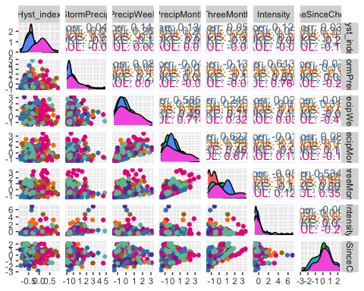

ggsave("fDOM_pairs.pdf",  
 path = here("Output_from_analysis", "09_Antecedent_Conditions_models", "plots"),  
 width = 10, height = 10)

HI_FI_fDOM_MOOS <- subset(HI_FI_fDOM, site.ID == "MOOS")  
HI_FI_fDOM_FRCH <- subset(HI_FI_fDOM, site.ID == "FRCH")  
HI_FI_fDOM_CARI <- subset(HI_FI_fDOM, site.ID == "CARI")  
HI_FI_fDOM_POKE <- subset(HI_FI_fDOM, site.ID == "POKE")  
HI_FI_fDOM_VAUL <- subset(HI_FI_fDOM, site.ID == "VAUL")  
HI_FI_fDOM_STRT <- subset(HI_FI_fDOM, site.ID == "STRT")

ggpairs(HI_FI_fDOM_MOOS,  
 columns = c("Hyst_index", "StormPrecip", "PrecipWeek", "PrecipMonth","ThreeMonth", "Intensity", "TimeSinceChena"),  
 ggplot2::aes(color = site.ID))+  
 scale_color_manual(values = c("#A6761D"))

## Warning in ggally_statistic(data = data, mapping = mapping, na.rm = na.rm, :  
## Removing 1 row that contained a missing value  
  
## Warning in ggally_statistic(data = data, mapping = mapping, na.rm = na.rm, :  
## Removing 1 row that contained a missing value  
  
## Warning in ggally_statistic(data = data, mapping = mapping, na.rm = na.rm, :  
## Removing 1 row that contained a missing value  
  
## Warning in ggally_statistic(data = data, mapping = mapping, na.rm = na.rm, :  
## Removing 1 row that contained a missing value  
  
## Warning in ggally_statistic(data = data, mapping = mapping, na.rm = na.rm, :  
## Removing 1 row that contained a missing value  
  
## Warning in ggally_statistic(data = data, mapping = mapping, na.rm = na.rm, :  
## Removing 1 row that contained a missing value

## Warning: Removed 1 rows containing non-finite values (stat_density).

## Warning: Removed 1 rows containing missing values (geom_point).  
## Removed 1 rows containing missing values (geom_point).  
## Removed 1 rows containing missing values (geom_point).  
## Removed 1 rows containing missing values (geom_point).  
## Removed 1 rows containing missing values (geom_point).  
## Removed 1 rows containing missing values (geom_point).

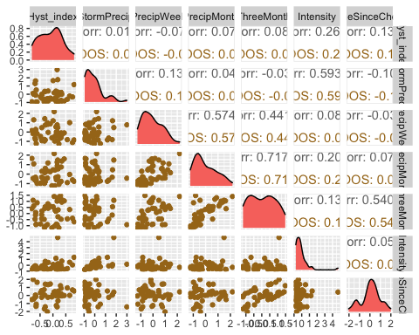

ggsave("fDOM_pairs_MOOS.pdf",  
 path = here("Output_from_analysis", "09_Antecedent_Conditions_models", "plots"),  
 width = 10, height = 10)

## Warning: Removed 1 rows containing non-finite values (stat_density).  
## Removed 1 rows containing missing values (geom_point).  
## Removed 1 rows containing missing values (geom_point).  
## Removed 1 rows containing missing values (geom_point).  
## Removed 1 rows containing missing values (geom_point).  
## Removed 1 rows containing missing values (geom_point).  
## Removed 1 rows containing missing values (geom_point).

MOOS.model <- lm(Hyst_index ~ StormPrecip + PrecipWeek + PrecipMonth + TimeSinceChena, data = HI_FI_fDOM_MOOS)  
  
vif(MOOS.model)

## StormPrecip PrecipWeek PrecipMonth TimeSinceChena   
## 1.041158 1.515695 1.502352 1.031561

plot(MOOS.model)

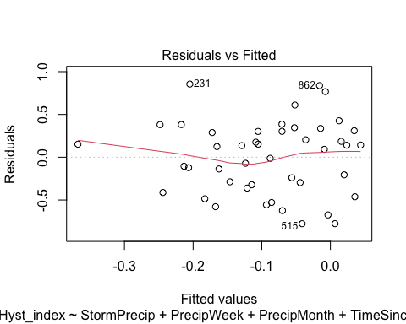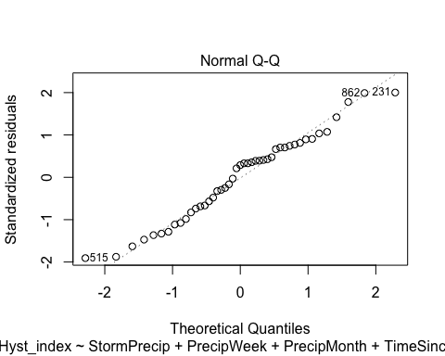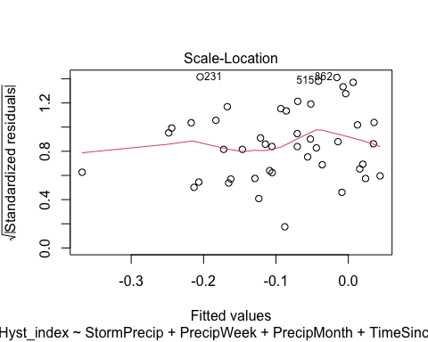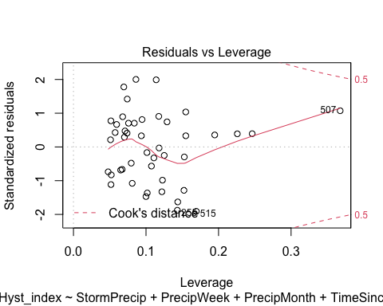

summary(MOOS.model)

##   
## Call:  
## lm(formula = Hyst_index ~ StormPrecip + PrecipWeek + PrecipMonth +   
## TimeSinceChena, data = HI_FI_fDOM_MOOS)  
##   
## Residuals:  
## Min 1Q Median 3Q Max   
## -0.7770 -0.3218 0.1245 0.3024 0.8554   
##   
## Coefficients:  
## Estimate Std. Error t value Pr(>|t|)  
## (Intercept) -0.10083 0.06745 -1.495 0.143  
## StormPrecip 0.02645 0.07903 0.335 0.740  
## PrecipWeek -0.09501 0.10152 -0.936 0.355  
## PrecipMonth 0.07925 0.09214 0.860 0.395  
## TimeSinceChena 0.06180 0.07653 0.808 0.424  
##   
## Residual standard error: 0.447 on 40 degrees of freedom  
## (1 observation deleted due to missingness)  
## Multiple R-squared: 0.04478, Adjusted R-squared: -0.05074   
## F-statistic: 0.4688 on 4 and 40 DF, p-value: 0.7582

ggpairs(HI_FI_fDOM_FRCH,  
 columns = c("Hyst_index", "StormPrecip", "PrecipWeek", "PrecipMonth","ThreeMonth", "Intensity", "TimeSinceChena"),  
 ggplot2::aes(color = site.ID))+  
 scale_color_manual(values = c("#FF7F00"))

## Warning in ggally_statistic(data = data, mapping = mapping, na.rm = na.rm, :  
## Removing 1 row that contained a missing value  
  
## Warning in ggally_statistic(data = data, mapping = mapping, na.rm = na.rm, :  
## Removing 1 row that contained a missing value  
  
## Warning in ggally_statistic(data = data, mapping = mapping, na.rm = na.rm, :  
## Removing 1 row that contained a missing value  
  
## Warning in ggally_statistic(data = data, mapping = mapping, na.rm = na.rm, :  
## Removing 1 row that contained a missing value  
  
## Warning in ggally_statistic(data = data, mapping = mapping, na.rm = na.rm, :  
## Removing 1 row that contained a missing value  
  
## Warning in ggally_statistic(data = data, mapping = mapping, na.rm = na.rm, :  
## Removing 1 row that contained a missing value

## Warning: Removed 1 rows containing missing values (geom_point).  
## Removed 1 rows containing missing values (geom_point).  
## Removed 1 rows containing missing values (geom_point).  
## Removed 1 rows containing missing values (geom_point).  
## Removed 1 rows containing missing values (geom_point).

## Warning: Removed 1 rows containing non-finite values (stat_density).

## Warning: Removed 1 rows containing missing values (geom_point).

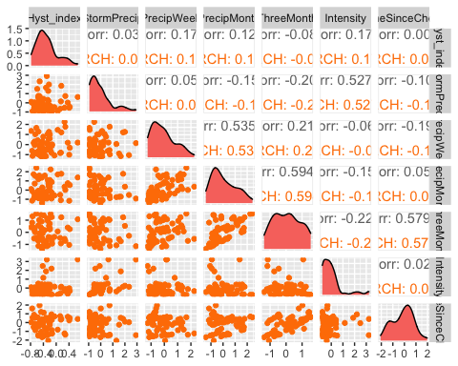

ggsave("fDOM_pairs_FRCH.pdf",  
 path = here("Output_from_analysis", "09_Antecedent_Conditions_models", "plots"),  
 width = 10, height = 10)

## Warning: Removed 1 rows containing missing values (geom_point).  
## Removed 1 rows containing missing values (geom_point).  
## Removed 1 rows containing missing values (geom_point).  
## Removed 1 rows containing missing values (geom_point).  
## Removed 1 rows containing missing values (geom_point).

## Warning: Removed 1 rows containing non-finite values (stat_density).

## Warning: Removed 1 rows containing missing values (geom_point).

FRCH.model <- lm(Hyst_index ~ StormPrecip + PrecipWeek + PrecipMonth + TimeSinceChena, data = HI_FI_fDOM_FRCH)  
  
vif(FRCH.model)

## StormPrecip PrecipWeek PrecipMonth TimeSinceChena   
## 1.058849 1.537815 1.518327 1.080334

plot(FRCH.model)

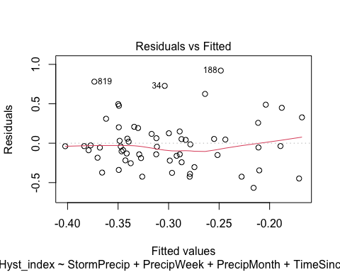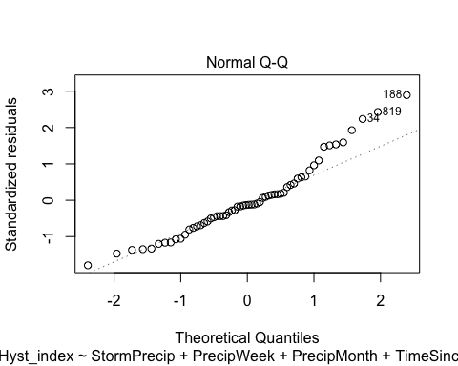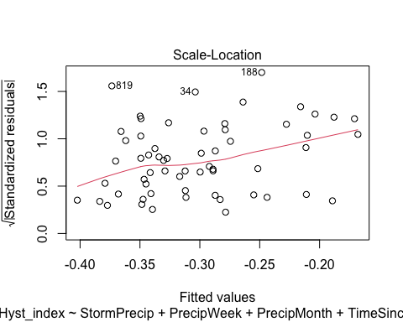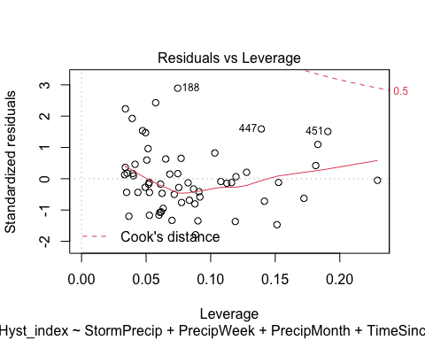

summary(FRCH.model)

##   
## Call:  
## lm(formula = Hyst_index ~ StormPrecip + PrecipWeek + PrecipMonth +   
## TimeSinceChena, data = HI_FI_fDOM_FRCH)  
##   
## Residuals:  
## Min 1Q Median 3Q Max   
## -0.56613 -0.19611 -0.03984 0.13182 0.92109   
##   
## Coefficients:  
## Estimate Std. Error t value Pr(>|t|)   
## (Intercept) -0.29501 0.04437 -6.649 1.41e-08 ***  
## StormPrecip 0.01427 0.04982 0.287 0.776   
## PrecipWeek 0.05564 0.06133 0.907 0.368   
## PrecipMonth 0.01541 0.05413 0.285 0.777   
## TimeSinceChena 0.01308 0.05006 0.261 0.795   
## ---  
## Signif. codes: 0 '***' 0.001 '**' 0.01 '*' 0.05 '.' 0.1 ' ' 1  
##   
## Residual standard error: 0.331 on 55 degrees of freedom  
## Multiple R-squared: 0.03263, Adjusted R-squared: -0.03772   
## F-statistic: 0.4638 on 4 and 55 DF, p-value: 0.762

what does a log transform look like

FRCH.model.log <- lm(logHI ~ StormPrecip + PrecipWeek + PrecipMonth + TimeSinceChena, data = HI_FI_fDOM_FRCH)  
  
vif(FRCH.model.log)

## StormPrecip PrecipWeek PrecipMonth TimeSinceChena   
## 1.058849 1.537815 1.518327 1.080334

plot(FRCH.model.log)

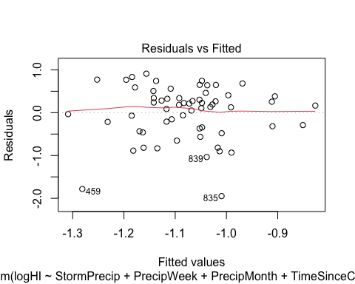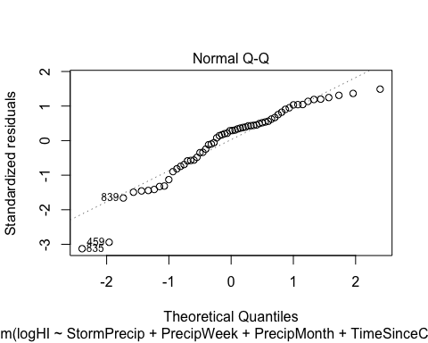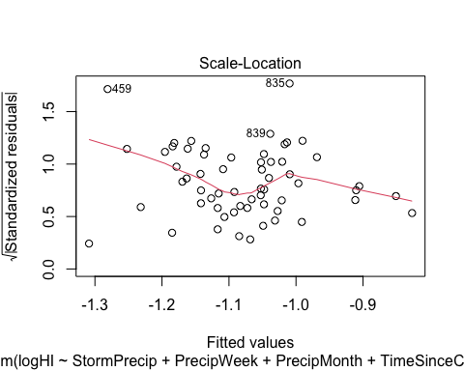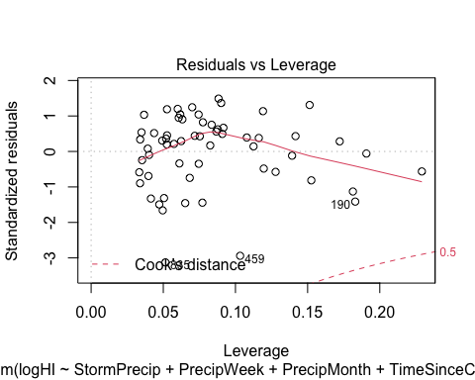 THis looks worse, lets stick with the original

ggpairs(HI_FI_fDOM_CARI,  
 columns = c("Hyst_index", "StormPrecip", "PrecipWeek", "PrecipMonth","ThreeMonth", "Intensity", "TimeSinceChena"),  
 ggplot2::aes(color = site.ID))+  
 scale_color_manual(values = c("#3288BD"))

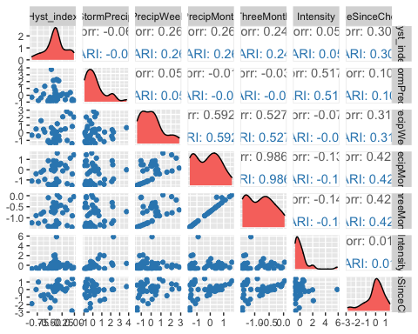

ggsave("fDOM_pairs_CARI.pdf",  
 path = here("Output_from_analysis", "09_Antecedent_Conditions_models", "plots"),  
 width = 10, height = 10)  
  
  
CARI.model <- lm(Hyst_index ~ StormPrecip + PrecipWeek + PrecipMonth + TimeSinceChena, data = HI_FI_fDOM_CARI)  
  
vif(CARI.model)

## StormPrecip PrecipWeek PrecipMonth TimeSinceChena   
## 1.019332 1.560191 1.713225 1.241131

plot(CARI.model)

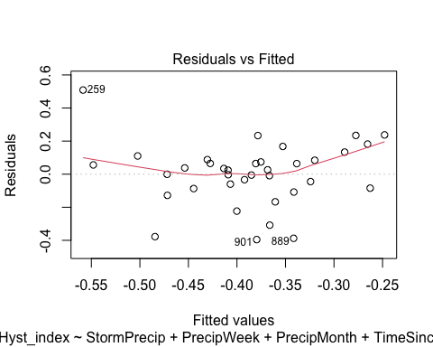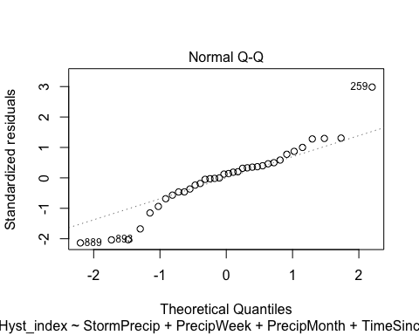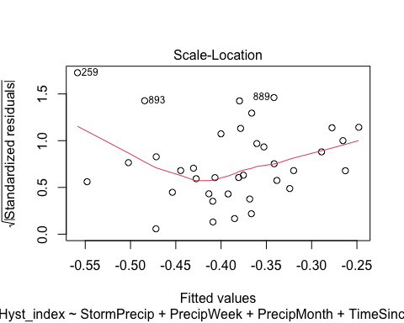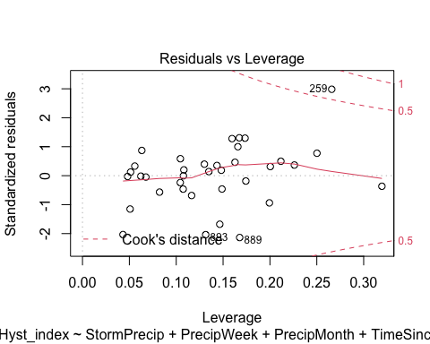

summary(CARI.model)

##   
## Call:  
## lm(formula = Hyst_index ~ StormPrecip + PrecipWeek + PrecipMonth +   
## TimeSinceChena, data = HI_FI_fDOM_CARI)  
##   
## Residuals:  
## Min 1Q Median 3Q Max   
## -0.39563 -0.08516 0.02511 0.08516 0.50868   
##   
## Coefficients:  
## Estimate Std. Error t value Pr(>|t|)   
## (Intercept) -0.37570 0.03583 -10.485 1.02e-11 ***  
## StormPrecip -0.01828 0.03057 -0.598 0.554   
## PrecipWeek 0.02836 0.03651 0.777 0.443   
## PrecipMonth 0.01373 0.04608 0.298 0.768   
## TimeSinceChena 0.04805 0.03836 1.253 0.220   
## ---  
## Signif. codes: 0 '***' 0.001 '**' 0.01 '*' 0.05 '.' 0.1 ' ' 1  
##   
## Residual standard error: 0.199 on 31 degrees of freedom  
## Multiple R-squared: 0.1374, Adjusted R-squared: 0.02612   
## F-statistic: 1.235 on 4 and 31 DF, p-value: 0.3165

lets log transform

CARI.model.log <- lm(logHI ~ StormPrecip + PrecipWeek + PrecipMonth + TimeSinceChena, data = HI_FI_fDOM_CARI)  
  
vif(CARI.model.log)

## StormPrecip PrecipWeek PrecipMonth TimeSinceChena   
## 1.019332 1.560191 1.713225 1.241131

plot(CARI.model.log)

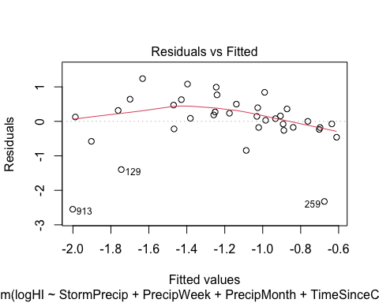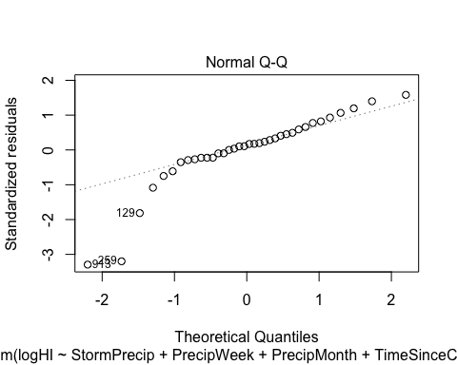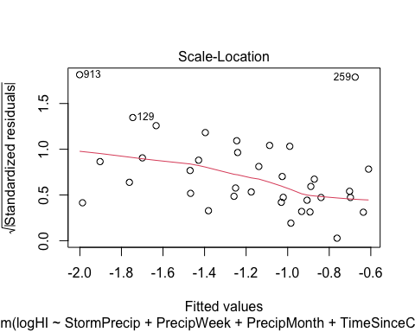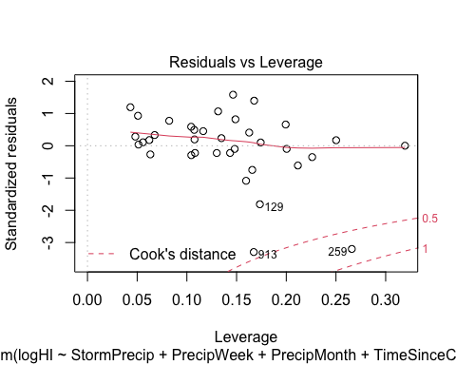 maybe further transform?

ggpairs(HI_FI_fDOM_POKE,  
 columns = c("Hyst_index", "StormPrecip", "PrecipWeek", "PrecipMonth","ThreeMonth", "Intensity", "TimeSinceChena"),  
 ggplot2::aes(color = site.ID))+  
 scale_color_manual(values = c("#6A3D9A"))

## Warning in ggally_statistic(data = data, mapping = mapping, na.rm = na.rm, :  
## Removing 1 row that contained a missing value  
  
## Warning in ggally_statistic(data = data, mapping = mapping, na.rm = na.rm, :  
## Removing 1 row that contained a missing value  
  
## Warning in ggally_statistic(data = data, mapping = mapping, na.rm = na.rm, :  
## Removing 1 row that contained a missing value  
  
## Warning in ggally_statistic(data = data, mapping = mapping, na.rm = na.rm, :  
## Removing 1 row that contained a missing value  
  
## Warning in ggally_statistic(data = data, mapping = mapping, na.rm = na.rm, :  
## Removing 1 row that contained a missing value  
  
## Warning in ggally_statistic(data = data, mapping = mapping, na.rm = na.rm, :  
## Removing 1 row that contained a missing value

## Warning: Removed 1 rows containing missing values (geom_point).  
## Removed 1 rows containing missing values (geom_point).  
## Removed 1 rows containing missing values (geom_point).  
## Removed 1 rows containing missing values (geom_point).  
## Removed 1 rows containing missing values (geom_point).

## Warning: Removed 1 rows containing non-finite values (stat_density).

## Warning: Removed 1 rows containing missing values (geom_point).

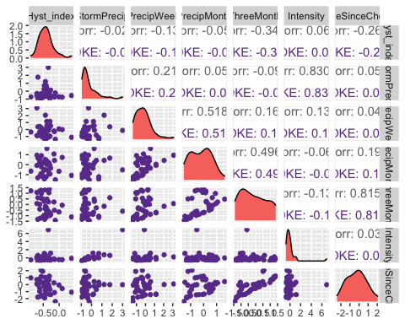

ggsave("fDOM_pairs_POKE.pdf",  
 path = here("Output_from_analysis", "09_Antecedent_Conditions_models", "plots"),  
 width = 10, height = 10)

## Warning: Removed 1 rows containing missing values (geom_point).  
## Removed 1 rows containing missing values (geom_point).  
## Removed 1 rows containing missing values (geom_point).  
## Removed 1 rows containing missing values (geom_point).  
## Removed 1 rows containing missing values (geom_point).

## Warning: Removed 1 rows containing non-finite values (stat_density).

## Warning: Removed 1 rows containing missing values (geom_point).

POKE.model <- lm(Hyst_index ~ StormPrecip + PrecipWeek + PrecipMonth + TimeSinceChena, data = HI_FI_fDOM_POKE)  
  
vif(POKE.model)

## StormPrecip PrecipWeek PrecipMonth TimeSinceChena   
## 1.054746 1.439955 1.430973 1.047057

plot(POKE.model)

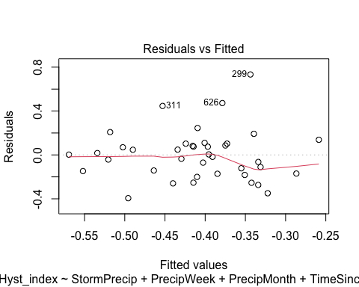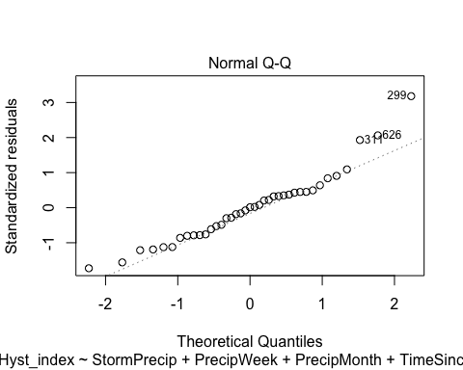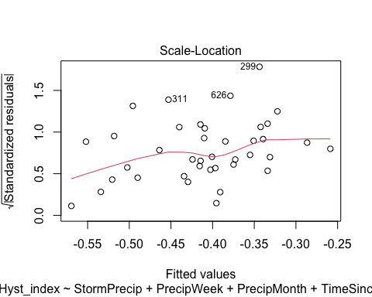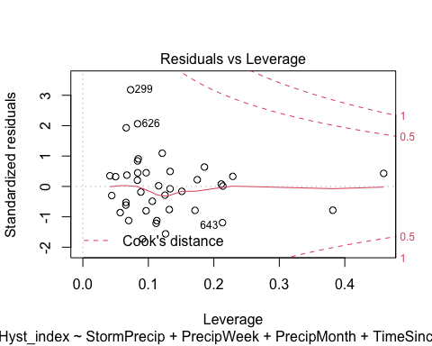

summary(POKE.model)

##   
## Call:  
## lm(formula = Hyst_index ~ StormPrecip + PrecipWeek + PrecipMonth +   
## TimeSinceChena, data = HI_FI_fDOM_POKE)  
##   
## Residuals:  
## Min 1Q Median 3Q Max   
## -0.39427 -0.15863 0.00270 0.09434 0.73324   
##   
## Coefficients:  
## Estimate Std. Error t value Pr(>|t|)   
## (Intercept) -0.428754 0.041696 -10.283 5.68e-12 ***  
## StormPrecip 0.007332 0.049040 0.150 0.882   
## PrecipWeek -0.045458 0.049704 -0.915 0.367   
## PrecipMonth 0.027443 0.057550 0.477 0.637   
## TimeSinceChena -0.061730 0.036906 -1.673 0.104   
## ---  
## Signif. codes: 0 '***' 0.001 '**' 0.01 '*' 0.05 '.' 0.1 ' ' 1  
##   
## Residual standard error: 0.2394 on 34 degrees of freedom  
## Multiple R-squared: 0.09444, Adjusted R-squared: -0.01209   
## F-statistic: 0.8865 on 4 and 34 DF, p-value: 0.4825

ggpairs(HI_FI_fDOM_VAUL,  
 columns = c("Hyst_index", "StormPrecip", "PrecipWeek", "PrecipMonth","ThreeMonth", "Intensity", "TimeSinceChena"),  
 ggplot2::aes(color = site.ID))+  
 scale_color_manual(values = c("#66C2A5"))

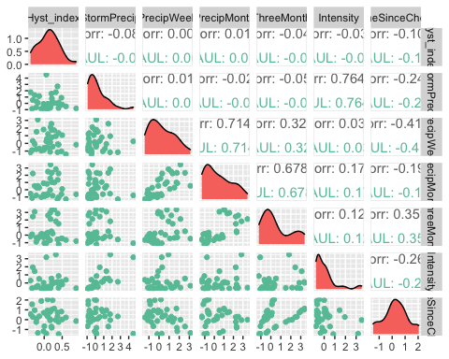

ggsave("fDOM_pairs_VAUL.pdf",  
 path = here("Output_from_analysis", "09_Antecedent_Conditions_models", "plots"),  
 width = 10, height = 10)  
  
  
VAUL.model <- lm(Hyst_index ~ StormPrecip + PrecipWeek + PrecipMonth + TimeSinceChena, data = HI_FI_fDOM_VAUL)  
  
vif(VAUL.model)

## StormPrecip PrecipWeek PrecipMonth TimeSinceChena   
## 1.075515 2.449107 2.091336 1.335090

plot(VAUL.model)

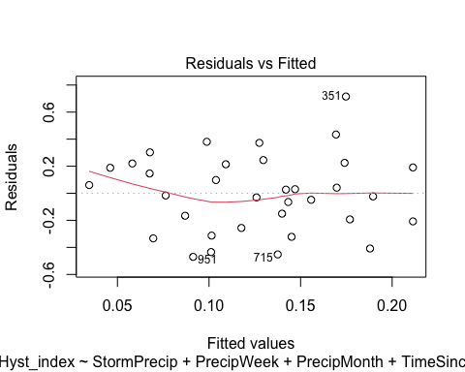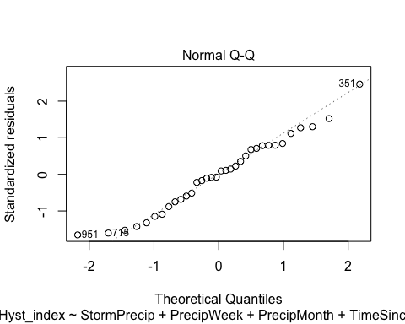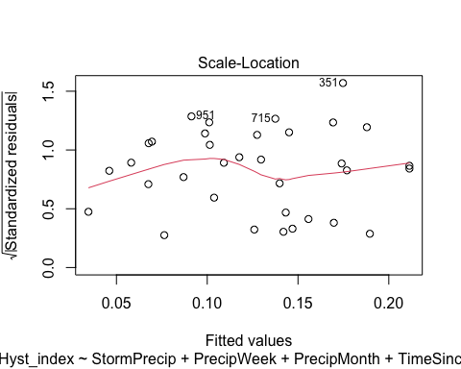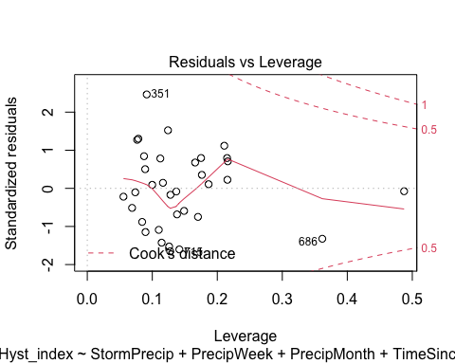

summary(VAUL.model)

##   
## Call:  
## lm(formula = Hyst_index ~ StormPrecip + PrecipWeek + PrecipMonth +   
## TimeSinceChena, data = HI_FI_fDOM_VAUL)  
##   
## Residuals:  
## Min 1Q Median 3Q Max   
## -0.4702 -0.2042 0.0051 0.2085 0.7151   
##   
## Coefficients:  
## Estimate Std. Error t value Pr(>|t|)   
## (Intercept) 0.14787 0.06047 2.445 0.0208 *  
## StormPrecip -0.02838 0.04604 -0.616 0.5424   
## PrecipWeek -0.02414 0.06908 -0.349 0.7293   
## PrecipMonth 0.01133 0.05559 0.204 0.8400   
## TimeSinceChena -0.05090 0.06598 -0.771 0.4467   
## ---  
## Signif. codes: 0 '***' 0.001 '**' 0.01 '*' 0.05 '.' 0.1 ' ' 1  
##   
## Residual standard error: 0.3045 on 29 degrees of freedom  
## Multiple R-squared: 0.0266, Adjusted R-squared: -0.1077   
## F-statistic: 0.1981 on 4 and 29 DF, p-value: 0.9373

Vifs may be a little high for precipweek

ggpairs(HI_FI_fDOM_STRT,  
 columns = c("Hyst_index", "StormPrecip", "PrecipWeek", "PrecipMonth","ThreeMonth", "Intensity", "TimeSinceChena"),  
 ggplot2::aes(color = site.ID))+  
 scale_color_manual(values = c("#E7298A"))

## Warning in ggally_statistic(data = data, mapping = mapping, na.rm = na.rm, :  
## Removing 1 row that contained a missing value  
  
## Warning in ggally_statistic(data = data, mapping = mapping, na.rm = na.rm, :  
## Removing 1 row that contained a missing value  
  
## Warning in ggally_statistic(data = data, mapping = mapping, na.rm = na.rm, :  
## Removing 1 row that contained a missing value  
  
## Warning in ggally_statistic(data = data, mapping = mapping, na.rm = na.rm, :  
## Removing 1 row that contained a missing value  
  
## Warning in ggally_statistic(data = data, mapping = mapping, na.rm = na.rm, :  
## Removing 1 row that contained a missing value  
  
## Warning in ggally_statistic(data = data, mapping = mapping, na.rm = na.rm, :  
## Removing 1 row that contained a missing value

## Warning: Removed 1 rows containing non-finite values (stat_density).

## Warning: Removed 1 rows containing missing values (geom_point).  
## Removed 1 rows containing missing values (geom_point).  
## Removed 1 rows containing missing values (geom_point).  
## Removed 1 rows containing missing values (geom_point).  
## Removed 1 rows containing missing values (geom_point).  
## Removed 1 rows containing missing values (geom_point).

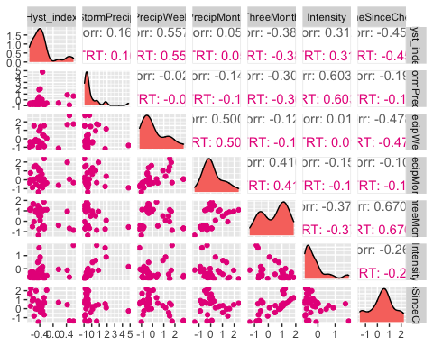

ggsave("fDOM_pairs_VAUL.pdf",  
 path = here("Output_from_analysis", "09_Antecedent_Conditions_models", "plots"),  
 width = 10, height = 10)

## Warning: Removed 1 rows containing non-finite values (stat_density).  
## Removed 1 rows containing missing values (geom_point).  
## Removed 1 rows containing missing values (geom_point).  
## Removed 1 rows containing missing values (geom_point).  
## Removed 1 rows containing missing values (geom_point).  
## Removed 1 rows containing missing values (geom_point).  
## Removed 1 rows containing missing values (geom_point).

STRT.model <- lm(Hyst_index ~ StormPrecip + PrecipWeek + PrecipMonth + TimeSinceChena, data = HI_FI_fDOM_STRT)  
  
vif(STRT.model)

## StormPrecip PrecipWeek PrecipMonth TimeSinceChena   
## 1.078833 1.761291 1.527550 1.276401

plot(STRT.model)

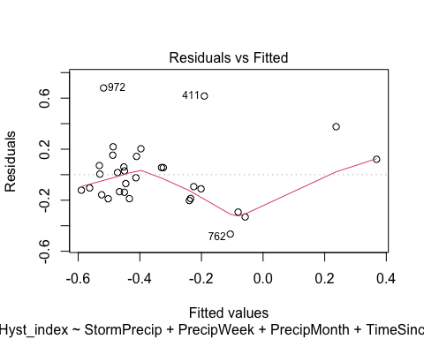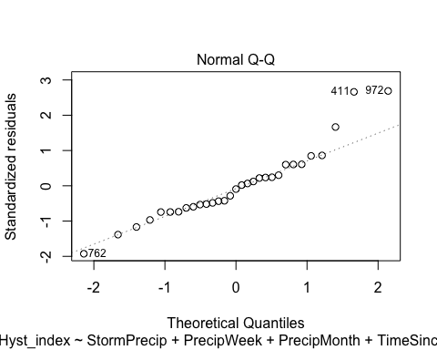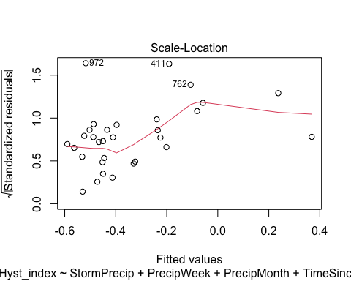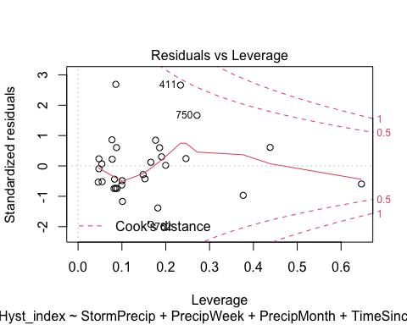

summary(STRT.model)

##   
## Call:  
## lm(formula = Hyst_index ~ StormPrecip + PrecipWeek + PrecipMonth +   
## TimeSinceChena, data = HI_FI_fDOM_STRT)  
##   
## Residuals:  
## Min 1Q Median 3Q Max   
## -0.46547 -0.14766 -0.02393 0.09614 0.67974   
##   
## Coefficients:  
## Estimate Std. Error t value Pr(>|t|)   
## (Intercept) -0.28972 0.05445 -5.321 1.44e-05 ***  
## StormPrecip 0.02172 0.04282 0.507 0.61627   
## PrecipWeek 0.21457 0.06216 3.452 0.00192 **   
## PrecipMonth -0.12540 0.06702 -1.871 0.07263 .   
## TimeSinceChena -0.07234 0.05642 -1.282 0.21105   
## ---  
## Signif. codes: 0 '***' 0.001 '**' 0.01 '*' 0.05 '.' 0.1 ' ' 1  
##   
## Residual standard error: 0.2645 on 26 degrees of freedom  
## (1 observation deleted due to missingness)  
## Multiple R-squared: 0.4577, Adjusted R-squared: 0.3743   
## F-statistic: 5.486 on 4 and 26 DF, p-value: 0.002439

Plot_1 <- plot_summs(MOOS.model, FRCH.model,   
 CARI.model, POKE.model,   
 VAUL.model, STRT.model, scale = TRUE,  
 model.names = c("MOOS", "FRCH", "CARI", "POKE", "VAUL", "STRT"),  
 colors = c("#A6761D", "#FF7F00","#3288BD", "#6A3D9A", "#E7298A", "#66C2A5"))

## Loading required namespace: broom.mixed  
## Loading required namespace: broom.mixed  
## Loading required namespace: broom.mixed  
## Loading required namespace: broom.mixed  
## Loading required namespace: broom.mixed  
## Loading required namespace: broom.mixed

fDOM_hi <- Plot_1 +   
 xlab("Coefficient estimate") + ylab("") +  
 geom_vline(xintercept = 0,  
 colour = "grey80",  
 linetype = 1) +  
scale_y_discrete(labels= c("Seasonality",   
 "Precipitation Month",   
 "Precipitation Week",  
 "Storm Precipitation")) +  
 theme_bw()   
  
ggsave("HI_fDOM.pdf",  
 path = here("plots", "Coefficient_Plots", "HI"),  
 width = 7, height = 7)

### SPC

# correlation   
SPC_data <- HI_FI_SPC[,c("Hyst_index", "site.ID", "StormPrecip", "PrecipWeek", "PrecipMonth", "ThreeMonth", "Intensity", "TimeSinceChena", "pf", "burn", "year")]  
SPC_data <- na.omit(SPC_data) # 244 to 236 rows   
  
HI_FI_SPC$logHI <- log(abs(HI_FI_SPC$Hyst_index))  
  
ggpairs(SPC_data,  
 columns = c("Hyst_index", "StormPrecip", "PrecipWeek", "PrecipMonth","ThreeMonth", "Intensity", "TimeSinceChena"),  
 ggplot2::aes(color = site.ID))+  
 scale_color_manual(values = c("#3288BD", "#FF7F00","#A6761D", "#6A3D9A", "#66C2A5", "#E7298A"))

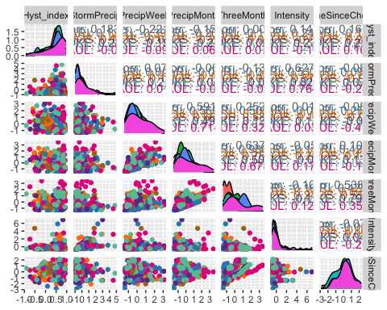

ggsave("SPC_pairs.pdf",  
 path = here("Output_from_analysis", "09_Antecedent_Conditions_models", "plots"),  
 width = 10, height = 10)

HI_FI_SPC_MOOS <- subset(HI_FI_SPC, site.ID == "MOOS")  
HI_FI_SPC_FRCH <- subset(HI_FI_SPC, site.ID == "FRCH")  
HI_FI_SPC_CARI <- subset(HI_FI_SPC, site.ID == "CARI")  
HI_FI_SPC_POKE <- subset(HI_FI_SPC, site.ID == "POKE")  
HI_FI_SPC_VAUL <- subset(HI_FI_SPC, site.ID == "VAUL")  
HI_FI_SPC_STRT <- subset(HI_FI_SPC, site.ID == "STRT")

ggpairs(HI_FI_SPC_MOOS,  
 columns = c("Hyst_index", "StormPrecip", "PrecipWeek", "PrecipMonth","ThreeMonth", "Intensity", "TimeSinceChena"),  
 ggplot2::aes(color = site.ID))+  
 scale_color_manual(values = c("#A6761D"))

## Warning in ggally_statistic(data = data, mapping = mapping, na.rm = na.rm, :  
## Removing 1 row that contained a missing value  
  
## Warning in ggally_statistic(data = data, mapping = mapping, na.rm = na.rm, :  
## Removing 1 row that contained a missing value  
  
## Warning in ggally_statistic(data = data, mapping = mapping, na.rm = na.rm, :  
## Removing 1 row that contained a missing value  
  
## Warning in ggally_statistic(data = data, mapping = mapping, na.rm = na.rm, :  
## Removing 1 row that contained a missing value  
  
## Warning in ggally_statistic(data = data, mapping = mapping, na.rm = na.rm, :  
## Removing 1 row that contained a missing value  
  
## Warning in ggally_statistic(data = data, mapping = mapping, na.rm = na.rm, :  
## Removing 1 row that contained a missing value

## Warning: Removed 1 rows containing non-finite values (stat_density).

## Warning: Removed 1 rows containing missing values (geom_point).  
## Removed 1 rows containing missing values (geom_point).  
## Removed 1 rows containing missing values (geom_point).  
## Removed 1 rows containing missing values (geom_point).  
## Removed 1 rows containing missing values (geom_point).  
## Removed 1 rows containing missing values (geom_point).

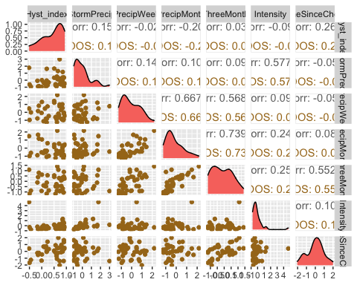

ggsave("SPC_pairs_MOOS.pdf",  
 path = here("Output_from_analysis", "09_Antecedent_Conditions_models", "plots"),  
 width = 10, height = 10)

## Warning: Removed 1 rows containing non-finite values (stat_density).  
## Removed 1 rows containing missing values (geom_point).  
## Removed 1 rows containing missing values (geom_point).  
## Removed 1 rows containing missing values (geom_point).  
## Removed 1 rows containing missing values (geom_point).  
## Removed 1 rows containing missing values (geom_point).  
## Removed 1 rows containing missing values (geom_point).

MOOS.model <- lm(Hyst_index ~ StormPrecip + PrecipWeek + PrecipMonth + TimeSinceChena, data = HI_FI_SPC_MOOS)  
  
vif(MOOS.model)

## StormPrecip PrecipWeek PrecipMonth TimeSinceChena   
## 1.034303 1.821559 1.832019 1.041046

plot(MOOS.model)

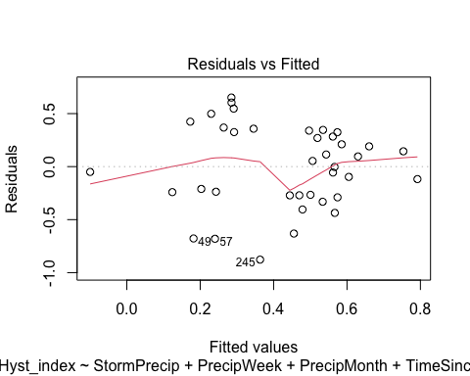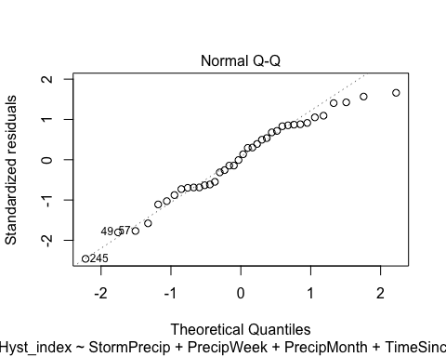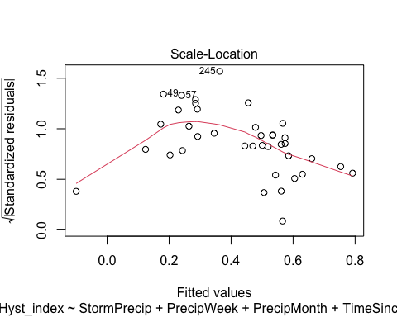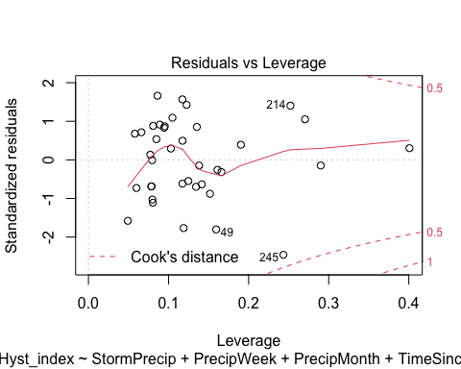

summary(MOOS.model)

##   
## Call:  
## lm(formula = Hyst_index ~ StormPrecip + PrecipWeek + PrecipMonth +   
## TimeSinceChena, data = HI_FI_SPC_MOOS)  
##   
## Residuals:  
## Min 1Q Median 3Q Max   
## -0.87732 -0.26944 0.02527 0.32513 0.65128   
##   
## Coefficients:  
## Estimate Std. Error t value Pr(>|t|)   
## (Intercept) 0.39672 0.06838 5.802 1.73e-06 ***  
## StormPrecip 0.09234 0.07504 1.231 0.2272   
## PrecipWeek 0.11032 0.10445 1.056 0.2985   
## PrecipMonth -0.21249 0.10875 -1.954 0.0592 .   
## TimeSinceChena 0.15471 0.07420 2.085 0.0449 *   
## ---  
## Signif. codes: 0 '***' 0.001 '**' 0.01 '*' 0.05 '.' 0.1 ' ' 1  
##   
## Residual standard error: 0.41 on 33 degrees of freedom  
## (1 observation deleted due to missingness)  
## Multiple R-squared: 0.1949, Adjusted R-squared: 0.09734   
## F-statistic: 1.998 on 4 and 33 DF, p-value: 0.1178

ggpairs(HI_FI_SPC_FRCH,  
 columns = c("Hyst_index", "StormPrecip", "PrecipWeek", "PrecipMonth","ThreeMonth", "Intensity", "TimeSinceChena"),  
 ggplot2::aes(color = site.ID))+  
 scale_color_manual(values = c("#FF7F00"))

## Warning in ggally_statistic(data = data, mapping = mapping, na.rm = na.rm, :  
## Removing 1 row that contained a missing value  
  
## Warning in ggally_statistic(data = data, mapping = mapping, na.rm = na.rm, :  
## Removing 1 row that contained a missing value  
  
## Warning in ggally_statistic(data = data, mapping = mapping, na.rm = na.rm, :  
## Removing 1 row that contained a missing value  
  
## Warning in ggally_statistic(data = data, mapping = mapping, na.rm = na.rm, :  
## Removing 1 row that contained a missing value  
  
## Warning in ggally_statistic(data = data, mapping = mapping, na.rm = na.rm, :  
## Removing 1 row that contained a missing value  
  
## Warning in ggally_statistic(data = data, mapping = mapping, na.rm = na.rm, :  
## Removing 1 row that contained a missing value

## Warning: Removed 1 rows containing missing values (geom_point).  
## Removed 1 rows containing missing values (geom_point).  
## Removed 1 rows containing missing values (geom_point).  
## Removed 1 rows containing missing values (geom_point).  
## Removed 1 rows containing missing values (geom_point).

## Warning: Removed 1 rows containing non-finite values (stat_density).

## Warning: Removed 1 rows containing missing values (geom_point).

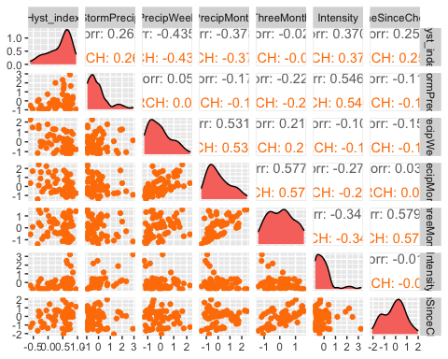

ggsave("SPC_pairs_FRCH.pdf",  
 path = here("Output_from_analysis", "09_Antecedent_Conditions_models", "plots"),  
 width = 10, height = 10)

## Warning: Removed 1 rows containing missing values (geom_point).  
## Removed 1 rows containing missing values (geom_point).  
## Removed 1 rows containing missing values (geom_point).  
## Removed 1 rows containing missing values (geom_point).  
## Removed 1 rows containing missing values (geom_point).

## Warning: Removed 1 rows containing non-finite values (stat_density).

## Warning: Removed 1 rows containing missing values (geom_point).

FRCH.model <- lm(Hyst_index ~ StormPrecip + PrecipWeek + PrecipMonth + TimeSinceChena, data = HI_FI_SPC_FRCH)  
  
vif(FRCH.model)

## StormPrecip PrecipWeek PrecipMonth TimeSinceChena   
## 1.070505 1.488804 1.498973 1.050278

plot(FRCH.model)

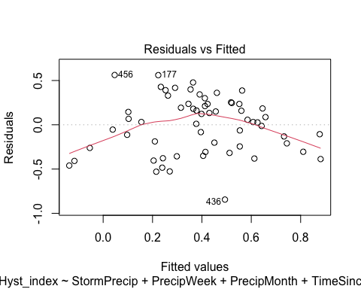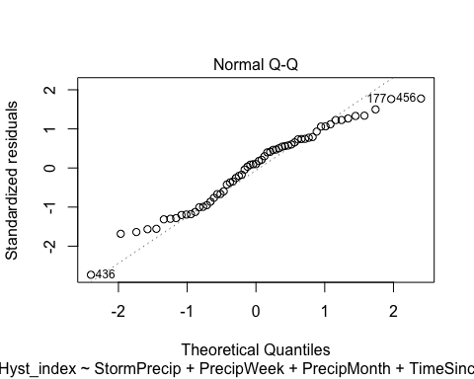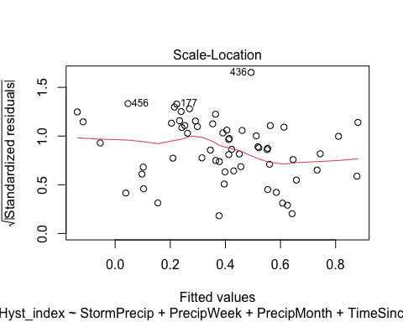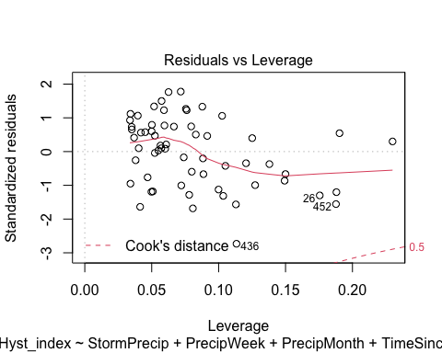

summary(FRCH.model)

##   
## Call:  
## lm(formula = Hyst_index ~ StormPrecip + PrecipWeek + PrecipMonth +   
## TimeSinceChena, data = HI_FI_SPC_FRCH)  
##   
## Residuals:  
## Min 1Q Median 3Q Max   
## -0.84465 -0.26145 0.03168 0.23500 0.56235   
##   
## Coefficients:  
## Estimate Std. Error t value Pr(>|t|)   
## (Intercept) 0.40387 0.04290 9.413 3.9e-13 ***  
## StormPrecip 0.12243 0.04990 2.454 0.0173 *   
## PrecipWeek -0.14554 0.05946 -2.448 0.0175 *   
## PrecipMonth -0.06680 0.05418 -1.233 0.2228   
## TimeSinceChena 0.10032 0.04689 2.140 0.0368 *   
## ---  
## Signif. codes: 0 '***' 0.001 '**' 0.01 '*' 0.05 '.' 0.1 ' ' 1  
##   
## Residual standard error: 0.3284 on 56 degrees of freedom  
## Multiple R-squared: 0.336, Adjusted R-squared: 0.2886   
## F-statistic: 7.084 on 4 and 56 DF, p-value: 0.0001092

ggpairs(HI_FI_SPC_CARI,  
 columns = c("Hyst_index", "StormPrecip", "PrecipWeek", "PrecipMonth","ThreeMonth", "Intensity", "TimeSinceChena"),  
 ggplot2::aes(color = site.ID))+  
 scale_color_manual(values = c("#3288BD"))

## Warning in ggally_statistic(data = data, mapping = mapping, na.rm = na.rm, :  
## Removing 1 row that contained a missing value  
  
## Warning in ggally_statistic(data = data, mapping = mapping, na.rm = na.rm, :  
## Removing 1 row that contained a missing value  
  
## Warning in ggally_statistic(data = data, mapping = mapping, na.rm = na.rm, :  
## Removing 1 row that contained a missing value  
  
## Warning in ggally_statistic(data = data, mapping = mapping, na.rm = na.rm, :  
## Removing 1 row that contained a missing value  
  
## Warning in ggally_statistic(data = data, mapping = mapping, na.rm = na.rm, :  
## Removing 1 row that contained a missing value  
  
## Warning in ggally_statistic(data = data, mapping = mapping, na.rm = na.rm, :  
## Removing 1 row that contained a missing value

## Warning: Removed 1 rows containing non-finite values (stat_density).

## Warning: Removed 1 rows containing missing values (geom_point).  
## Removed 1 rows containing missing values (geom_point).  
## Removed 1 rows containing missing values (geom_point).  
## Removed 1 rows containing missing values (geom_point).  
## Removed 1 rows containing missing values (geom_point).  
## Removed 1 rows containing missing values (geom_point).

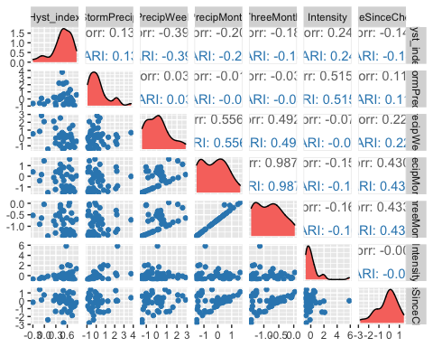

ggsave("SPC_pairs_CARI.pdf",  
 path = here("Output_from_analysis", "09_Antecedent_Conditions_models", "plots"),  
 width = 10, height = 10)

## Warning: Removed 1 rows containing non-finite values (stat_density).  
## Removed 1 rows containing missing values (geom_point).  
## Removed 1 rows containing missing values (geom_point).  
## Removed 1 rows containing missing values (geom_point).  
## Removed 1 rows containing missing values (geom_point).  
## Removed 1 rows containing missing values (geom_point).  
## Removed 1 rows containing missing values (geom_point).

CARI.model <- lm(Hyst_index ~ StormPrecip + PrecipWeek + PrecipMonth + TimeSinceChena, data = HI_FI_SPC_CARI)  
  
vif(CARI.model)

## StormPrecip PrecipWeek PrecipMonth TimeSinceChena   
## 1.019998 1.487969 1.711128 1.240433

plot(CARI.model)

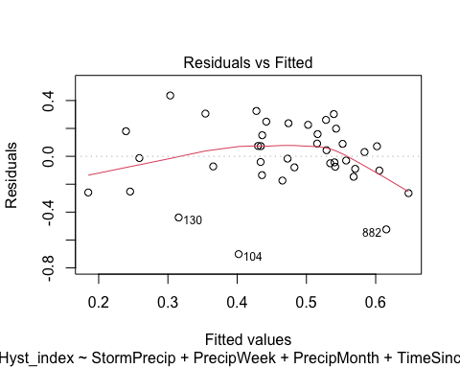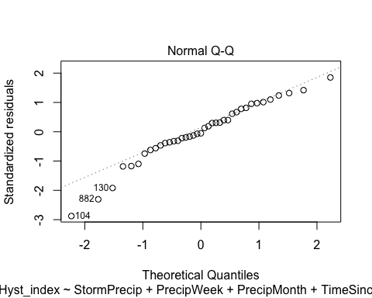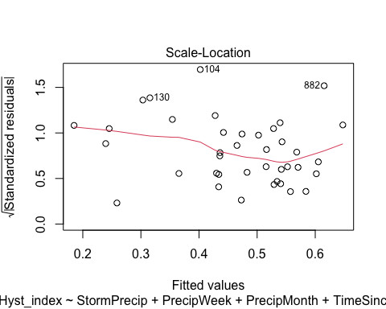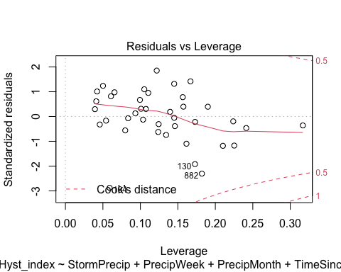

summary(CARI.model)

##   
## Call:  
## lm(formula = Hyst_index ~ StormPrecip + PrecipWeek + PrecipMonth +   
## TimeSinceChena, data = HI_FI_SPC_CARI)  
##   
## Residuals:  
## Min 1Q Median 3Q Max   
## -0.70117 -0.09594 -0.01241 0.16970 0.43614   
##   
## Coefficients:  
## Estimate Std. Error t value Pr(>|t|)   
## (Intercept) 0.46670 0.04420 10.558 2.85e-12 ***  
## StormPrecip 0.04049 0.03845 1.053 0.2997   
## PrecipWeek -0.10056 0.04427 -2.272 0.0296 *   
## PrecipMonth 0.02377 0.05757 0.413 0.6823   
## TimeSinceChena -0.02236 0.04622 -0.484 0.6316   
## ---  
## Signif. codes: 0 '***' 0.001 '**' 0.01 '*' 0.05 '.' 0.1 ' ' 1  
##   
## Residual standard error: 0.2512 on 34 degrees of freedom  
## (1 observation deleted due to missingness)  
## Multiple R-squared: 0.1862, Adjusted R-squared: 0.09041   
## F-statistic: 1.944 on 4 and 34 DF, p-value: 0.1255

ggpairs(HI_FI_SPC_POKE,  
 columns = c("Hyst_index", "StormPrecip", "PrecipWeek", "PrecipMonth","ThreeMonth", "Intensity", "TimeSinceChena"),  
 ggplot2::aes(color = site.ID))+  
 scale_color_manual(values = c("#6A3D9A"))

## Warning in ggally_statistic(data = data, mapping = mapping, na.rm = na.rm, :  
## Removing 1 row that contained a missing value  
  
## Warning in ggally_statistic(data = data, mapping = mapping, na.rm = na.rm, :  
## Removing 1 row that contained a missing value  
  
## Warning in ggally_statistic(data = data, mapping = mapping, na.rm = na.rm, :  
## Removing 1 row that contained a missing value  
  
## Warning in ggally_statistic(data = data, mapping = mapping, na.rm = na.rm, :  
## Removing 1 row that contained a missing value  
  
## Warning in ggally_statistic(data = data, mapping = mapping, na.rm = na.rm, :  
## Removing 1 row that contained a missing value  
  
## Warning in ggally_statistic(data = data, mapping = mapping, na.rm = na.rm, :  
## Removing 1 row that contained a missing value

## Warning: Removed 1 rows containing missing values (geom_point).  
## Removed 1 rows containing missing values (geom_point).  
## Removed 1 rows containing missing values (geom_point).  
## Removed 1 rows containing missing values (geom_point).  
## Removed 1 rows containing missing values (geom_point).

## Warning: Removed 1 rows containing non-finite values (stat_density).

## Warning: Removed 1 rows containing missing values (geom_point).

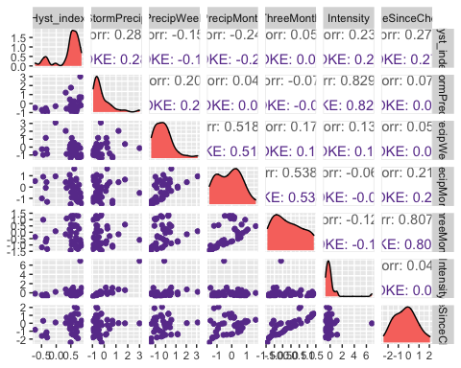

ggsave("SPC_pairs_POKE.pdf",  
 path = here("Output_from_analysis", "09_Antecedent_Conditions_models", "plots"),  
 width = 10, height = 10)

## Warning: Removed 1 rows containing missing values (geom_point).  
## Removed 1 rows containing missing values (geom_point).  
## Removed 1 rows containing missing values (geom_point).  
## Removed 1 rows containing missing values (geom_point).  
## Removed 1 rows containing missing values (geom_point).

## Warning: Removed 1 rows containing non-finite values (stat_density).

## Warning: Removed 1 rows containing missing values (geom_point).

POKE.model <- lm(Hyst_index ~ StormPrecip + PrecipWeek + PrecipMonth + TimeSinceChena, data = HI_FI_SPC_POKE)  
  
vif(POKE.model)

## StormPrecip PrecipWeek PrecipMonth TimeSinceChena   
## 1.059261 1.445139 1.448822 1.061587

plot(POKE.model)

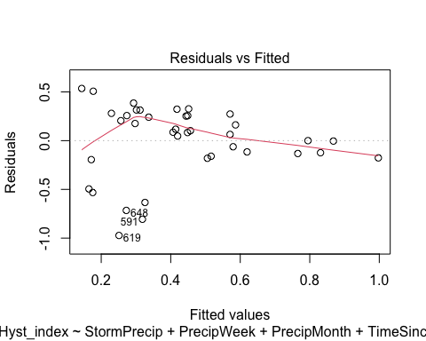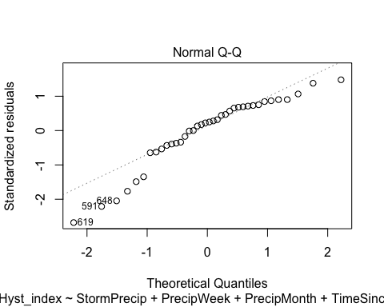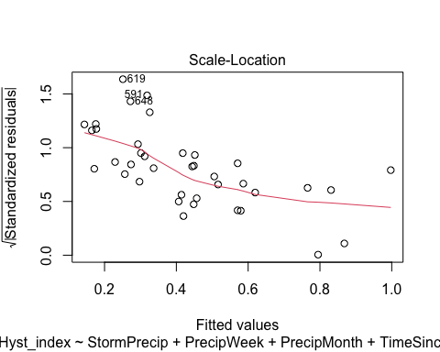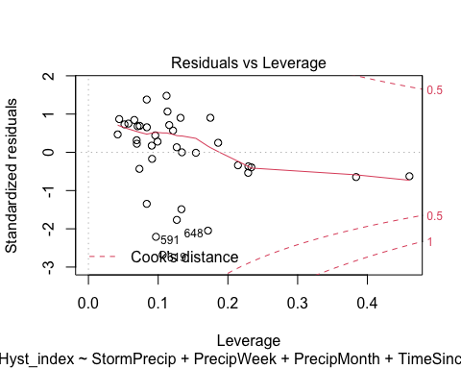 lets log transform

POKE.model.log <- lm(logHI ~ StormPrecip + PrecipWeek + PrecipMonth + TimeSinceChena, data = HI_FI_SPC_POKE)  
  
vif(POKE.model.log)

## StormPrecip PrecipWeek PrecipMonth TimeSinceChena   
## 1.059261 1.445139 1.448822 1.061587

plot(POKE.model.log)

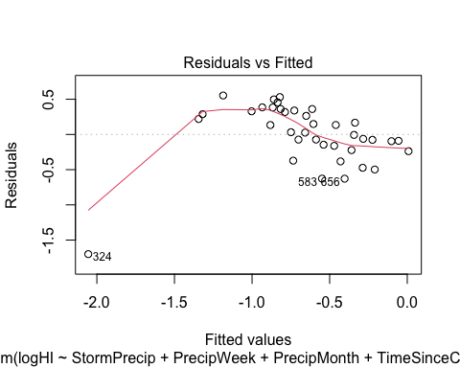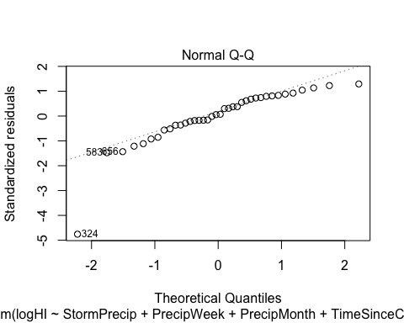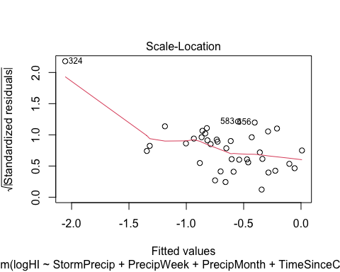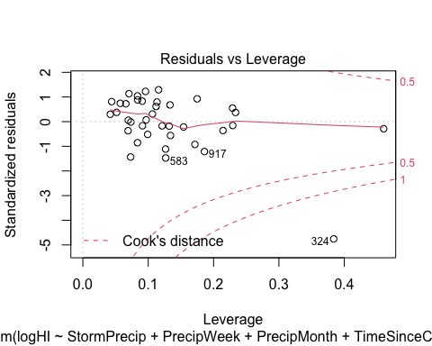 mostly works except one point

ggpairs(HI_FI_SPC_VAUL,  
 columns = c("Hyst_index", "StormPrecip", "PrecipWeek", "PrecipMonth","ThreeMonth", "Intensity", "TimeSinceChena"),  
 ggplot2::aes(color = site.ID))+  
 scale_color_manual(values = c("#E7298A"))

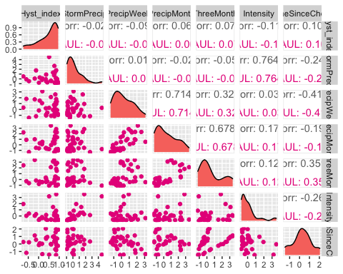

ggsave("SPC_pairs_VAUL.pdf",  
 path = here("Output_from_analysis", "09_Antecedent_Conditions_models", "plots"),  
 width = 10, height = 10)  
  
  
VAUL.model <- lm(Hyst_index ~ StormPrecip + PrecipWeek + PrecipMonth + TimeSinceChena, data = HI_FI_SPC_VAUL)  
  
vif(VAUL.model)

## StormPrecip PrecipWeek PrecipMonth TimeSinceChena   
## 1.075515 2.449107 2.091336 1.335090

plot(VAUL.model)

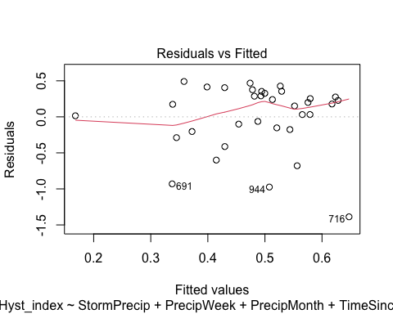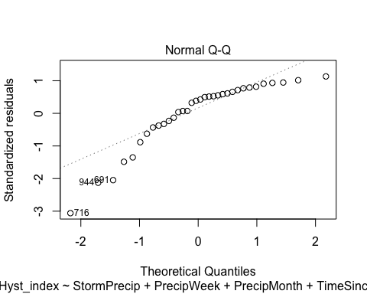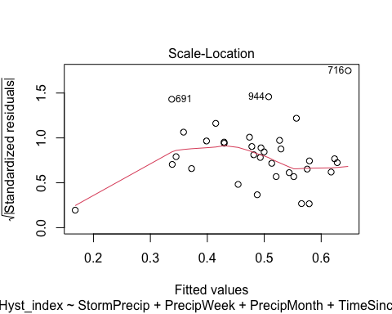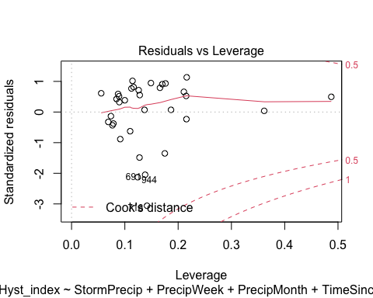 Lets log transform

VAUL.model.log <- lm(logHI ~ StormPrecip + PrecipWeek + PrecipMonth + TimeSinceChena, data = HI_FI_SPC_VAUL)  
  
vif(VAUL.model.log)

## StormPrecip PrecipWeek PrecipMonth TimeSinceChena   
## 1.075515 2.449107 2.091336 1.335090

plot(VAUL.model.log)

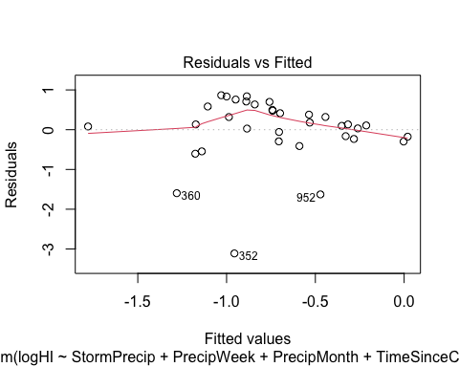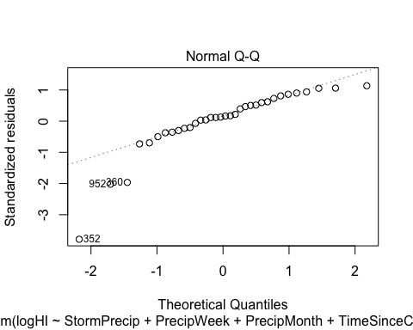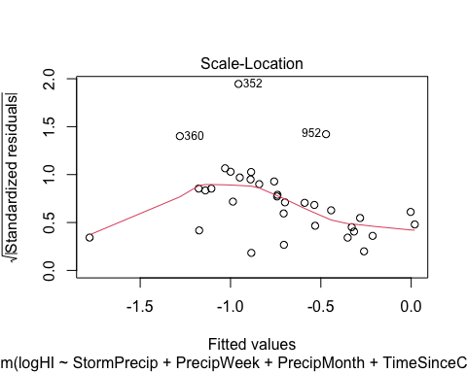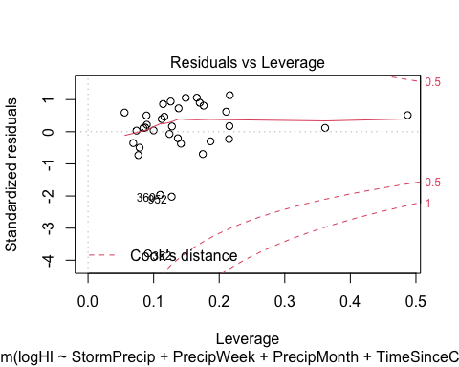

ggpairs(HI_FI_SPC_STRT,  
 columns = c("Hyst_index", "StormPrecip", "PrecipWeek", "PrecipMonth","ThreeMonth", "Intensity", "TimeSinceChena"),  
 ggplot2::aes(color = site.ID))+  
 scale_color_manual(values = c("#66C2A5"))

## Warning in ggally_statistic(data = data, mapping = mapping, na.rm = na.rm, :  
## Removed 2 rows containing missing values  
  
## Warning in ggally_statistic(data = data, mapping = mapping, na.rm = na.rm, :  
## Removed 2 rows containing missing values

## Warning in ggally_statistic(data = data, mapping = mapping, na.rm = na.rm, :  
## Removing 1 row that contained a missing value

## Warning in ggally_statistic(data = data, mapping = mapping, na.rm = na.rm, :  
## Removed 2 rows containing missing values

## Warning in ggally_statistic(data = data, mapping = mapping, na.rm = na.rm, :  
## Removing 1 row that contained a missing value  
  
## Warning in ggally_statistic(data = data, mapping = mapping, na.rm = na.rm, :  
## Removing 1 row that contained a missing value

## Warning in ggally_statistic(data = data, mapping = mapping, na.rm = na.rm, :  
## Removed 2 rows containing missing values

## Warning in ggally_statistic(data = data, mapping = mapping, na.rm = na.rm, :  
## Removing 1 row that contained a missing value  
  
## Warning in ggally_statistic(data = data, mapping = mapping, na.rm = na.rm, :  
## Removing 1 row that contained a missing value  
  
## Warning in ggally_statistic(data = data, mapping = mapping, na.rm = na.rm, :  
## Removing 1 row that contained a missing value

## Warning in ggally_statistic(data = data, mapping = mapping, na.rm = na.rm, :  
## Removed 2 rows containing missing values

## Warning in ggally_statistic(data = data, mapping = mapping, na.rm = na.rm, :  
## Removing 1 row that contained a missing value  
  
## Warning in ggally_statistic(data = data, mapping = mapping, na.rm = na.rm, :  
## Removing 1 row that contained a missing value  
  
## Warning in ggally_statistic(data = data, mapping = mapping, na.rm = na.rm, :  
## Removing 1 row that contained a missing value  
  
## Warning in ggally_statistic(data = data, mapping = mapping, na.rm = na.rm, :  
## Removing 1 row that contained a missing value

## Warning in ggally_statistic(data = data, mapping = mapping, na.rm = na.rm, :  
## Removed 2 rows containing missing values

## Warning in ggally_statistic(data = data, mapping = mapping, na.rm = na.rm, :  
## Removing 1 row that contained a missing value  
  
## Warning in ggally_statistic(data = data, mapping = mapping, na.rm = na.rm, :  
## Removing 1 row that contained a missing value  
  
## Warning in ggally_statistic(data = data, mapping = mapping, na.rm = na.rm, :  
## Removing 1 row that contained a missing value  
  
## Warning in ggally_statistic(data = data, mapping = mapping, na.rm = na.rm, :  
## Removing 1 row that contained a missing value  
  
## Warning in ggally_statistic(data = data, mapping = mapping, na.rm = na.rm, :  
## Removing 1 row that contained a missing value

## Warning: Removed 1 rows containing non-finite values (stat_density).

## Warning: Removed 2 rows containing missing values (geom_point).

## Warning: Removed 1 rows containing non-finite values (stat_density).

## Warning: Removed 2 rows containing missing values (geom_point).

## Warning: Removed 1 rows containing missing values (geom_point).

## Warning: Removed 1 rows containing non-finite values (stat_density).

## Warning: Removed 2 rows containing missing values (geom_point).

## Warning: Removed 1 rows containing missing values (geom_point).  
## Removed 1 rows containing missing values (geom_point).

## Warning: Removed 1 rows containing non-finite values (stat_density).

## Warning: Removed 2 rows containing missing values (geom_point).

## Warning: Removed 1 rows containing missing values (geom_point).  
## Removed 1 rows containing missing values (geom_point).  
## Removed 1 rows containing missing values (geom_point).

## Warning: Removed 1 rows containing non-finite values (stat_density).

## Warning: Removed 2 rows containing missing values (geom_point).

## Warning: Removed 1 rows containing missing values (geom_point).  
## Removed 1 rows containing missing values (geom_point).  
## Removed 1 rows containing missing values (geom_point).  
## Removed 1 rows containing missing values (geom_point).

## Warning: Removed 1 rows containing non-finite values (stat_density).

## Warning: Removed 2 rows containing missing values (geom_point).

## Warning: Removed 1 rows containing missing values (geom_point).  
## Removed 1 rows containing missing values (geom_point).  
## Removed 1 rows containing missing values (geom_point).  
## Removed 1 rows containing missing values (geom_point).  
## Removed 1 rows containing missing values (geom_point).

## Warning: Removed 1 rows containing non-finite values (stat_density).

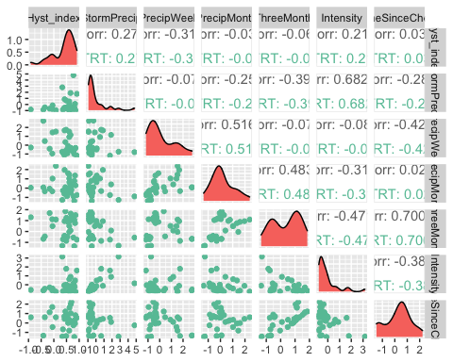

ggsave("SPC_pairs_VAUL.pdf",  
 path = here("Output_from_analysis", "09_Antecedent_Conditions_models", "plots"),  
 width = 10, height = 10)

## Warning: Removed 1 rows containing non-finite values (stat_density).

## Warning: Removed 2 rows containing missing values (geom_point).

## Warning: Removed 1 rows containing non-finite values (stat_density).

## Warning: Removed 2 rows containing missing values (geom_point).

## Warning: Removed 1 rows containing missing values (geom_point).

## Warning: Removed 1 rows containing non-finite values (stat_density).

## Warning: Removed 2 rows containing missing values (geom_point).

## Warning: Removed 1 rows containing missing values (geom_point).  
## Removed 1 rows containing missing values (geom_point).

## Warning: Removed 1 rows containing non-finite values (stat_density).

## Warning: Removed 2 rows containing missing values (geom_point).

## Warning: Removed 1 rows containing missing values (geom_point).  
## Removed 1 rows containing missing values (geom_point).  
## Removed 1 rows containing missing values (geom_point).

## Warning: Removed 1 rows containing non-finite values (stat_density).

## Warning: Removed 2 rows containing missing values (geom_point).

## Warning: Removed 1 rows containing missing values (geom_point).  
## Removed 1 rows containing missing values (geom_point).  
## Removed 1 rows containing missing values (geom_point).  
## Removed 1 rows containing missing values (geom_point).

## Warning: Removed 1 rows containing non-finite values (stat_density).

## Warning: Removed 2 rows containing missing values (geom_point).

## Warning: Removed 1 rows containing missing values (geom_point).  
## Removed 1 rows containing missing values (geom_point).  
## Removed 1 rows containing missing values (geom_point).  
## Removed 1 rows containing missing values (geom_point).  
## Removed 1 rows containing missing values (geom_point).

## Warning: Removed 1 rows containing non-finite values (stat_density).

STRT.model <- lm(Hyst_index ~ StormPrecip + PrecipWeek + PrecipMonth + TimeSinceChena, data = HI_FI_SPC_STRT)  
  
vif(STRT.model)

## StormPrecip PrecipWeek PrecipMonth TimeSinceChena   
## 1.188202 1.863288 1.690306 1.365779

plot(STRT.model)

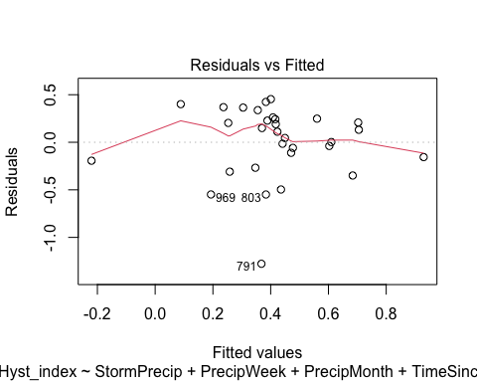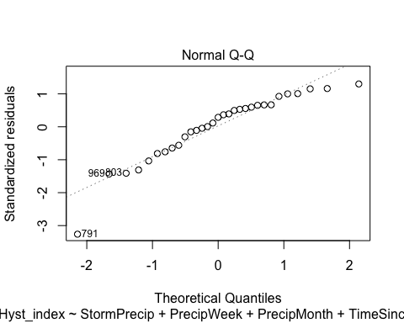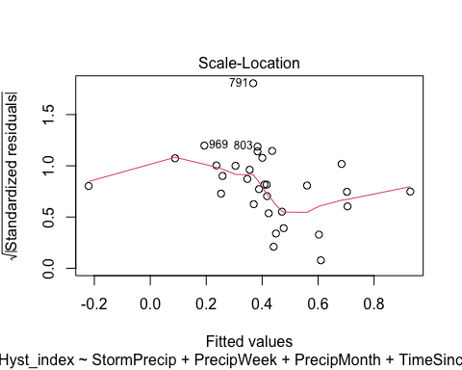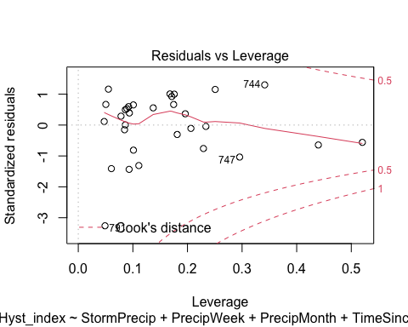

summary(STRT.model)

##   
## Call:  
## lm(formula = Hyst_index ~ StormPrecip + PrecipWeek + PrecipMonth +   
## TimeSinceChena, data = HI_FI_SPC_STRT)  
##   
## Residuals:  
## Min 1Q Median 3Q Max   
## -1.2774 -0.1749 0.1108 0.2456 0.4537   
##   
## Coefficients:  
## Estimate Std. Error t value Pr(>|t|)   
## (Intercept) 0.40554 0.07813 5.191 2.03e-05 ***  
## StormPrecip 0.10276 0.06231 1.649 0.111   
## PrecipWeek -0.21029 0.09619 -2.186 0.038 *   
## PrecipMonth 0.15686 0.10322 1.520 0.141   
## TimeSinceChena -0.02259 0.08771 -0.258 0.799   
## ---  
## Signif. codes: 0 '***' 0.001 '**' 0.01 '*' 0.05 '.' 0.1 ' ' 1  
##   
## Residual standard error: 0.4017 on 26 degrees of freedom  
## (2 observations deleted due to missingness)  
## Multiple R-squared: 0.2335, Adjusted R-squared: 0.1155   
## F-statistic: 1.98 on 4 and 26 DF, p-value: 0.1273

Plot_1 <- plot_summs(MOOS.model, FRCH.model,   
 CARI.model, POKE.model,   
 VAUL.model, STRT.model, scale = TRUE,  
 model.names = c("MOOS", "FRCH", "CARI", "POKE", "VAUL", "STRT"),  
 colors = c("#A6761D", "#FF7F00","#3288BD", "#6A3D9A", "#E7298A", "#66C2A5"))

## Loading required namespace: broom.mixed  
## Loading required namespace: broom.mixed  
## Loading required namespace: broom.mixed  
## Loading required namespace: broom.mixed  
## Loading required namespace: broom.mixed  
## Loading required namespace: broom.mixed

SPC_hi <- Plot_1 +   
 xlab("Coefficient estimate") + ylab("") +  
 geom_vline(xintercept = 0,  
 colour = "grey80",  
 linetype = 1) +  
scale_y_discrete(labels= c("Seasonality",   
 "Precipitation Month",   
 "Precipitation Week",  
 "Storm Precipitation")) +  
 theme_bw()   
  
ggsave("HI_SPC.pdf",  
 path = here("plots", "Coefficient_Plots", "HI"),  
 width = 7, height = 7)

### turb

# correlation   
turb_data <- HI_FI_turb[,c("Hyst_index", "site.ID", "StormPrecip", "PrecipWeek", "PrecipMonth", "ThreeMonth", "Intensity", "TimeSinceChena", "pf", "burn", "year")]  
turb_data <- na.omit(turb_data) # 244 to 236 rows   
  
HI_FI_turb$logHI <- log(abs(HI_FI_turb$Hyst_index))  
  
ggpairs(turb_data,  
 columns = c("Hyst_index", "StormPrecip", "PrecipWeek", "PrecipMonth","ThreeMonth", "Intensity", "TimeSinceChena"),  
 ggplot2::aes(color = site.ID))+  
 scale_color_manual(values = c("#3288BD", "#FF7F00","#A6761D", "#6A3D9A", "#66C2A5", "#E7298A"))

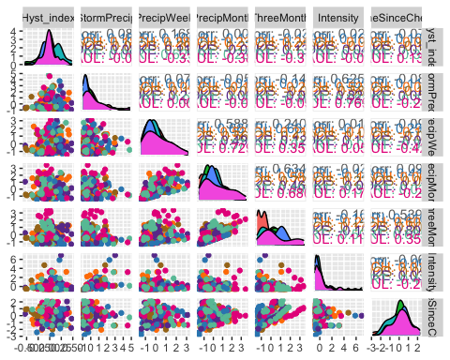

ggsave("turb_pairs.pdf",  
 path = here("Output_from_analysis", "09_Antecedent_Conditions_models", "plots"),  
 width = 10, height = 10)

HI_FI_turb_MOOS <- subset(HI_FI_turb, site.ID == "MOOS")  
HI_FI_turb_FRCH <- subset(HI_FI_turb, site.ID == "FRCH")  
HI_FI_turb_CARI <- subset(HI_FI_turb, site.ID == "CARI")  
HI_FI_turb_POKE <- subset(HI_FI_turb, site.ID == "POKE")  
HI_FI_turb_VAUL <- subset(HI_FI_turb, site.ID == "VAUL")  
HI_FI_turb_STRT <- subset(HI_FI_turb, site.ID == "STRT")

ggpairs(HI_FI_turb_MOOS,  
 columns = c("Hyst_index", "StormPrecip", "PrecipWeek", "PrecipMonth","ThreeMonth", "Intensity", "TimeSinceChena"),  
 ggplot2::aes(color = site.ID))+  
 scale_color_manual(values = c("#A6761D"))

## Warning in ggally_statistic(data = data, mapping = mapping, na.rm = na.rm, :  
## Removing 1 row that contained a missing value  
  
## Warning in ggally_statistic(data = data, mapping = mapping, na.rm = na.rm, :  
## Removing 1 row that contained a missing value  
  
## Warning in ggally_statistic(data = data, mapping = mapping, na.rm = na.rm, :  
## Removing 1 row that contained a missing value  
  
## Warning in ggally_statistic(data = data, mapping = mapping, na.rm = na.rm, :  
## Removing 1 row that contained a missing value  
  
## Warning in ggally_statistic(data = data, mapping = mapping, na.rm = na.rm, :  
## Removing 1 row that contained a missing value  
  
## Warning in ggally_statistic(data = data, mapping = mapping, na.rm = na.rm, :  
## Removing 1 row that contained a missing value

## Warning: Removed 1 rows containing non-finite values (stat_density).

## Warning: Removed 1 rows containing missing values (geom_point).  
## Removed 1 rows containing missing values (geom_point).  
## Removed 1 rows containing missing values (geom_point).  
## Removed 1 rows containing missing values (geom_point).  
## Removed 1 rows containing missing values (geom_point).  
## Removed 1 rows containing missing values (geom_point).

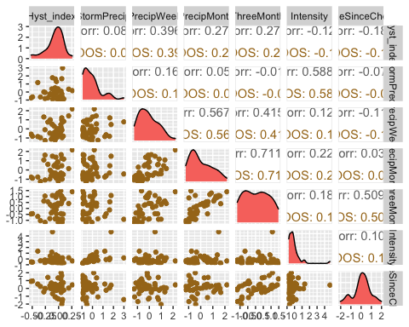

ggsave("turb_pairs_MOOS.pdf",  
 path = here("Output_from_analysis", "09_Antecedent_Conditions_models", "plots"),  
 width = 10, height = 10)

## Warning: Removed 1 rows containing non-finite values (stat_density).  
## Removed 1 rows containing missing values (geom_point).  
## Removed 1 rows containing missing values (geom_point).  
## Removed 1 rows containing missing values (geom_point).  
## Removed 1 rows containing missing values (geom_point).  
## Removed 1 rows containing missing values (geom_point).  
## Removed 1 rows containing missing values (geom_point).

MOOS.model <- lm(Hyst_index ~ StormPrecip + PrecipWeek + PrecipMonth + TimeSinceChena, data = HI_FI_turb_MOOS)  
  
vif(MOOS.model)

## StormPrecip PrecipWeek PrecipMonth TimeSinceChena   
## 1.041982 1.531344 1.488314 1.032331

plot(MOOS.model)

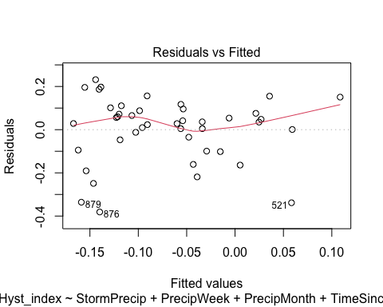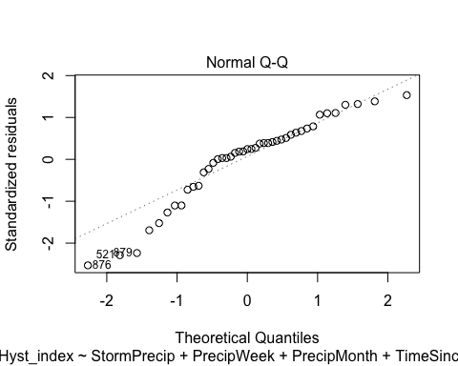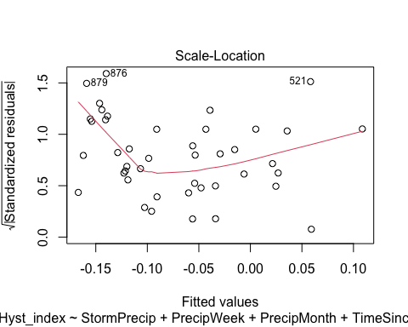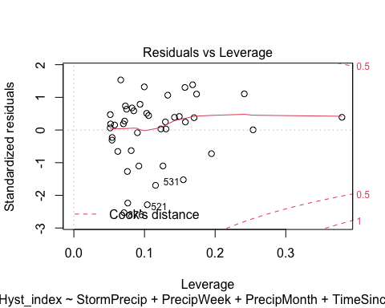 lets log transform

MOOS.model.log <- lm(logHI ~ StormPrecip + PrecipWeek + PrecipMonth + TimeSinceChena, data = HI_FI_turb_MOOS)  
  
vif(MOOS.model.log)

## StormPrecip PrecipWeek PrecipMonth TimeSinceChena   
## 1.041982 1.531344 1.488314 1.032331

plot(MOOS.model.log)

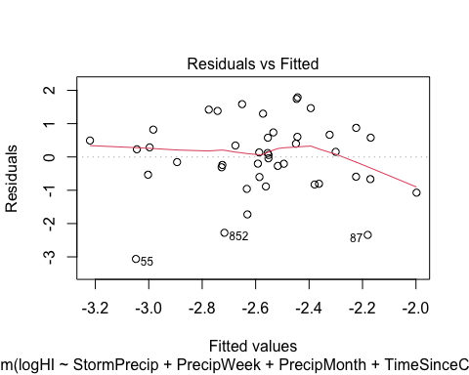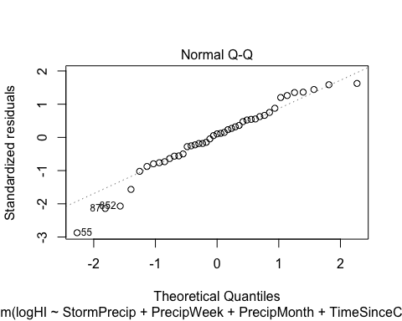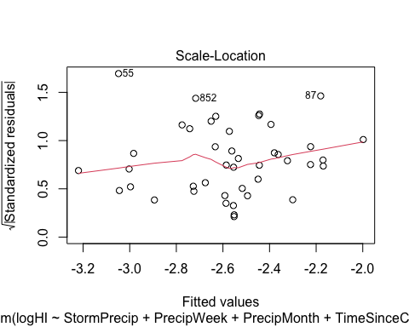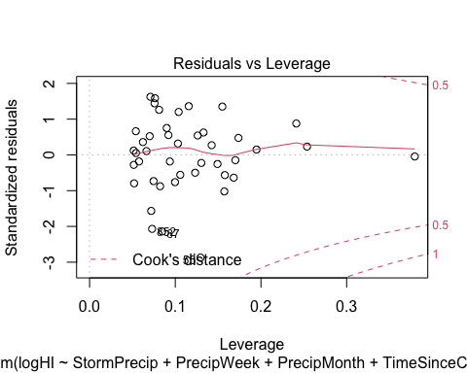

summary(MOOS.model.log)

##   
## Call:  
## lm(formula = logHI ~ StormPrecip + PrecipWeek + PrecipMonth +   
## TimeSinceChena, data = HI_FI_turb_MOOS)  
##   
## Residuals:  
## Min 1Q Median 3Q Max   
## -3.0625 -0.5975 0.1179 0.6353 1.7910   
##   
## Coefficients:  
## Estimate Std. Error t value Pr(>|t|)   
## (Intercept) -2.58345 0.17666 -14.624 <2e-16 ***  
## StormPrecip 0.09865 0.20322 0.485 0.630   
## PrecipWeek 0.15565 0.26800 0.581 0.565   
## PrecipMonth -0.05923 0.23688 -0.250 0.804   
## TimeSinceChena 0.28817 0.20817 1.384 0.174   
## ---  
## Signif. codes: 0 '***' 0.001 '**' 0.01 '*' 0.05 '.' 0.1 ' ' 1  
##   
## Residual standard error: 1.143 on 38 degrees of freedom  
## (1 observation deleted due to missingness)  
## Multiple R-squared: 0.05775, Adjusted R-squared: -0.04144   
## F-statistic: 0.5822 on 4 and 38 DF, p-value: 0.6774

ggpairs(HI_FI_turb_FRCH,  
 columns = c("Hyst_index", "StormPrecip", "PrecipWeek", "PrecipMonth","ThreeMonth", "Intensity", "TimeSinceChena"),  
 ggplot2::aes(color = site.ID))+  
 scale_color_manual(values = c("#FF7F00"))

## Warning in ggally_statistic(data = data, mapping = mapping, na.rm = na.rm, :  
## Removing 1 row that contained a missing value  
  
## Warning in ggally_statistic(data = data, mapping = mapping, na.rm = na.rm, :  
## Removing 1 row that contained a missing value  
  
## Warning in ggally_statistic(data = data, mapping = mapping, na.rm = na.rm, :  
## Removing 1 row that contained a missing value  
  
## Warning in ggally_statistic(data = data, mapping = mapping, na.rm = na.rm, :  
## Removing 1 row that contained a missing value  
  
## Warning in ggally_statistic(data = data, mapping = mapping, na.rm = na.rm, :  
## Removing 1 row that contained a missing value  
  
## Warning in ggally_statistic(data = data, mapping = mapping, na.rm = na.rm, :  
## Removing 1 row that contained a missing value

## Warning: Removed 1 rows containing missing values (geom_point).  
## Removed 1 rows containing missing values (geom_point).  
## Removed 1 rows containing missing values (geom_point).  
## Removed 1 rows containing missing values (geom_point).  
## Removed 1 rows containing missing values (geom_point).

## Warning: Removed 1 rows containing non-finite values (stat_density).

## Warning: Removed 1 rows containing missing values (geom_point).

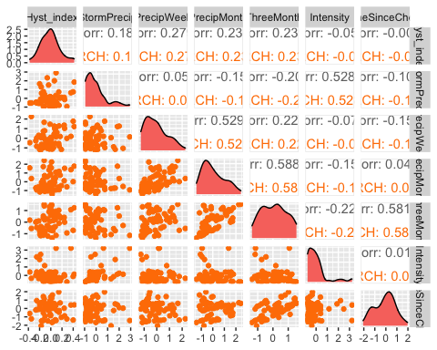

ggsave("turb_pairs_FRCH.pdf",  
 path = here("Output_from_analysis", "09_Antecedent_Conditions_models", "plots"),  
 width = 10, height = 10)

## Warning: Removed 1 rows containing missing values (geom_point).  
## Removed 1 rows containing missing values (geom_point).  
## Removed 1 rows containing missing values (geom_point).  
## Removed 1 rows containing missing values (geom_point).  
## Removed 1 rows containing missing values (geom_point).

## Warning: Removed 1 rows containing non-finite values (stat_density).

## Warning: Removed 1 rows containing missing values (geom_point).

FRCH.model <- lm(Hyst_index ~ StormPrecip + PrecipWeek + PrecipMonth + TimeSinceChena, data = HI_FI_turb_FRCH)  
  
vif(FRCH.model)

## StormPrecip PrecipWeek PrecipMonth TimeSinceChena   
## 1.057695 1.483044 1.484324 1.051440

plot(FRCH.model)

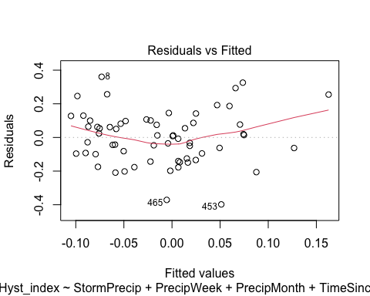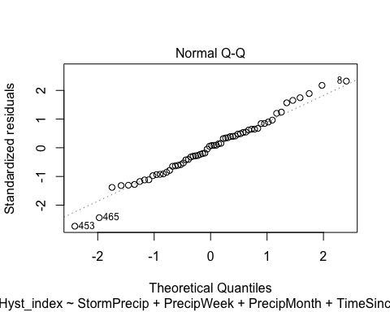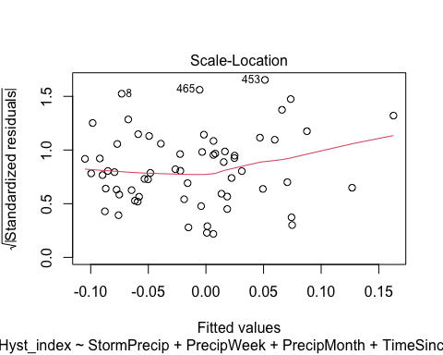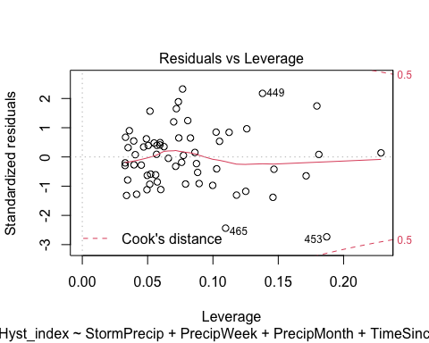

summary(FRCH.model)

##   
## Call:  
## lm(formula = Hyst_index ~ StormPrecip + PrecipWeek + PrecipMonth +   
## TimeSinceChena, data = HI_FI_turb_FRCH)  
##   
## Residuals:  
## Min 1Q Median 3Q Max   
## -0.39788 -0.09843 0.01021 0.09475 0.36053   
##   
## Coefficients:  
## Estimate Std. Error t value Pr(>|t|)  
## (Intercept) -0.009608 0.020936 -0.459 0.648  
## StormPrecip 0.039881 0.024253 1.644 0.106  
## PrecipWeek 0.035775 0.029144 1.228 0.225  
## PrecipMonth 0.029186 0.026090 1.119 0.268  
## TimeSinceChena 0.007360 0.023001 0.320 0.750  
##   
## Residual standard error: 0.1614 on 57 degrees of freedom  
## Multiple R-squared: 0.1305, Adjusted R-squared: 0.06952   
## F-statistic: 2.139 on 4 and 57 DF, p-value: 0.08763

ggpairs(HI_FI_turb_CARI,  
 columns = c("Hyst_index", "StormPrecip", "PrecipWeek", "PrecipMonth","ThreeMonth", "Intensity", "TimeSinceChena"),  
 ggplot2::aes(color = site.ID))+  
 scale_color_manual(values = c("#3288BD"))

## Warning in ggally_statistic(data = data, mapping = mapping, na.rm = na.rm, :  
## Removing 1 row that contained a missing value  
  
## Warning in ggally_statistic(data = data, mapping = mapping, na.rm = na.rm, :  
## Removing 1 row that contained a missing value  
  
## Warning in ggally_statistic(data = data, mapping = mapping, na.rm = na.rm, :  
## Removing 1 row that contained a missing value  
  
## Warning in ggally_statistic(data = data, mapping = mapping, na.rm = na.rm, :  
## Removing 1 row that contained a missing value  
  
## Warning in ggally_statistic(data = data, mapping = mapping, na.rm = na.rm, :  
## Removing 1 row that contained a missing value  
  
## Warning in ggally_statistic(data = data, mapping = mapping, na.rm = na.rm, :  
## Removing 1 row that contained a missing value

## Warning: Removed 1 rows containing non-finite values (stat_density).

## Warning: Removed 1 rows containing missing values (geom_point).  
## Removed 1 rows containing missing values (geom_point).  
## Removed 1 rows containing missing values (geom_point).  
## Removed 1 rows containing missing values (geom_point).  
## Removed 1 rows containing missing values (geom_point).  
## Removed 1 rows containing missing values (geom_point).

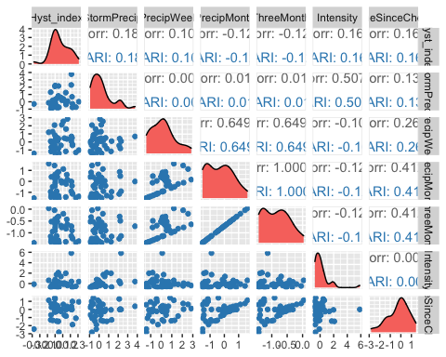

ggsave("turb_pairs_CARI.pdf",  
 path = here("Output_from_analysis", "09_Antecedent_Conditions_models", "plots"),  
 width = 10, height = 10)

## Warning: Removed 1 rows containing non-finite values (stat_density).  
## Removed 1 rows containing missing values (geom_point).  
## Removed 1 rows containing missing values (geom_point).  
## Removed 1 rows containing missing values (geom_point).  
## Removed 1 rows containing missing values (geom_point).  
## Removed 1 rows containing missing values (geom_point).  
## Removed 1 rows containing missing values (geom_point).

CARI.model <- lm(Hyst_index ~ StormPrecip + PrecipWeek + PrecipMonth + TimeSinceChena, data = HI_FI_turb_CARI)  
  
vif(CARI.model)

## StormPrecip PrecipWeek PrecipMonth TimeSinceChena   
## 1.015206 1.777952 1.952014 1.222154

plot(CARI.model)

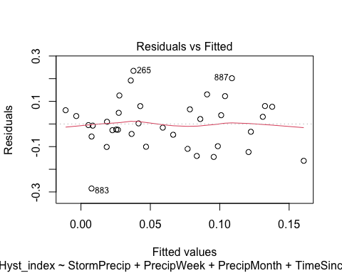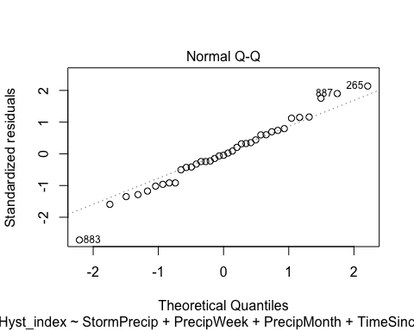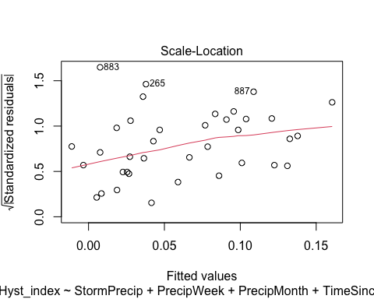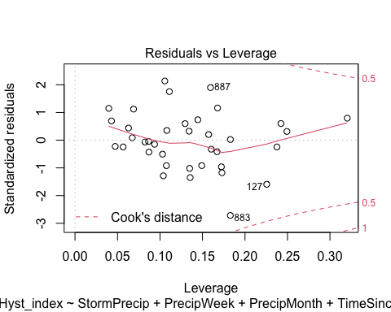

summary(CARI.model)

##   
## Call:  
## lm(formula = Hyst_index ~ StormPrecip + PrecipWeek + PrecipMonth +   
## TimeSinceChena, data = HI_FI_turb_CARI)  
##   
## Residuals:  
## Min 1Q Median 3Q Max   
## -0.284954 -0.055405 -0.005047 0.064639 0.234595   
##   
## Coefficients:  
## Estimate Std. Error t value Pr(>|t|)   
## (Intercept) 0.04032 0.02264 1.781 0.0845 .  
## StormPrecip 0.01687 0.01793 0.941 0.3538   
## PrecipWeek 0.03337 0.02295 1.454 0.1557   
## PrecipMonth -0.05581 0.02928 -1.906 0.0657 .  
## TimeSinceChena 0.02714 0.02140 1.268 0.2138   
## ---  
## Signif. codes: 0 '***' 0.001 '**' 0.01 '*' 0.05 '.' 0.1 ' ' 1  
##   
## Residual standard error: 0.116 on 32 degrees of freedom  
## (1 observation deleted due to missingness)  
## Multiple R-squared: 0.1524, Adjusted R-squared: 0.04647   
## F-statistic: 1.439 on 4 and 32 DF, p-value: 0.244

ggpairs(HI_FI_turb_POKE,  
 columns = c("Hyst_index", "StormPrecip", "PrecipWeek", "PrecipMonth","ThreeMonth", "Intensity", "TimeSinceChena"),  
 ggplot2::aes(color = site.ID))+  
 scale_color_manual(values = c("#6A3D9A"))

## Warning in ggally_statistic(data = data, mapping = mapping, na.rm = na.rm, :  
## Removing 1 row that contained a missing value  
  
## Warning in ggally_statistic(data = data, mapping = mapping, na.rm = na.rm, :  
## Removing 1 row that contained a missing value  
  
## Warning in ggally_statistic(data = data, mapping = mapping, na.rm = na.rm, :  
## Removing 1 row that contained a missing value  
  
## Warning in ggally_statistic(data = data, mapping = mapping, na.rm = na.rm, :  
## Removing 1 row that contained a missing value  
  
## Warning in ggally_statistic(data = data, mapping = mapping, na.rm = na.rm, :  
## Removing 1 row that contained a missing value  
  
## Warning in ggally_statistic(data = data, mapping = mapping, na.rm = na.rm, :  
## Removing 1 row that contained a missing value

## Warning: Removed 1 rows containing missing values (geom_point).  
## Removed 1 rows containing missing values (geom_point).  
## Removed 1 rows containing missing values (geom_point).  
## Removed 1 rows containing missing values (geom_point).  
## Removed 1 rows containing missing values (geom_point).

## Warning: Removed 1 rows containing non-finite values (stat_density).

## Warning: Removed 1 rows containing missing values (geom_point).

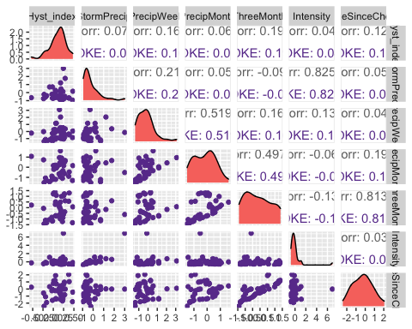

ggsave("turb_pairs_POKE.pdf",  
 path = here("Output_from_analysis", "09_Antecedent_Conditions_models", "plots"),  
 width = 10, height = 10)

## Warning: Removed 1 rows containing missing values (geom_point).  
## Removed 1 rows containing missing values (geom_point).  
## Removed 1 rows containing missing values (geom_point).  
## Removed 1 rows containing missing values (geom_point).  
## Removed 1 rows containing missing values (geom_point).

## Warning: Removed 1 rows containing non-finite values (stat_density).

## Warning: Removed 1 rows containing missing values (geom_point).

POKE.model <- lm(Hyst_index ~ StormPrecip + PrecipWeek + PrecipMonth + TimeSinceChena, data = HI_FI_turb_POKE)  
  
vif(POKE.model)

## StormPrecip PrecipWeek PrecipMonth TimeSinceChena   
## 1.055058 1.442902 1.431687 1.045731

plot(POKE.model)

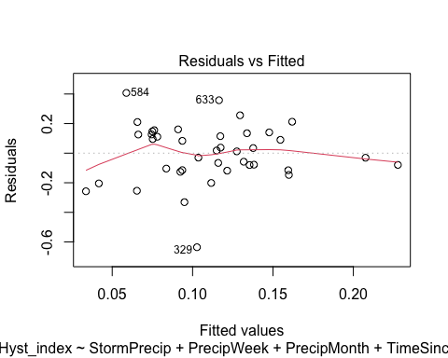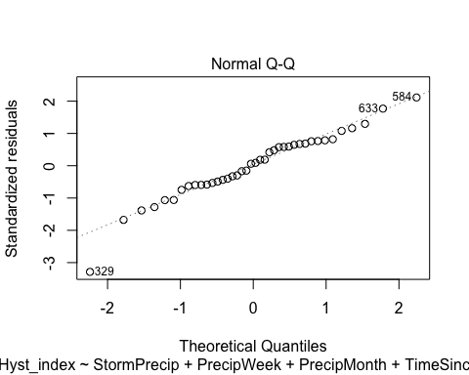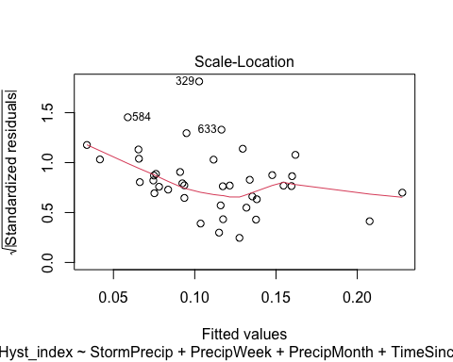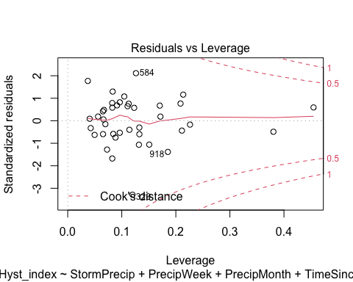

summary(POKE.model)

##   
## Call:  
## lm(formula = Hyst_index ~ StormPrecip + PrecipWeek + PrecipMonth +   
## TimeSinceChena, data = HI_FI_turb_POKE)  
##   
## Residuals:  
## Min 1Q Median 3Q Max   
## -0.63567 -0.11479 0.01504 0.12858 0.40742   
##   
## Coefficients:  
## Estimate Std. Error t value Pr(>|t|)   
## (Intercept) 0.124306 0.035370 3.514 0.00124 **  
## StormPrecip 0.009703 0.042103 0.230 0.81908   
## PrecipWeek 0.037179 0.042795 0.869 0.39090   
## PrecipMonth -0.011919 0.049436 -0.241 0.81088   
## TimeSinceChena 0.022514 0.031747 0.709 0.48291   
## ---  
## Signif. codes: 0 '***' 0.001 '**' 0.01 '*' 0.05 '.' 0.1 ' ' 1  
##   
## Residual standard error: 0.2061 on 35 degrees of freedom  
## Multiple R-squared: 0.04234, Adjusted R-squared: -0.0671   
## F-statistic: 0.3869 on 4 and 35 DF, p-value: 0.8165

ggpairs(HI_FI_turb_VAUL,  
 columns = c("Hyst_index", "StormPrecip", "PrecipWeek", "PrecipMonth","ThreeMonth", "Intensity", "TimeSinceChena"),  
 ggplot2::aes(color = site.ID))+  
 scale_color_manual(values = c("#E7298A"))

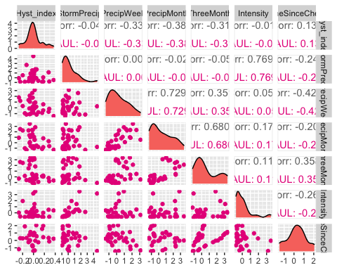

ggsave("turb_pairs_VAUL.pdf",  
 path = here("Output_from_analysis", "09_Antecedent_Conditions_models", "plots"),  
 width = 10, height = 10)  
  
  
VAUL.model <- lm(Hyst_index ~ StormPrecip + PrecipWeek + PrecipMonth + TimeSinceChena, data = HI_FI_turb_VAUL)  
  
vif(VAUL.model)

## StormPrecip PrecipWeek PrecipMonth TimeSinceChena   
## 1.075939 2.578594 2.197776 1.344559

plot(VAUL.model)

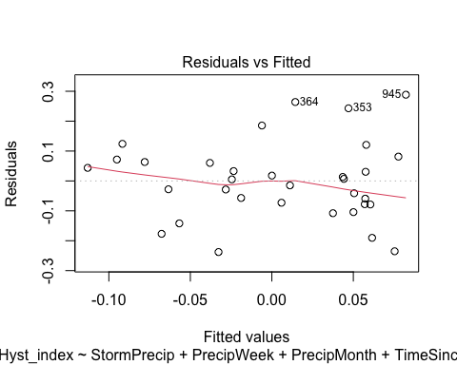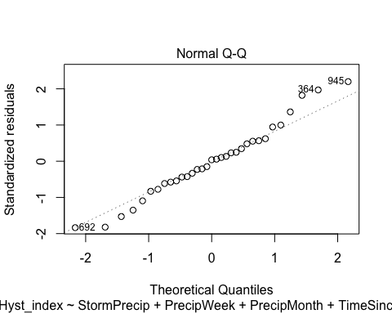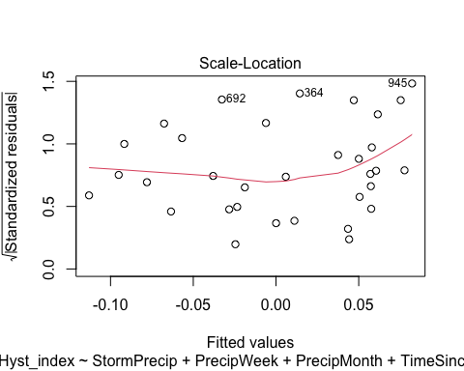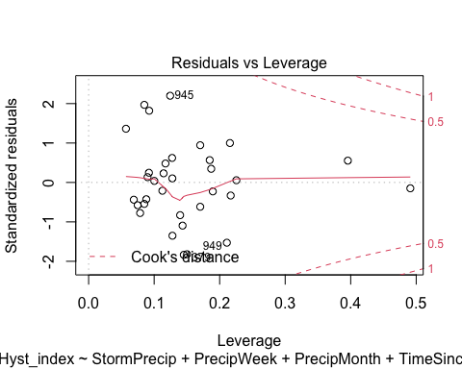

summary(VAUL.model)

##   
## Call:  
## lm(formula = Hyst_index ~ StormPrecip + PrecipWeek + PrecipMonth +   
## TimeSinceChena, data = HI_FI_turb_VAUL)  
##   
## Residuals:  
## Min 1Q Median 3Q Max   
## -0.237843 -0.077844 0.005195 0.063348 0.288453   
##   
## Coefficients:  
## Estimate Std. Error t value Pr(>|t|)  
## (Intercept) 0.020706 0.028024 0.739 0.466  
## StormPrecip -0.005819 0.021200 -0.274 0.786  
## PrecipWeek -0.011746 0.033187 -0.354 0.726  
## PrecipMonth -0.031920 0.026239 -1.217 0.234  
## TimeSinceChena 0.003219 0.030496 0.106 0.917  
##   
## Residual standard error: 0.1402 on 28 degrees of freedom  
## Multiple R-squared: 0.1593, Adjusted R-squared: 0.03923   
## F-statistic: 1.327 on 4 and 28 DF, p-value: 0.2845

ggpairs(HI_FI_turb_STRT,  
 columns = c("Hyst_index", "StormPrecip", "PrecipWeek", "PrecipMonth","ThreeMonth", "Intensity", "TimeSinceChena"),  
 ggplot2::aes(color = site.ID))+  
 scale_color_manual(values = c("#66C2A5"))

## Warning in ggally_statistic(data = data, mapping = mapping, na.rm = na.rm, :  
## Removed 2 rows containing missing values  
  
## Warning in ggally_statistic(data = data, mapping = mapping, na.rm = na.rm, :  
## Removed 2 rows containing missing values

## Warning in ggally_statistic(data = data, mapping = mapping, na.rm = na.rm, :  
## Removing 1 row that contained a missing value

## Warning in ggally_statistic(data = data, mapping = mapping, na.rm = na.rm, :  
## Removed 2 rows containing missing values

## Warning in ggally_statistic(data = data, mapping = mapping, na.rm = na.rm, :  
## Removing 1 row that contained a missing value  
  
## Warning in ggally_statistic(data = data, mapping = mapping, na.rm = na.rm, :  
## Removing 1 row that contained a missing value

## Warning in ggally_statistic(data = data, mapping = mapping, na.rm = na.rm, :  
## Removed 2 rows containing missing values

## Warning in ggally_statistic(data = data, mapping = mapping, na.rm = na.rm, :  
## Removing 1 row that contained a missing value  
  
## Warning in ggally_statistic(data = data, mapping = mapping, na.rm = na.rm, :  
## Removing 1 row that contained a missing value  
  
## Warning in ggally_statistic(data = data, mapping = mapping, na.rm = na.rm, :  
## Removing 1 row that contained a missing value

## Warning in ggally_statistic(data = data, mapping = mapping, na.rm = na.rm, :  
## Removed 2 rows containing missing values

## Warning in ggally_statistic(data = data, mapping = mapping, na.rm = na.rm, :  
## Removing 1 row that contained a missing value  
  
## Warning in ggally_statistic(data = data, mapping = mapping, na.rm = na.rm, :  
## Removing 1 row that contained a missing value  
  
## Warning in ggally_statistic(data = data, mapping = mapping, na.rm = na.rm, :  
## Removing 1 row that contained a missing value  
  
## Warning in ggally_statistic(data = data, mapping = mapping, na.rm = na.rm, :  
## Removing 1 row that contained a missing value

## Warning in ggally_statistic(data = data, mapping = mapping, na.rm = na.rm, :  
## Removed 2 rows containing missing values

## Warning in ggally_statistic(data = data, mapping = mapping, na.rm = na.rm, :  
## Removing 1 row that contained a missing value  
  
## Warning in ggally_statistic(data = data, mapping = mapping, na.rm = na.rm, :  
## Removing 1 row that contained a missing value  
  
## Warning in ggally_statistic(data = data, mapping = mapping, na.rm = na.rm, :  
## Removing 1 row that contained a missing value  
  
## Warning in ggally_statistic(data = data, mapping = mapping, na.rm = na.rm, :  
## Removing 1 row that contained a missing value  
  
## Warning in ggally_statistic(data = data, mapping = mapping, na.rm = na.rm, :  
## Removing 1 row that contained a missing value

## Warning: Removed 1 rows containing non-finite values (stat_density).

## Warning: Removed 2 rows containing missing values (geom_point).

## Warning: Removed 1 rows containing non-finite values (stat_density).

## Warning: Removed 2 rows containing missing values (geom_point).

## Warning: Removed 1 rows containing missing values (geom_point).

## Warning: Removed 1 rows containing non-finite values (stat_density).

## Warning: Removed 2 rows containing missing values (geom_point).

## Warning: Removed 1 rows containing missing values (geom_point).  
## Removed 1 rows containing missing values (geom_point).

## Warning: Removed 1 rows containing non-finite values (stat_density).

## Warning: Removed 2 rows containing missing values (geom_point).

## Warning: Removed 1 rows containing missing values (geom_point).  
## Removed 1 rows containing missing values (geom_point).  
## Removed 1 rows containing missing values (geom_point).

## Warning: Removed 1 rows containing non-finite values (stat_density).

## Warning: Removed 2 rows containing missing values (geom_point).

## Warning: Removed 1 rows containing missing values (geom_point).  
## Removed 1 rows containing missing values (geom_point).  
## Removed 1 rows containing missing values (geom_point).  
## Removed 1 rows containing missing values (geom_point).

## Warning: Removed 1 rows containing non-finite values (stat_density).

## Warning: Removed 2 rows containing missing values (geom_point).

## Warning: Removed 1 rows containing missing values (geom_point).  
## Removed 1 rows containing missing values (geom_point).  
## Removed 1 rows containing missing values (geom_point).  
## Removed 1 rows containing missing values (geom_point).  
## Removed 1 rows containing missing values (geom_point).

## Warning: Removed 1 rows containing non-finite values (stat_density).

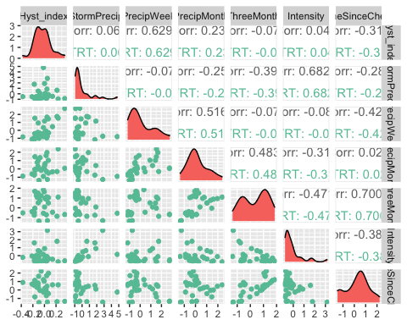

ggsave("turb_pairs_VAUL.pdf",  
 path = here("Output_from_analysis", "09_Antecedent_Conditions_models", "plots"),  
 width = 10, height = 10)

## Warning: Removed 1 rows containing non-finite values (stat_density).

## Warning: Removed 2 rows containing missing values (geom_point).

## Warning: Removed 1 rows containing non-finite values (stat_density).

## Warning: Removed 2 rows containing missing values (geom_point).

## Warning: Removed 1 rows containing missing values (geom_point).

## Warning: Removed 1 rows containing non-finite values (stat_density).

## Warning: Removed 2 rows containing missing values (geom_point).

## Warning: Removed 1 rows containing missing values (geom_point).  
## Removed 1 rows containing missing values (geom_point).

## Warning: Removed 1 rows containing non-finite values (stat_density).

## Warning: Removed 2 rows containing missing values (geom_point).

## Warning: Removed 1 rows containing missing values (geom_point).  
## Removed 1 rows containing missing values (geom_point).  
## Removed 1 rows containing missing values (geom_point).

## Warning: Removed 1 rows containing non-finite values (stat_density).

## Warning: Removed 2 rows containing missing values (geom_point).

## Warning: Removed 1 rows containing missing values (geom_point).  
## Removed 1 rows containing missing values (geom_point).  
## Removed 1 rows containing missing values (geom_point).  
## Removed 1 rows containing missing values (geom_point).

## Warning: Removed 1 rows containing non-finite values (stat_density).

## Warning: Removed 2 rows containing missing values (geom_point).

## Warning: Removed 1 rows containing missing values (geom_point).  
## Removed 1 rows containing missing values (geom_point).  
## Removed 1 rows containing missing values (geom_point).  
## Removed 1 rows containing missing values (geom_point).  
## Removed 1 rows containing missing values (geom_point).

## Warning: Removed 1 rows containing non-finite values (stat_density).

STRT.model <- lm(Hyst_index ~ StormPrecip + PrecipWeek + PrecipMonth + TimeSinceChena, data = HI_FI_turb_STRT)  
  
vif(STRT.model)

## StormPrecip PrecipWeek PrecipMonth TimeSinceChena   
## 1.188202 1.863288 1.690306 1.365779

plot(STRT.model)

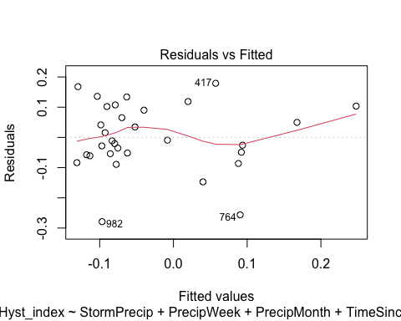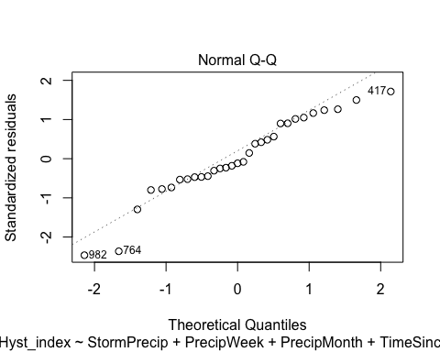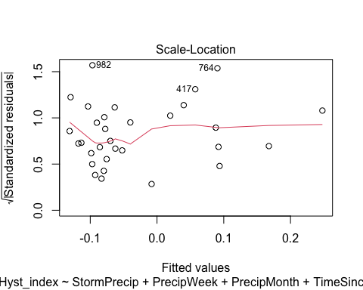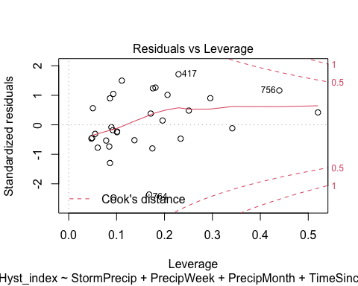 lets log transform

STRT.model.log <- lm(logHI ~ StormPrecip + PrecipWeek + PrecipMonth + TimeSinceChena, data = HI_FI_turb_STRT)  
  
vif(STRT.model.log)

## StormPrecip PrecipWeek PrecipMonth TimeSinceChena   
## 1.188202 1.863288 1.690306 1.365779

plot(STRT.model.log)

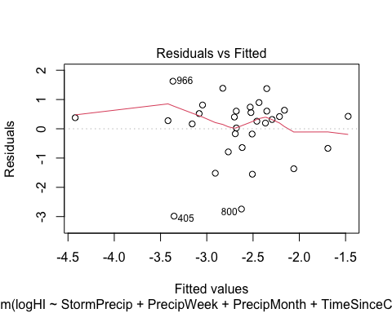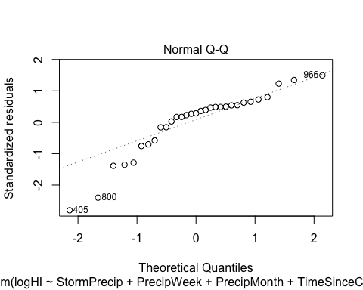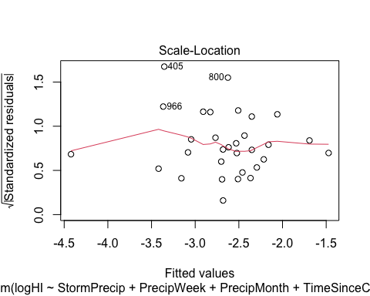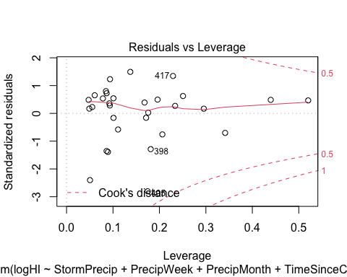 may need further transformation

Plot_1 <- plot_summs(MOOS.model, FRCH.model,   
 CARI.model, POKE.model,   
 VAUL.model, STRT.model, scale = TRUE,  
 model.names = c("MOOS", "FRCH", "CARI", "POKE", "VAUL", "STRT"),  
 colors = c("#A6761D", "#FF7F00","#3288BD", "#6A3D9A", "#E7298A", "#66C2A5"))

## Loading required namespace: broom.mixed  
## Loading required namespace: broom.mixed  
## Loading required namespace: broom.mixed  
## Loading required namespace: broom.mixed  
## Loading required namespace: broom.mixed  
## Loading required namespace: broom.mixed

turb_hi <- Plot_1 +   
 xlab("Coefficient estimate") + ylab("") +  
 geom_vline(xintercept = 0,  
 colour = "grey80",  
 linetype = 1) +  
scale_y_discrete(labels= c("Seasonality",   
 "Precipitation Month",   
 "Precipitation Week",  
 "Storm Precipitation")) +  
 theme_bw()   
  
ggsave("HI_turb.pdf",  
 path = here("plots", "Coefficient_Plots", "HI"),  
 width = 7, height = 7)

### BETA

# NO3

#### Correlation   
NO3_data <- HI_FI_NO3[,c("Beta_index", "site.ID", "StormPrecip", "PrecipWeek", "PrecipMonth", "ThreeMonth", "Intensity", "TimeSinceChena", "pf", "burn", "year")]  
NO3_data <- na.omit(NO3_data) # 244 to 236 rows   
  
HI_FI_NO3$logBETA <- log(abs(HI_FI_NO3$Beta_index))  
  
ggpairs(NO3_data,  
 columns = c("Beta_index", "StormPrecip", "PrecipWeek", "PrecipMonth","ThreeMonth", "Intensity", "TimeSinceChena"),  
 ggplot2::aes(color = site.ID))+  
 scale_color_manual(values = c("#3288BD", "#FF7F00","#A6761D", "#6A3D9A", "#66C2A5", "#E7298A"))

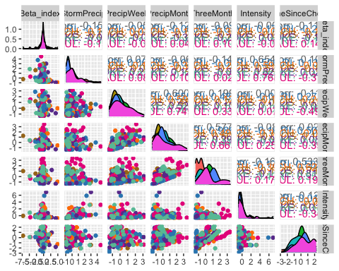

ggsave("NO3_pairs_BETA.pdf",  
 path = here("Output_from_analysis", "09_Antecedent_Conditions_models", "plots"),  
 width = 10, height = 10)

1. StormTemp is heavily correlated with TempWeek leading up to a storm (0.778) but TempWeek is slightly more correlated with HI (-.05 to -.03)
2. StormTemp is also correlated with time since chena (-0.735) but time since chena is more correlated with HI (0.251 vs. -0.173) so this makes me want to keep Time since Chena and temperature a week before considering that is a more marginal comparison with HI and the temperature predictors.

3)Precip week is correlated with precip month (0.511) but precip week is more correlated with HI than precip month (-0.242 vs. 0.048)

4)Precip month is correlated with three month precip (0.591) but three month precip is more correlated with HI (0.220 vs. 0.048)

1. Three month is correlated with Time since Chena (0.619) but time since chena is more correlated with HI (0.251 vs. 0.220)

* to sum up this makes me want to drop storm temperature and three month precipitation…..but lets run the model with all of the candidate predictors first and go from there

HI_FI_NO3_MOOS <- subset(HI_FI_NO3, site.ID == "MOOS")  
HI_FI_NO3_FRCH <- subset(HI_FI_NO3, site.ID == "FRCH")  
HI_FI_NO3_CARI <- subset(HI_FI_NO3, site.ID == "CARI")  
HI_FI_NO3_POKE <- subset(HI_FI_NO3, site.ID == "POKE")  
HI_FI_NO3_VAUL <- subset(HI_FI_NO3, site.ID == "VAUL")  
HI_FI_NO3_STRT <- subset(HI_FI_NO3, site.ID == "STRT")

ggpairs(HI_FI_NO3_MOOS,  
 columns = c("Beta_index", "StormPrecip", "PrecipWeek", "PrecipMonth","ThreeMonth", "Intensity", "TimeSinceChena"),  
 ggplot2::aes(color = site.ID))+  
 scale_color_manual(values = c("#A6761D"))

## Warning in ggally_statistic(data = data, mapping = mapping, na.rm = na.rm, :  
## Removing 1 row that contained a missing value  
  
## Warning in ggally_statistic(data = data, mapping = mapping, na.rm = na.rm, :  
## Removing 1 row that contained a missing value  
  
## Warning in ggally_statistic(data = data, mapping = mapping, na.rm = na.rm, :  
## Removing 1 row that contained a missing value  
  
## Warning in ggally_statistic(data = data, mapping = mapping, na.rm = na.rm, :  
## Removing 1 row that contained a missing value  
  
## Warning in ggally_statistic(data = data, mapping = mapping, na.rm = na.rm, :  
## Removing 1 row that contained a missing value  
  
## Warning in ggally_statistic(data = data, mapping = mapping, na.rm = na.rm, :  
## Removing 1 row that contained a missing value

## Warning: Removed 1 rows containing non-finite values (stat_density).

## Warning: Removed 1 rows containing missing values (geom_point).  
## Removed 1 rows containing missing values (geom_point).  
## Removed 1 rows containing missing values (geom_point).  
## Removed 1 rows containing missing values (geom_point).  
## Removed 1 rows containing missing values (geom_point).  
## Removed 1 rows containing missing values (geom_point).

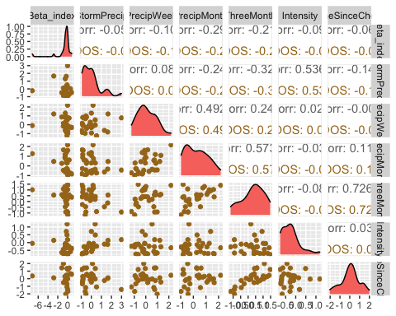

ggsave("NO3_pairs_BETA_MOOS.pdf",  
 path = here("Output_from_analysis", "09_Antecedent_Conditions_models", "plots"),  
 width = 10, height = 10)

## Warning: Removed 1 rows containing non-finite values (stat_density).  
## Removed 1 rows containing missing values (geom_point).  
## Removed 1 rows containing missing values (geom_point).  
## Removed 1 rows containing missing values (geom_point).  
## Removed 1 rows containing missing values (geom_point).  
## Removed 1 rows containing missing values (geom_point).  
## Removed 1 rows containing missing values (geom_point).

MOOS.model <- lm(Beta_index ~ StormPrecip + PrecipWeek + PrecipMonth + TimeSinceChena, data = HI_FI_NO3_MOOS)  
  
vif(MOOS.model)

## StormPrecip PrecipWeek PrecipMonth TimeSinceChena   
## 1.159617 1.404085 1.480382 1.043649

plot(MOOS.model)

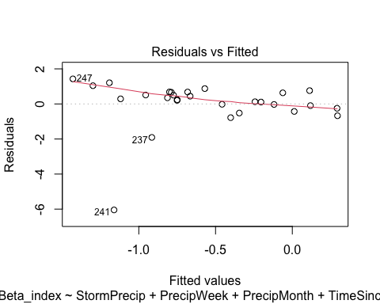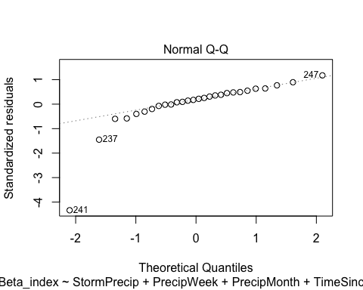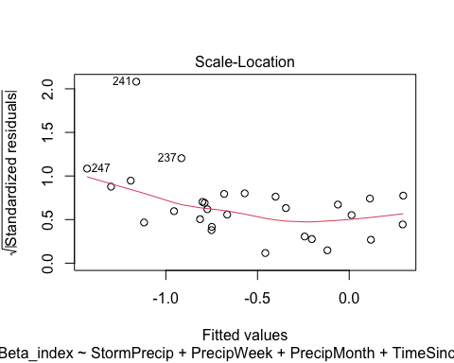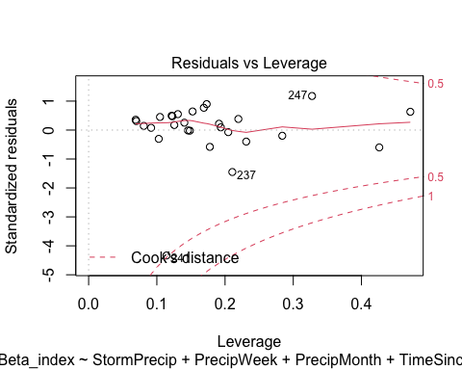

ggpairs(HI_FI_NO3_FRCH,  
 columns = c("Beta_index", "StormPrecip", "PrecipWeek", "PrecipMonth","ThreeMonth", "Intensity", "TimeSinceChena"),  
 ggplot2::aes(color = site.ID))+  
 scale_color_manual(values = c("#FF7F00"))

## Warning in ggally_statistic(data = data, mapping = mapping, na.rm = na.rm, :  
## Removed 5 rows containing missing values  
  
## Warning in ggally_statistic(data = data, mapping = mapping, na.rm = na.rm, :  
## Removed 5 rows containing missing values

## Warning in ggally_statistic(data = data, mapping = mapping, na.rm = na.rm, :  
## Removed 2 rows containing missing values

## Warning in ggally_statistic(data = data, mapping = mapping, na.rm = na.rm, :  
## Removed 5 rows containing missing values

## Warning in ggally_statistic(data = data, mapping = mapping, na.rm = na.rm, :  
## Removed 2 rows containing missing values  
  
## Warning in ggally_statistic(data = data, mapping = mapping, na.rm = na.rm, :  
## Removed 2 rows containing missing values

## Warning in ggally_statistic(data = data, mapping = mapping, na.rm = na.rm, :  
## Removed 5 rows containing missing values

## Warning in ggally_statistic(data = data, mapping = mapping, na.rm = na.rm, :  
## Removed 2 rows containing missing values  
  
## Warning in ggally_statistic(data = data, mapping = mapping, na.rm = na.rm, :  
## Removed 2 rows containing missing values  
  
## Warning in ggally_statistic(data = data, mapping = mapping, na.rm = na.rm, :  
## Removed 2 rows containing missing values

## Warning in ggally_statistic(data = data, mapping = mapping, na.rm = na.rm, :  
## Removed 6 rows containing missing values

## Warning in ggally_statistic(data = data, mapping = mapping, na.rm = na.rm, :  
## Removed 4 rows containing missing values  
  
## Warning in ggally_statistic(data = data, mapping = mapping, na.rm = na.rm, :  
## Removed 4 rows containing missing values  
  
## Warning in ggally_statistic(data = data, mapping = mapping, na.rm = na.rm, :  
## Removed 4 rows containing missing values  
  
## Warning in ggally_statistic(data = data, mapping = mapping, na.rm = na.rm, :  
## Removed 4 rows containing missing values

## Warning in ggally_statistic(data = data, mapping = mapping, na.rm = na.rm, :  
## Removed 5 rows containing missing values

## Warning in ggally_statistic(data = data, mapping = mapping, na.rm = na.rm, :  
## Removed 2 rows containing missing values  
  
## Warning in ggally_statistic(data = data, mapping = mapping, na.rm = na.rm, :  
## Removed 2 rows containing missing values  
  
## Warning in ggally_statistic(data = data, mapping = mapping, na.rm = na.rm, :  
## Removed 2 rows containing missing values  
  
## Warning in ggally_statistic(data = data, mapping = mapping, na.rm = na.rm, :  
## Removed 2 rows containing missing values

## Warning in ggally_statistic(data = data, mapping = mapping, na.rm = na.rm, :  
## Removed 4 rows containing missing values

## Warning: Removed 5 rows containing non-finite values (stat_density).

## Warning: Removed 5 rows containing missing values (geom_point).

## Warning: Removed 2 rows containing non-finite values (stat_density).

## Warning: Removed 5 rows containing missing values (geom_point).

## Warning: Removed 2 rows containing missing values (geom_point).

## Warning: Removed 2 rows containing non-finite values (stat_density).

## Warning: Removed 5 rows containing missing values (geom_point).

## Warning: Removed 2 rows containing missing values (geom_point).  
## Removed 2 rows containing missing values (geom_point).

## Warning: Removed 2 rows containing non-finite values (stat_density).

## Warning: Removed 5 rows containing missing values (geom_point).

## Warning: Removed 2 rows containing missing values (geom_point).  
## Removed 2 rows containing missing values (geom_point).  
## Removed 2 rows containing missing values (geom_point).

## Warning: Removed 2 rows containing non-finite values (stat_density).

## Warning: Removed 6 rows containing missing values (geom_point).

## Warning: Removed 4 rows containing missing values (geom_point).  
## Removed 4 rows containing missing values (geom_point).  
## Removed 4 rows containing missing values (geom_point).  
## Removed 4 rows containing missing values (geom_point).

## Warning: Removed 4 rows containing non-finite values (stat_density).

## Warning: Removed 5 rows containing missing values (geom_point).

## Warning: Removed 2 rows containing missing values (geom_point).  
## Removed 2 rows containing missing values (geom_point).  
## Removed 2 rows containing missing values (geom_point).  
## Removed 2 rows containing missing values (geom_point).

## Warning: Removed 4 rows containing missing values (geom_point).

## Warning: Removed 2 rows containing non-finite values (stat_density).

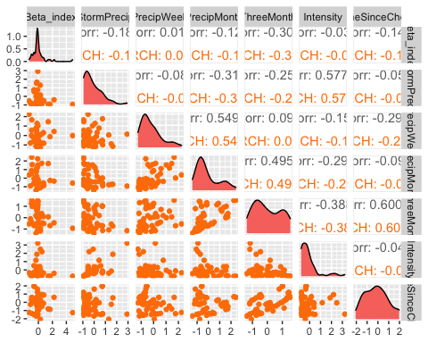

ggsave("NO3_pairs_BETA_FRCH.pdf",  
 path = here("Output_from_analysis", "09_Antecedent_Conditions_models", "plots"),  
 width = 10, height = 10)

## Warning: Removed 5 rows containing non-finite values (stat_density).

## Warning: Removed 5 rows containing missing values (geom_point).

## Warning: Removed 2 rows containing non-finite values (stat_density).

## Warning: Removed 5 rows containing missing values (geom_point).

## Warning: Removed 2 rows containing missing values (geom_point).

## Warning: Removed 2 rows containing non-finite values (stat_density).

## Warning: Removed 5 rows containing missing values (geom_point).

## Warning: Removed 2 rows containing missing values (geom_point).  
## Removed 2 rows containing missing values (geom_point).

## Warning: Removed 2 rows containing non-finite values (stat_density).

## Warning: Removed 5 rows containing missing values (geom_point).

## Warning: Removed 2 rows containing missing values (geom_point).  
## Removed 2 rows containing missing values (geom_point).  
## Removed 2 rows containing missing values (geom_point).

## Warning: Removed 2 rows containing non-finite values (stat_density).

## Warning: Removed 6 rows containing missing values (geom_point).

## Warning: Removed 4 rows containing missing values (geom_point).  
## Removed 4 rows containing missing values (geom_point).  
## Removed 4 rows containing missing values (geom_point).  
## Removed 4 rows containing missing values (geom_point).

## Warning: Removed 4 rows containing non-finite values (stat_density).

## Warning: Removed 5 rows containing missing values (geom_point).

## Warning: Removed 2 rows containing missing values (geom_point).  
## Removed 2 rows containing missing values (geom_point).  
## Removed 2 rows containing missing values (geom_point).  
## Removed 2 rows containing missing values (geom_point).

## Warning: Removed 4 rows containing missing values (geom_point).

## Warning: Removed 2 rows containing non-finite values (stat_density).

FRCH.model <- lm(Beta_index ~ StormPrecip + PrecipWeek + PrecipMonth + TimeSinceChena, data = HI_FI_NO3_FRCH)  
  
vif(FRCH.model)

## StormPrecip PrecipWeek PrecipMonth TimeSinceChena   
## 1.135005 1.693115 1.750422 1.083423

plot(FRCH.model)

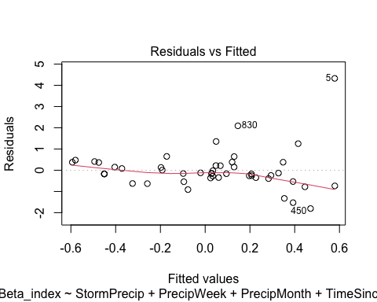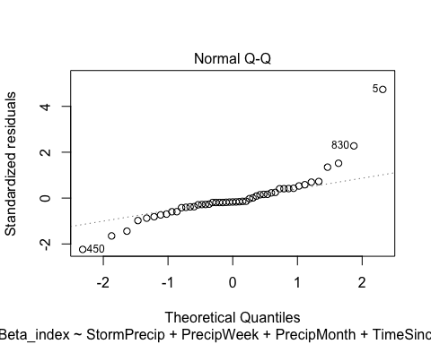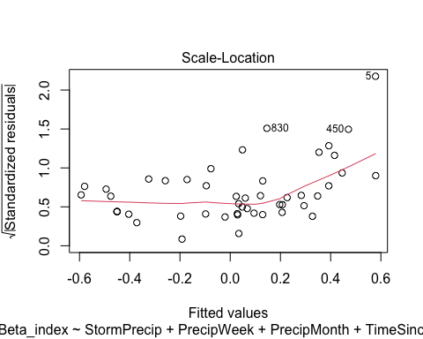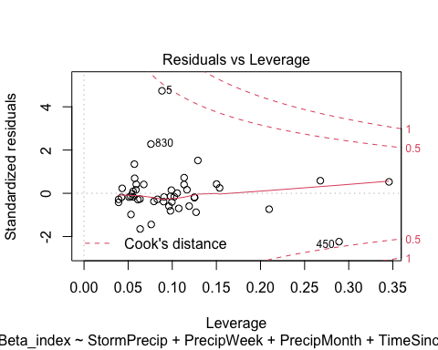

ggpairs(HI_FI_NO3_CARI,  
 columns = c("Beta_index", "StormPrecip", "PrecipWeek", "PrecipMonth","ThreeMonth", "Intensity", "TimeSinceChena"),  
 ggplot2::aes(color = site.ID))+  
 scale_color_manual(values = c("#3288BD"))

## Warning in ggally_statistic(data = data, mapping = mapping, na.rm = na.rm, :  
## Removed 3 rows containing missing values  
  
## Warning in ggally_statistic(data = data, mapping = mapping, na.rm = na.rm, :  
## Removed 3 rows containing missing values

## Warning in ggally_statistic(data = data, mapping = mapping, na.rm = na.rm, :  
## Removing 1 row that contained a missing value

## Warning in ggally_statistic(data = data, mapping = mapping, na.rm = na.rm, :  
## Removed 3 rows containing missing values

## Warning in ggally_statistic(data = data, mapping = mapping, na.rm = na.rm, :  
## Removing 1 row that contained a missing value  
  
## Warning in ggally_statistic(data = data, mapping = mapping, na.rm = na.rm, :  
## Removing 1 row that contained a missing value

## Warning in ggally_statistic(data = data, mapping = mapping, na.rm = na.rm, :  
## Removed 3 rows containing missing values

## Warning in ggally_statistic(data = data, mapping = mapping, na.rm = na.rm, :  
## Removing 1 row that contained a missing value  
  
## Warning in ggally_statistic(data = data, mapping = mapping, na.rm = na.rm, :  
## Removing 1 row that contained a missing value  
  
## Warning in ggally_statistic(data = data, mapping = mapping, na.rm = na.rm, :  
## Removing 1 row that contained a missing value

## Warning in ggally_statistic(data = data, mapping = mapping, na.rm = na.rm, :  
## Removed 3 rows containing missing values

## Warning in ggally_statistic(data = data, mapping = mapping, na.rm = na.rm, :  
## Removing 1 row that contained a missing value  
  
## Warning in ggally_statistic(data = data, mapping = mapping, na.rm = na.rm, :  
## Removing 1 row that contained a missing value  
  
## Warning in ggally_statistic(data = data, mapping = mapping, na.rm = na.rm, :  
## Removing 1 row that contained a missing value  
  
## Warning in ggally_statistic(data = data, mapping = mapping, na.rm = na.rm, :  
## Removing 1 row that contained a missing value

## Warning in ggally_statistic(data = data, mapping = mapping, na.rm = na.rm, :  
## Removed 3 rows containing missing values

## Warning in ggally_statistic(data = data, mapping = mapping, na.rm = na.rm, :  
## Removing 1 row that contained a missing value  
  
## Warning in ggally_statistic(data = data, mapping = mapping, na.rm = na.rm, :  
## Removing 1 row that contained a missing value  
  
## Warning in ggally_statistic(data = data, mapping = mapping, na.rm = na.rm, :  
## Removing 1 row that contained a missing value  
  
## Warning in ggally_statistic(data = data, mapping = mapping, na.rm = na.rm, :  
## Removing 1 row that contained a missing value  
  
## Warning in ggally_statistic(data = data, mapping = mapping, na.rm = na.rm, :  
## Removing 1 row that contained a missing value

## Warning: Removed 2 rows containing non-finite values (stat_density).

## Warning: Removed 3 rows containing missing values (geom_point).

## Warning: Removed 1 rows containing non-finite values (stat_density).

## Warning: Removed 3 rows containing missing values (geom_point).

## Warning: Removed 1 rows containing missing values (geom_point).

## Warning: Removed 1 rows containing non-finite values (stat_density).

## Warning: Removed 3 rows containing missing values (geom_point).

## Warning: Removed 1 rows containing missing values (geom_point).  
## Removed 1 rows containing missing values (geom_point).

## Warning: Removed 1 rows containing non-finite values (stat_density).

## Warning: Removed 3 rows containing missing values (geom_point).

## Warning: Removed 1 rows containing missing values (geom_point).  
## Removed 1 rows containing missing values (geom_point).  
## Removed 1 rows containing missing values (geom_point).

## Warning: Removed 1 rows containing non-finite values (stat_density).

## Warning: Removed 3 rows containing missing values (geom_point).

## Warning: Removed 1 rows containing missing values (geom_point).  
## Removed 1 rows containing missing values (geom_point).  
## Removed 1 rows containing missing values (geom_point).  
## Removed 1 rows containing missing values (geom_point).

## Warning: Removed 1 rows containing non-finite values (stat_density).

## Warning: Removed 3 rows containing missing values (geom_point).

## Warning: Removed 1 rows containing missing values (geom_point).  
## Removed 1 rows containing missing values (geom_point).  
## Removed 1 rows containing missing values (geom_point).  
## Removed 1 rows containing missing values (geom_point).  
## Removed 1 rows containing missing values (geom_point).

## Warning: Removed 1 rows containing non-finite values (stat_density).

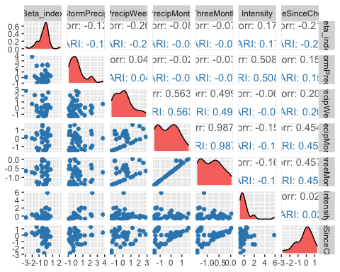

ggsave("NO3_pairs_BETA_CARI.pdf",  
 path = here("Output_from_analysis", "09_Antecedent_Conditions_models", "plots"),  
 width = 10, height = 10)

## Warning: Removed 2 rows containing non-finite values (stat_density).

## Warning: Removed 3 rows containing missing values (geom_point).

## Warning: Removed 1 rows containing non-finite values (stat_density).

## Warning: Removed 3 rows containing missing values (geom_point).

## Warning: Removed 1 rows containing missing values (geom_point).

## Warning: Removed 1 rows containing non-finite values (stat_density).

## Warning: Removed 3 rows containing missing values (geom_point).

## Warning: Removed 1 rows containing missing values (geom_point).  
## Removed 1 rows containing missing values (geom_point).

## Warning: Removed 1 rows containing non-finite values (stat_density).

## Warning: Removed 3 rows containing missing values (geom_point).

## Warning: Removed 1 rows containing missing values (geom_point).  
## Removed 1 rows containing missing values (geom_point).  
## Removed 1 rows containing missing values (geom_point).

## Warning: Removed 1 rows containing non-finite values (stat_density).

## Warning: Removed 3 rows containing missing values (geom_point).

## Warning: Removed 1 rows containing missing values (geom_point).  
## Removed 1 rows containing missing values (geom_point).  
## Removed 1 rows containing missing values (geom_point).  
## Removed 1 rows containing missing values (geom_point).

## Warning: Removed 1 rows containing non-finite values (stat_density).

## Warning: Removed 3 rows containing missing values (geom_point).

## Warning: Removed 1 rows containing missing values (geom_point).  
## Removed 1 rows containing missing values (geom_point).  
## Removed 1 rows containing missing values (geom_point).  
## Removed 1 rows containing missing values (geom_point).  
## Removed 1 rows containing missing values (geom_point).

## Warning: Removed 1 rows containing non-finite values (stat_density).

CARI.model <- lm(Beta_index ~ StormPrecip + PrecipWeek + PrecipMonth + TimeSinceChena, data = HI_FI_NO3_CARI)  
  
vif(CARI.model)

## StormPrecip PrecipWeek PrecipMonth TimeSinceChena   
## 1.042648 1.458914 1.822320 1.375582

plot(CARI.model)

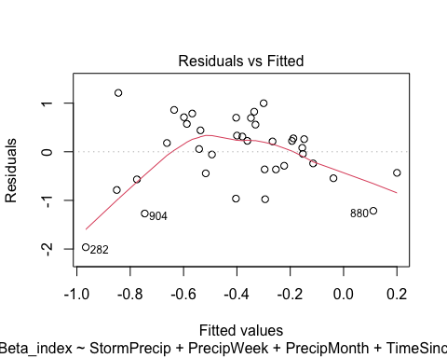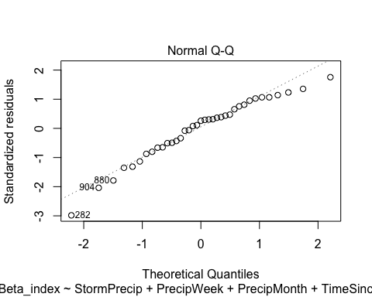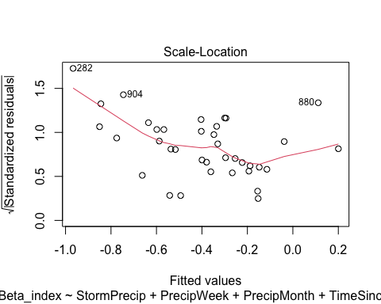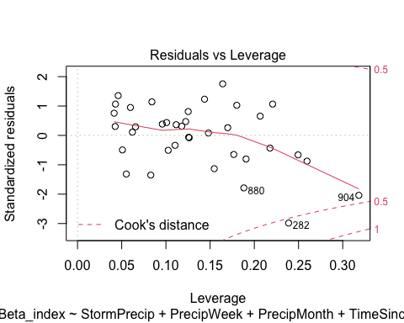

ggpairs(HI_FI_NO3_POKE,  
 columns = c("Beta_index", "StormPrecip", "PrecipWeek", "PrecipMonth","ThreeMonth", "Intensity", "TimeSinceChena"),  
 ggplot2::aes(color = site.ID))+  
 scale_color_manual(values = c("#6A3D9A"))

## Warning in ggally_statistic(data = data, mapping = mapping, na.rm = na.rm, :  
## Removed 8 rows containing missing values  
  
## Warning in ggally_statistic(data = data, mapping = mapping, na.rm = na.rm, :  
## Removed 8 rows containing missing values  
  
## Warning in ggally_statistic(data = data, mapping = mapping, na.rm = na.rm, :  
## Removed 8 rows containing missing values  
  
## Warning in ggally_statistic(data = data, mapping = mapping, na.rm = na.rm, :  
## Removed 8 rows containing missing values  
  
## Warning in ggally_statistic(data = data, mapping = mapping, na.rm = na.rm, :  
## Removed 8 rows containing missing values

## Warning in ggally_statistic(data = data, mapping = mapping, na.rm = na.rm, :  
## Removed 4 rows containing missing values  
  
## Warning in ggally_statistic(data = data, mapping = mapping, na.rm = na.rm, :  
## Removed 4 rows containing missing values  
  
## Warning in ggally_statistic(data = data, mapping = mapping, na.rm = na.rm, :  
## Removed 4 rows containing missing values  
  
## Warning in ggally_statistic(data = data, mapping = mapping, na.rm = na.rm, :  
## Removed 4 rows containing missing values

## Warning in ggally_statistic(data = data, mapping = mapping, na.rm = na.rm, :  
## Removed 8 rows containing missing values

## Warning in ggally_statistic(data = data, mapping = mapping, na.rm = na.rm, :  
## Removed 4 rows containing missing values

## Warning: Removed 8 rows containing non-finite values (stat_density).

## Warning: Removed 8 rows containing missing values (geom_point).  
## Removed 8 rows containing missing values (geom_point).  
## Removed 8 rows containing missing values (geom_point).  
## Removed 8 rows containing missing values (geom_point).  
## Removed 8 rows containing missing values (geom_point).

## Warning: Removed 4 rows containing missing values (geom_point).  
## Removed 4 rows containing missing values (geom_point).  
## Removed 4 rows containing missing values (geom_point).  
## Removed 4 rows containing missing values (geom_point).

## Warning: Removed 4 rows containing non-finite values (stat_density).

## Warning: Removed 8 rows containing missing values (geom_point).

## Warning: Removed 4 rows containing missing values (geom_point).

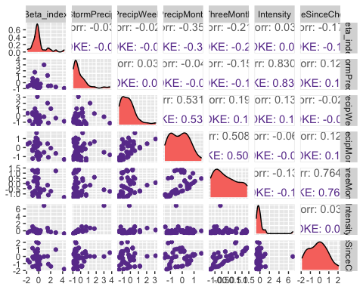

ggsave("NO3_pairs_BETA_POKE.pdf",  
 path = here("Output_from_analysis", "09_Antecedent_Conditions_models", "plots"),  
 width = 10, height = 10)

## Warning: Removed 8 rows containing non-finite values (stat_density).

## Warning: Removed 8 rows containing missing values (geom_point).  
## Removed 8 rows containing missing values (geom_point).  
## Removed 8 rows containing missing values (geom_point).  
## Removed 8 rows containing missing values (geom_point).  
## Removed 8 rows containing missing values (geom_point).

## Warning: Removed 4 rows containing missing values (geom_point).  
## Removed 4 rows containing missing values (geom_point).  
## Removed 4 rows containing missing values (geom_point).  
## Removed 4 rows containing missing values (geom_point).

## Warning: Removed 4 rows containing non-finite values (stat_density).

## Warning: Removed 8 rows containing missing values (geom_point).

## Warning: Removed 4 rows containing missing values (geom_point).

POKE.model <- lm(Beta_index ~ StormPrecip + PrecipWeek + PrecipMonth + TimeSinceChena, data = HI_FI_NO3_POKE)  
  
vif(POKE.model)

## StormPrecip PrecipWeek PrecipMonth TimeSinceChena   
## 1.060863 1.444153 1.390587 1.013358

plot(POKE.model)

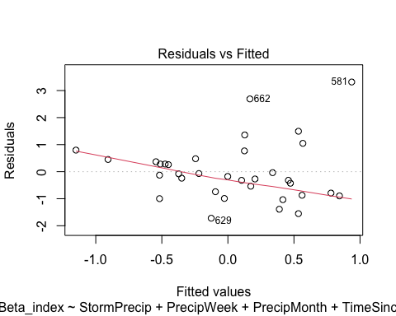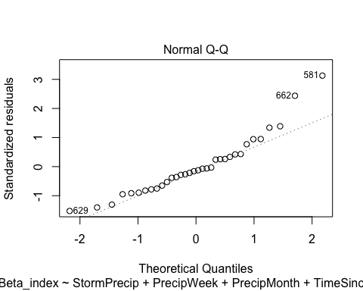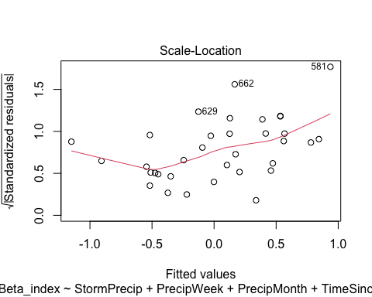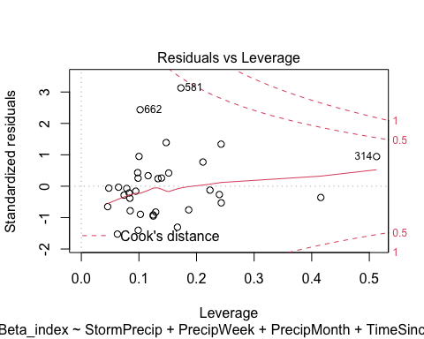

summary(POKE.model)

##   
## Call:  
## lm(formula = Beta_index ~ StormPrecip + PrecipWeek + PrecipMonth +   
## TimeSinceChena, data = HI_FI_NO3_POKE)  
##   
## Residuals:  
## Min 1Q Median 3Q Max   
## -1.7211 -0.7791 -0.1523 0.4301 3.3166   
##   
## Coefficients:  
## Estimate Std. Error t value Pr(>|t|)   
## (Intercept) -0.07523 0.21368 -0.352 0.7273   
## StormPrecip -0.04476 0.24876 -0.180 0.8585   
## PrecipWeek 0.27506 0.25593 1.075 0.2914   
## PrecipMonth -0.70663 0.31288 -2.258 0.0316 *  
## TimeSinceChena -0.15538 0.19989 -0.777 0.4433   
## ---  
## Signif. codes: 0 '***' 0.001 '**' 0.01 '*' 0.05 '.' 0.1 ' ' 1  
##   
## Residual standard error: 1.166 on 29 degrees of freedom  
## (8 observations deleted due to missingness)  
## Multiple R-squared: 0.1764, Adjusted R-squared: 0.06283   
## F-statistic: 1.553 on 4 and 29 DF, p-value: 0.2133

ggpairs(HI_FI_NO3_VAUL,  
 columns = c("Beta_index", "StormPrecip", "PrecipWeek", "PrecipMonth","ThreeMonth", "Intensity", "TimeSinceChena"),  
 ggplot2::aes(color = site.ID))+  
 scale_color_manual(values = c("#66C2A5"))

## Warning in ggally_statistic(data = data, mapping = mapping, na.rm = na.rm, :  
## Removed 3 rows containing missing values  
  
## Warning in ggally_statistic(data = data, mapping = mapping, na.rm = na.rm, :  
## Removed 3 rows containing missing values  
  
## Warning in ggally_statistic(data = data, mapping = mapping, na.rm = na.rm, :  
## Removed 3 rows containing missing values  
  
## Warning in ggally_statistic(data = data, mapping = mapping, na.rm = na.rm, :  
## Removed 3 rows containing missing values  
  
## Warning in ggally_statistic(data = data, mapping = mapping, na.rm = na.rm, :  
## Removed 3 rows containing missing values  
  
## Warning in ggally_statistic(data = data, mapping = mapping, na.rm = na.rm, :  
## Removed 3 rows containing missing values

## Warning: Removed 3 rows containing non-finite values (stat_density).

## Warning: Removed 3 rows containing missing values (geom_point).  
## Removed 3 rows containing missing values (geom_point).  
## Removed 3 rows containing missing values (geom_point).  
## Removed 3 rows containing missing values (geom_point).  
## Removed 3 rows containing missing values (geom_point).  
## Removed 3 rows containing missing values (geom_point).

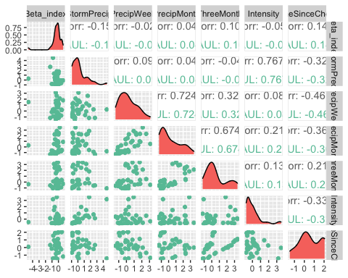

ggsave("NO3_pairs_BETA_VAUL.pdf",  
 path = here("Output_from_analysis", "09_Antecedent_Conditions_models", "plots"),  
 width = 10, height = 10)

## Warning: Removed 3 rows containing non-finite values (stat_density).  
## Removed 3 rows containing missing values (geom_point).  
## Removed 3 rows containing missing values (geom_point).  
## Removed 3 rows containing missing values (geom_point).  
## Removed 3 rows containing missing values (geom_point).  
## Removed 3 rows containing missing values (geom_point).  
## Removed 3 rows containing missing values (geom_point).

VAUL.model <- lm(Beta_index ~ StormPrecip + PrecipWeek + PrecipMonth + TimeSinceChena, data = HI_FI_NO3_VAUL)  
  
vif(VAUL.model)

## StormPrecip PrecipWeek PrecipMonth TimeSinceChena   
## 1.124075 2.562576 2.288900 1.470700

plot(VAUL.model)

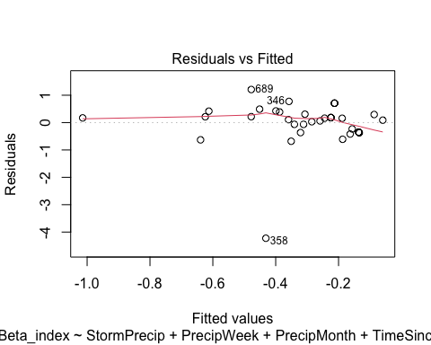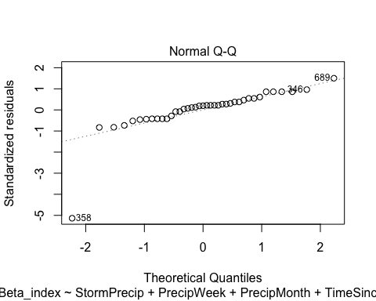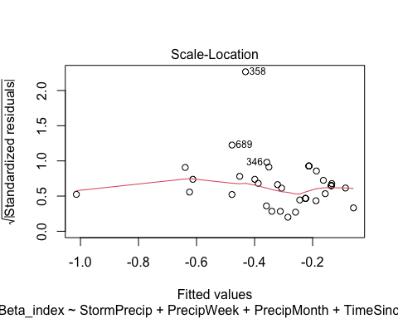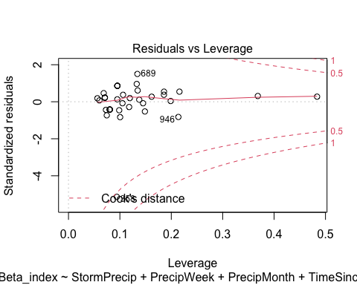

ggpairs(HI_FI_NO3_STRT,  
 columns = c("Beta_index", "StormPrecip", "PrecipWeek", "PrecipMonth","ThreeMonth", "Intensity", "TimeSinceChena"),  
 ggplot2::aes(color = site.ID))+  
 scale_color_manual(values = c("#E7298A"))

## Warning in ggally_statistic(data = data, mapping = mapping, na.rm = na.rm, :  
## Removed 2 rows containing missing values  
  
## Warning in ggally_statistic(data = data, mapping = mapping, na.rm = na.rm, :  
## Removed 2 rows containing missing values  
  
## Warning in ggally_statistic(data = data, mapping = mapping, na.rm = na.rm, :  
## Removed 2 rows containing missing values  
  
## Warning in ggally_statistic(data = data, mapping = mapping, na.rm = na.rm, :  
## Removed 2 rows containing missing values  
  
## Warning in ggally_statistic(data = data, mapping = mapping, na.rm = na.rm, :  
## Removed 2 rows containing missing values  
  
## Warning in ggally_statistic(data = data, mapping = mapping, na.rm = na.rm, :  
## Removed 2 rows containing missing values

## Warning: Removed 2 rows containing non-finite values (stat_density).

## Warning: Removed 2 rows containing missing values (geom_point).  
## Removed 2 rows containing missing values (geom_point).  
## Removed 2 rows containing missing values (geom_point).  
## Removed 2 rows containing missing values (geom_point).  
## Removed 2 rows containing missing values (geom_point).  
## Removed 2 rows containing missing values (geom_point).

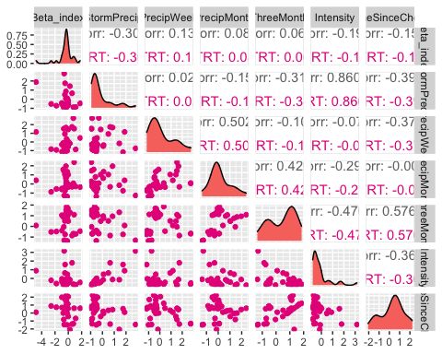

ggsave("NO3_pairs_BETA_VAUL.pdf",  
 path = here("Output_from_analysis", "09_Antecedent_Conditions_models", "plots"),  
 width = 10, height = 10)

## Warning: Removed 2 rows containing non-finite values (stat_density).  
## Removed 2 rows containing missing values (geom_point).  
## Removed 2 rows containing missing values (geom_point).  
## Removed 2 rows containing missing values (geom_point).  
## Removed 2 rows containing missing values (geom_point).  
## Removed 2 rows containing missing values (geom_point).  
## Removed 2 rows containing missing values (geom_point).

STRT.model <- lm(Beta_index ~ StormPrecip + PrecipWeek + PrecipMonth + TimeSinceChena, data = HI_FI_NO3_STRT)  
  
vif(STRT.model)

## StormPrecip PrecipWeek PrecipMonth TimeSinceChena   
## 1.241137 1.688993 1.560116 1.367847

plot(STRT.model)

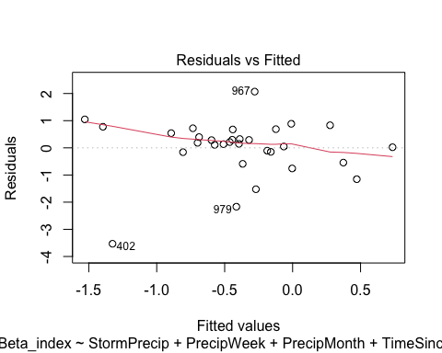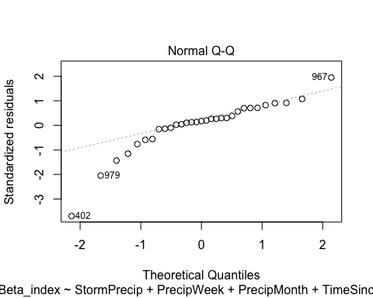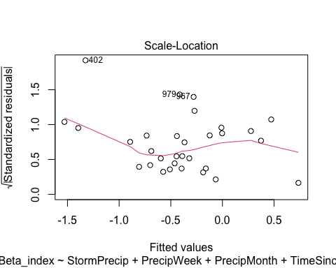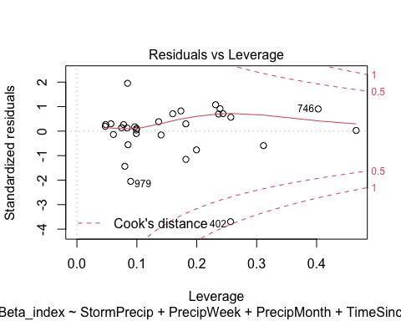 let me log transform

STRT.model.log <- lm(logBETA ~ StormPrecip + PrecipWeek + PrecipMonth + TimeSinceChena, data = HI_FI_NO3_STRT)  
  
vif(STRT.model.log)

## StormPrecip PrecipWeek PrecipMonth TimeSinceChena   
## 1.241137 1.688993 1.560116 1.367847

plot(STRT.model.log)

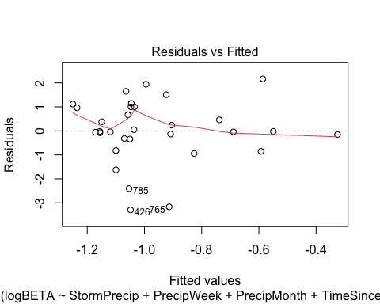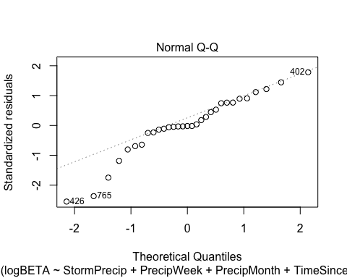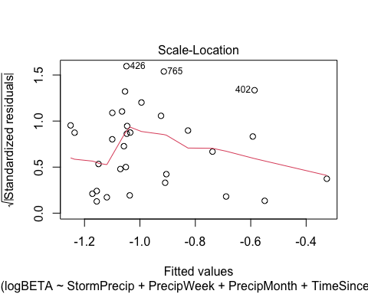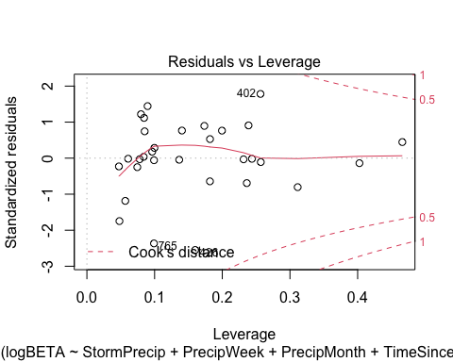

Plot_1 <- plot_summs(MOOS.model, FRCH.model,   
 CARI.model, POKE.model,   
 VAUL.model, STRT.model, scale = TRUE,  
 model.names = c("MOOS", "FRCH", "CARI", "POKE", "VAUL", "STRT"),  
 colors = c("#A6761D", "#FF7F00","#3288BD", "#6A3D9A", "#E7298A", "#66C2A5"))

## Loading required namespace: broom.mixed  
## Loading required namespace: broom.mixed  
## Loading required namespace: broom.mixed  
## Loading required namespace: broom.mixed  
## Loading required namespace: broom.mixed  
## Loading required namespace: broom.mixed

no3_beta <- Plot_1 +   
 xlab("Coefficient estimate") + ylab("") +  
 geom_vline(xintercept = 0,  
 colour = "grey80",  
 linetype = 1) +  
scale_y_discrete(labels= c("Seasonality",   
 "Precipitation Month",   
 "Precipitation Week",  
 "Storm Precipitation")) +  
 theme_bw()   
  
ggsave("BETA_NO3.pdf",  
 path = here("plots", "Coefficient_Plots", "HI"),  
 width = 7, height = 7)

### fDOM

# correlation   
fDOM_data <- HI_FI_fDOM[,c("Beta_index", "site.ID", "StormPrecip", "PrecipWeek", "PrecipMonth", "ThreeMonth", "Intensity", "TimeSinceChena", "pf", "burn", "year")]  
fDOM_data <- na.omit(fDOM_data) # 244 to 236 rows   
  
HI_FI_fDOM$logBETA <- log(abs(HI_FI_fDOM$Beta_index))  
  
ggpairs(fDOM_data,  
 columns = c("Beta_index", "StormPrecip", "PrecipWeek", "PrecipMonth","ThreeMonth", "Intensity", "TimeSinceChena"),  
 ggplot2::aes(color = site.ID))+  
 scale_color_manual(values = c("#3288BD", "#FF7F00","#A6761D", "#6A3D9A", "#66C2A5", "#E7298A"))

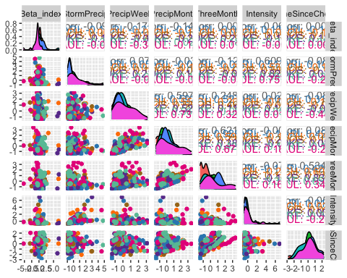

ggsave("fDOM_pairs_BETA.pdf",  
 path = here("Output_from_analysis", "09_Antecedent_Conditions_models", "plots"),  
 width = 10, height = 10)

HI_FI_fDOM_MOOS <- subset(HI_FI_fDOM, site.ID == "MOOS")  
HI_FI_fDOM_FRCH <- subset(HI_FI_fDOM, site.ID == "FRCH")  
HI_FI_fDOM_CARI <- subset(HI_FI_fDOM, site.ID == "CARI")  
HI_FI_fDOM_POKE <- subset(HI_FI_fDOM, site.ID == "POKE")  
HI_FI_fDOM_VAUL <- subset(HI_FI_fDOM, site.ID == "VAUL")  
HI_FI_fDOM_STRT <- subset(HI_FI_fDOM, site.ID == "STRT")

ggpairs(HI_FI_fDOM_MOOS,  
 columns = c("Beta_index", "StormPrecip", "PrecipWeek", "PrecipMonth","ThreeMonth", "Intensity", "TimeSinceChena"),  
 ggplot2::aes(color = site.ID))+  
 scale_color_manual(values = c("#A6761D"))

## Warning in ggally_statistic(data = data, mapping = mapping, na.rm = na.rm, :  
## Removing 1 row that contained a missing value  
  
## Warning in ggally_statistic(data = data, mapping = mapping, na.rm = na.rm, :  
## Removing 1 row that contained a missing value  
  
## Warning in ggally_statistic(data = data, mapping = mapping, na.rm = na.rm, :  
## Removing 1 row that contained a missing value  
  
## Warning in ggally_statistic(data = data, mapping = mapping, na.rm = na.rm, :  
## Removing 1 row that contained a missing value  
  
## Warning in ggally_statistic(data = data, mapping = mapping, na.rm = na.rm, :  
## Removing 1 row that contained a missing value  
  
## Warning in ggally_statistic(data = data, mapping = mapping, na.rm = na.rm, :  
## Removing 1 row that contained a missing value

## Warning: Removed 1 rows containing non-finite values (stat_density).

## Warning: Removed 1 rows containing missing values (geom_point).  
## Removed 1 rows containing missing values (geom_point).  
## Removed 1 rows containing missing values (geom_point).  
## Removed 1 rows containing missing values (geom_point).  
## Removed 1 rows containing missing values (geom_point).  
## Removed 1 rows containing missing values (geom_point).

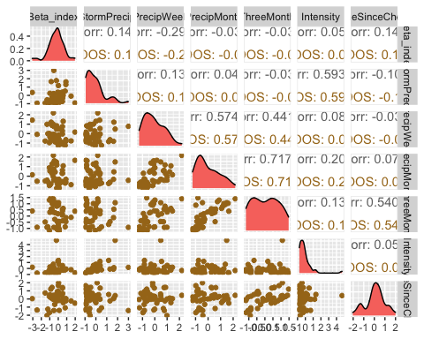

ggsave("fDOM_pairs_BETA_MOOS.pdf",  
 path = here("Output_from_analysis", "09_Antecedent_Conditions_models", "plots"),  
 width = 10, height = 10)

## Warning: Removed 1 rows containing non-finite values (stat_density).  
## Removed 1 rows containing missing values (geom_point).  
## Removed 1 rows containing missing values (geom_point).  
## Removed 1 rows containing missing values (geom_point).  
## Removed 1 rows containing missing values (geom_point).  
## Removed 1 rows containing missing values (geom_point).  
## Removed 1 rows containing missing values (geom_point).

MOOS.model <- lm(Beta_index ~ StormPrecip + PrecipWeek + PrecipMonth + TimeSinceChena, data = HI_FI_fDOM_MOOS)  
  
vif(MOOS.model)

## StormPrecip PrecipWeek PrecipMonth TimeSinceChena   
## 1.041158 1.515695 1.502352 1.031561

plot(MOOS.model)

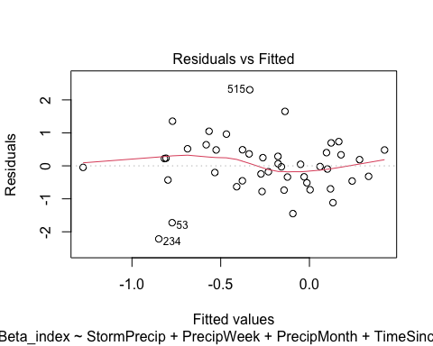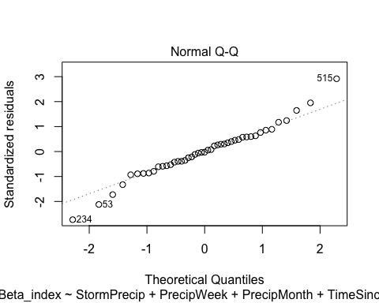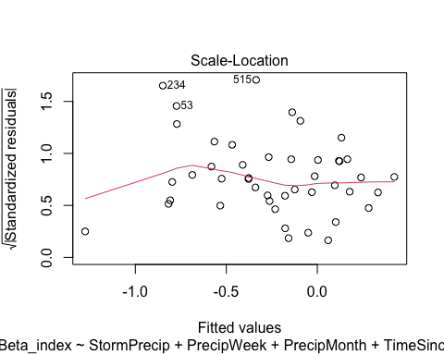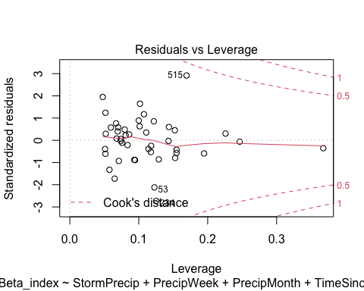

summary(MOOS.model)

##   
## Call:  
## lm(formula = Beta_index ~ StormPrecip + PrecipWeek + PrecipMonth +   
## TimeSinceChena, data = HI_FI_fDOM_MOOS)  
##   
## Residuals:  
## Min 1Q Median 3Q Max   
## -2.2161 -0.4535 -0.0216 0.4809 2.3068   
##   
## Coefficients:  
## Estimate Std. Error t value Pr(>|t|)   
## (Intercept) -0.2813 0.1310 -2.147 0.0379 *  
## StormPrecip 0.2282 0.1535 1.487 0.1449   
## PrecipWeek -0.4767 0.1971 -2.418 0.0203 *  
## PrecipMonth 0.1883 0.1789 1.053 0.2988   
## TimeSinceChena 0.1583 0.1486 1.065 0.2932   
## ---  
## Signif. codes: 0 '***' 0.001 '**' 0.01 '*' 0.05 '.' 0.1 ' ' 1  
##   
## Residual standard error: 0.8679 on 40 degrees of freedom  
## (1 observation deleted due to missingness)  
## Multiple R-squared: 0.1728, Adjusted R-squared: 0.09009   
## F-statistic: 2.089 on 4 and 40 DF, p-value: 0.1003

ggpairs(HI_FI_fDOM_FRCH,  
 columns = c("Beta_index", "StormPrecip", "PrecipWeek", "PrecipMonth","ThreeMonth", "Intensity", "TimeSinceChena"),  
 ggplot2::aes(color = site.ID))+  
 scale_color_manual(values = c("#FF7F00"))

## Warning in ggally_statistic(data = data, mapping = mapping, na.rm = na.rm, :  
## Removing 1 row that contained a missing value  
  
## Warning in ggally_statistic(data = data, mapping = mapping, na.rm = na.rm, :  
## Removing 1 row that contained a missing value  
  
## Warning in ggally_statistic(data = data, mapping = mapping, na.rm = na.rm, :  
## Removing 1 row that contained a missing value  
  
## Warning in ggally_statistic(data = data, mapping = mapping, na.rm = na.rm, :  
## Removing 1 row that contained a missing value

## Warning in ggally_statistic(data = data, mapping = mapping, na.rm = na.rm, :  
## Removed 2 rows containing missing values

## Warning in ggally_statistic(data = data, mapping = mapping, na.rm = na.rm, :  
## Removing 1 row that contained a missing value  
  
## Warning in ggally_statistic(data = data, mapping = mapping, na.rm = na.rm, :  
## Removing 1 row that contained a missing value  
  
## Warning in ggally_statistic(data = data, mapping = mapping, na.rm = na.rm, :  
## Removing 1 row that contained a missing value  
  
## Warning in ggally_statistic(data = data, mapping = mapping, na.rm = na.rm, :  
## Removing 1 row that contained a missing value  
  
## Warning in ggally_statistic(data = data, mapping = mapping, na.rm = na.rm, :  
## Removing 1 row that contained a missing value  
  
## Warning in ggally_statistic(data = data, mapping = mapping, na.rm = na.rm, :  
## Removing 1 row that contained a missing value

## Warning: Removed 1 rows containing non-finite values (stat_density).

## Warning: Removed 1 rows containing missing values (geom_point).  
## Removed 1 rows containing missing values (geom_point).  
## Removed 1 rows containing missing values (geom_point).  
## Removed 1 rows containing missing values (geom_point).

## Warning: Removed 2 rows containing missing values (geom_point).

## Warning: Removed 1 rows containing missing values (geom_point).  
## Removed 1 rows containing missing values (geom_point).  
## Removed 1 rows containing missing values (geom_point).  
## Removed 1 rows containing missing values (geom_point).

## Warning: Removed 1 rows containing non-finite values (stat_density).

## Warning: Removed 1 rows containing missing values (geom_point).  
## Removed 1 rows containing missing values (geom_point).

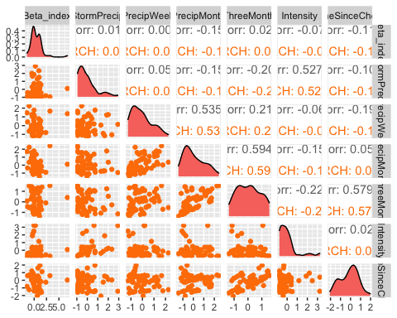

ggsave("fDOM_pairs_BETA_FRCH.pdf",  
 path = here("Output_from_analysis", "09_Antecedent_Conditions_models", "plots"),  
 width = 10, height = 10)

## Warning: Removed 1 rows containing non-finite values (stat_density).  
## Removed 1 rows containing missing values (geom_point).  
## Removed 1 rows containing missing values (geom_point).  
## Removed 1 rows containing missing values (geom_point).  
## Removed 1 rows containing missing values (geom_point).

## Warning: Removed 2 rows containing missing values (geom_point).

## Warning: Removed 1 rows containing missing values (geom_point).  
## Removed 1 rows containing missing values (geom_point).  
## Removed 1 rows containing missing values (geom_point).  
## Removed 1 rows containing missing values (geom_point).

## Warning: Removed 1 rows containing non-finite values (stat_density).

## Warning: Removed 1 rows containing missing values (geom_point).  
## Removed 1 rows containing missing values (geom_point).

FRCH.model <- lm(Beta_index ~ StormPrecip + PrecipWeek + PrecipMonth + TimeSinceChena, data = HI_FI_fDOM_FRCH)  
  
vif(FRCH.model)

## StormPrecip PrecipWeek PrecipMonth TimeSinceChena   
## 1.053736 1.614297 1.588519 1.097018

plot(FRCH.model)

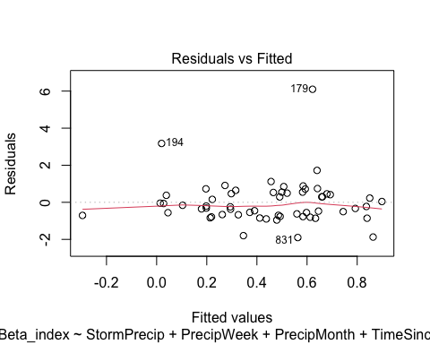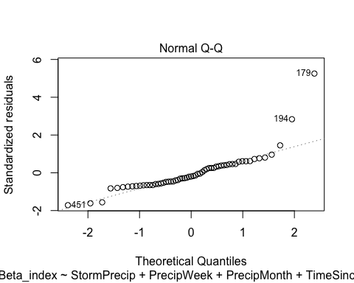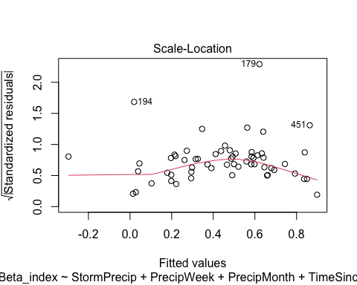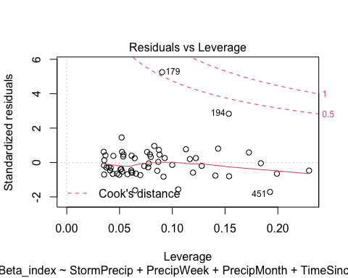

summary(FRCH.model)

##   
## Call:  
## lm(formula = Beta_index ~ StormPrecip + PrecipWeek + PrecipMonth +   
## TimeSinceChena, data = HI_FI_fDOM_FRCH)  
##   
## Residuals:  
## Min 1Q Median 3Q Max   
## -1.9008 -0.6880 -0.2249 0.4802 6.0986   
##   
## Coefficients:  
## Estimate Std. Error t value Pr(>|t|)   
## (Intercept) 0.45056 0.16337 2.758 0.00792 **  
## StormPrecip -0.04876 0.18317 -0.266 0.79111   
## PrecipWeek 0.15596 0.23139 0.674 0.50319   
## PrecipMonth -0.27433 0.20789 -1.320 0.19254   
## TimeSinceChena -0.11130 0.18588 -0.599 0.55182   
## ---  
## Signif. codes: 0 '***' 0.001 '**' 0.01 '*' 0.05 '.' 0.1 ' ' 1  
##   
## Residual standard error: 1.217 on 54 degrees of freedom  
## (1 observation deleted due to missingness)  
## Multiple R-squared: 0.04484, Adjusted R-squared: -0.02591   
## F-statistic: 0.6338 on 4 and 54 DF, p-value: 0.6406

ggpairs(HI_FI_fDOM_CARI,  
 columns = c("Beta_index", "StormPrecip", "PrecipWeek", "PrecipMonth","ThreeMonth", "Intensity", "TimeSinceChena"),  
 ggplot2::aes(color = site.ID))+  
 scale_color_manual(values = c("#3288BD"))

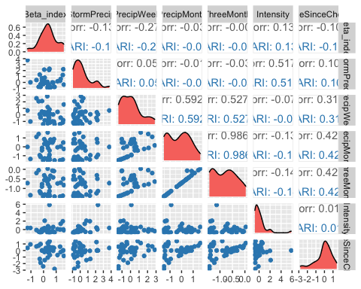

ggsave("fDOM_pairs_BETA_CARI.pdf",  
 path = here("Output_from_analysis", "09_Antecedent_Conditions_models", "plots"),  
 width = 10, height = 10)  
  
  
CARI.model <- lm(Beta_index ~ StormPrecip + PrecipWeek + PrecipMonth + TimeSinceChena, data = HI_FI_fDOM_CARI)  
  
vif(CARI.model)

## StormPrecip PrecipWeek PrecipMonth TimeSinceChena   
## 1.019332 1.560191 1.713225 1.241131

plot(CARI.model)

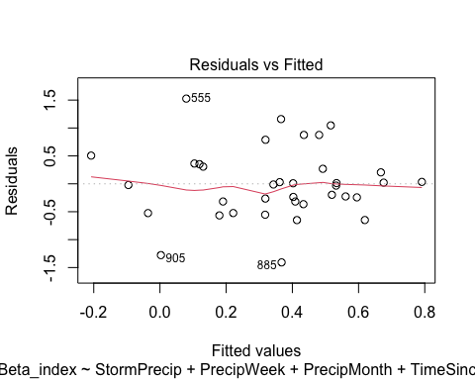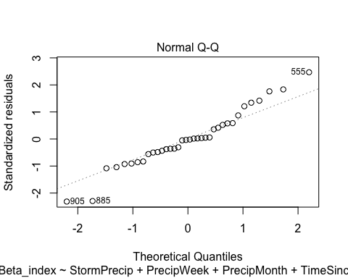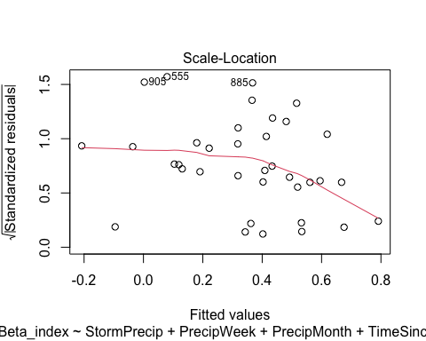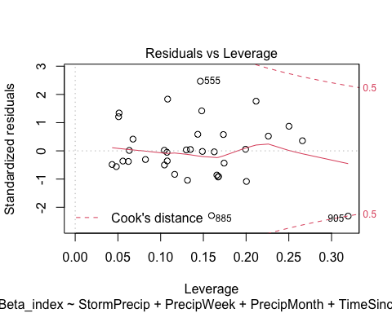

summary(CARI.model)

##   
## Call:  
## lm(formula = Beta_index ~ StormPrecip + PrecipWeek + PrecipMonth +   
## TimeSinceChena, data = HI_FI_fDOM_CARI)  
##   
## Residuals:  
## Min 1Q Median 3Q Max   
## -1.40793 -0.32916 -0.01691 0.31838 1.52663   
##   
## Coefficients:  
## Estimate Std. Error t value Pr(>|t|)   
## (Intercept) 0.40464 0.12057 3.356 0.0021 **  
## StormPrecip -0.06120 0.10284 -0.595 0.5561   
## PrecipWeek -0.21966 0.12285 -1.788 0.0836 .   
## PrecipMonth 0.15442 0.15504 0.996 0.3270   
## TimeSinceChena -0.04995 0.12906 -0.387 0.7014   
## ---  
## Signif. codes: 0 '***' 0.001 '**' 0.01 '*' 0.05 '.' 0.1 ' ' 1  
##   
## Residual standard error: 0.6695 on 31 degrees of freedom  
## Multiple R-squared: 0.1178, Adjusted R-squared: 0.003927   
## F-statistic: 1.034 on 4 and 31 DF, p-value: 0.4052

ggpairs(HI_FI_fDOM_POKE,  
 columns = c("Beta_index", "StormPrecip", "PrecipWeek", "PrecipMonth","ThreeMonth", "Intensity", "TimeSinceChena"),  
 ggplot2::aes(color = site.ID))+  
 scale_color_manual(values = c("#6A3D9A"))

## Warning in ggally_statistic(data = data, mapping = mapping, na.rm = na.rm, :  
## Removed 3 rows containing missing values  
  
## Warning in ggally_statistic(data = data, mapping = mapping, na.rm = na.rm, :  
## Removed 3 rows containing missing values  
  
## Warning in ggally_statistic(data = data, mapping = mapping, na.rm = na.rm, :  
## Removed 3 rows containing missing values  
  
## Warning in ggally_statistic(data = data, mapping = mapping, na.rm = na.rm, :  
## Removed 3 rows containing missing values

## Warning in ggally_statistic(data = data, mapping = mapping, na.rm = na.rm, :  
## Removed 4 rows containing missing values

## Warning in ggally_statistic(data = data, mapping = mapping, na.rm = na.rm, :  
## Removing 1 row that contained a missing value  
  
## Warning in ggally_statistic(data = data, mapping = mapping, na.rm = na.rm, :  
## Removing 1 row that contained a missing value  
  
## Warning in ggally_statistic(data = data, mapping = mapping, na.rm = na.rm, :  
## Removing 1 row that contained a missing value  
  
## Warning in ggally_statistic(data = data, mapping = mapping, na.rm = na.rm, :  
## Removing 1 row that contained a missing value

## Warning in ggally_statistic(data = data, mapping = mapping, na.rm = na.rm, :  
## Removed 3 rows containing missing values

## Warning in ggally_statistic(data = data, mapping = mapping, na.rm = na.rm, :  
## Removing 1 row that contained a missing value

## Warning: Removed 3 rows containing non-finite values (stat_density).

## Warning: Removed 3 rows containing missing values (geom_point).  
## Removed 3 rows containing missing values (geom_point).  
## Removed 3 rows containing missing values (geom_point).  
## Removed 3 rows containing missing values (geom_point).

## Warning: Removed 4 rows containing missing values (geom_point).

## Warning: Removed 1 rows containing missing values (geom_point).  
## Removed 1 rows containing missing values (geom_point).  
## Removed 1 rows containing missing values (geom_point).  
## Removed 1 rows containing missing values (geom_point).

## Warning: Removed 1 rows containing non-finite values (stat_density).

## Warning: Removed 3 rows containing missing values (geom_point).

## Warning: Removed 1 rows containing missing values (geom_point).

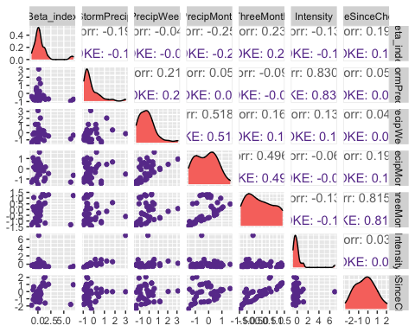

ggsave("fDOM_pairs_BETA_POKE.pdf",  
 path = here("Output_from_analysis", "09_Antecedent_Conditions_models", "plots"),  
 width = 10, height = 10)

## Warning: Removed 3 rows containing non-finite values (stat_density).

## Warning: Removed 3 rows containing missing values (geom_point).  
## Removed 3 rows containing missing values (geom_point).  
## Removed 3 rows containing missing values (geom_point).  
## Removed 3 rows containing missing values (geom_point).

## Warning: Removed 4 rows containing missing values (geom_point).

## Warning: Removed 1 rows containing missing values (geom_point).  
## Removed 1 rows containing missing values (geom_point).  
## Removed 1 rows containing missing values (geom_point).  
## Removed 1 rows containing missing values (geom_point).

## Warning: Removed 1 rows containing non-finite values (stat_density).

## Warning: Removed 3 rows containing missing values (geom_point).

## Warning: Removed 1 rows containing missing values (geom_point).

POKE.model <- lm(Beta_index ~ StormPrecip + PrecipWeek + PrecipMonth + TimeSinceChena, data = HI_FI_fDOM_POKE)  
  
vif(POKE.model)

## StormPrecip PrecipWeek PrecipMonth TimeSinceChena   
## 1.056562 1.501533 1.480447 1.033514

plot(POKE.model)

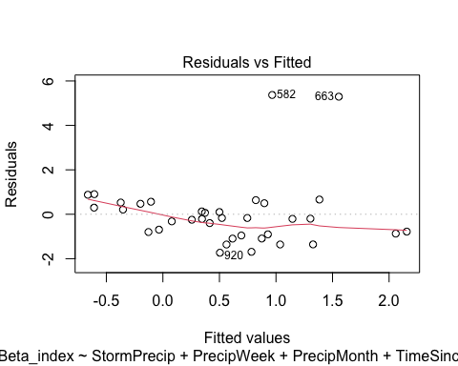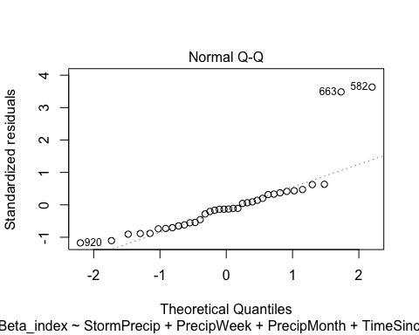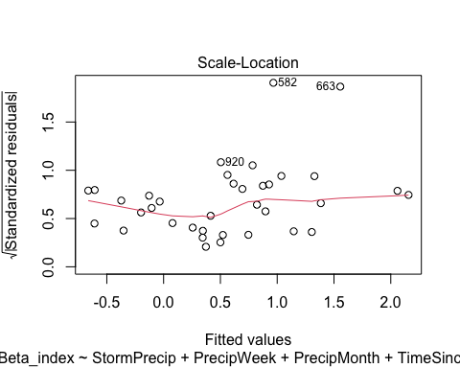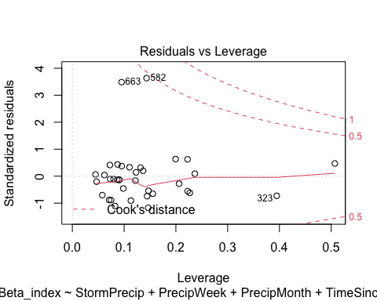

summary(POKE.model)

##   
## Call:  
## lm(formula = Beta_index ~ StormPrecip + PrecipWeek + PrecipMonth +   
## TimeSinceChena, data = HI_FI_fDOM_POKE)  
##   
## Residuals:  
## Min 1Q Median 3Q Max   
## -1.7314 -0.8783 -0.2021 0.4777 5.3693   
##   
## Coefficients:  
## Estimate Std. Error t value Pr(>|t|)   
## (Intercept) 0.4791 0.2860 1.675 0.1040   
## StormPrecip -0.4101 0.3400 -1.206 0.2369   
## PrecipWeek 0.3467 0.3475 0.998 0.3261   
## PrecipMonth -0.8249 0.4222 -1.954 0.0598 .  
## TimeSinceChena 0.3814 0.2524 1.511 0.1409   
## ---  
## Signif. codes: 0 '***' 0.001 '**' 0.01 '*' 0.05 '.' 0.1 ' ' 1  
##   
## Residual standard error: 1.596 on 31 degrees of freedom  
## (3 observations deleted due to missingness)  
## Multiple R-squared: 0.1781, Adjusted R-squared: 0.07203   
## F-statistic: 1.679 on 4 and 31 DF, p-value: 0.1799

ggpairs(HI_FI_fDOM_VAUL,  
 columns = c("Beta_index", "StormPrecip", "PrecipWeek", "PrecipMonth","ThreeMonth", "Intensity", "TimeSinceChena"),  
 ggplot2::aes(color = site.ID))+  
 scale_color_manual(values = c("#66C2A5"))

## Warning in ggally_statistic(data = data, mapping = mapping, na.rm = na.rm, :  
## Removed 2 rows containing missing values  
  
## Warning in ggally_statistic(data = data, mapping = mapping, na.rm = na.rm, :  
## Removed 2 rows containing missing values  
  
## Warning in ggally_statistic(data = data, mapping = mapping, na.rm = na.rm, :  
## Removed 2 rows containing missing values  
  
## Warning in ggally_statistic(data = data, mapping = mapping, na.rm = na.rm, :  
## Removed 2 rows containing missing values  
  
## Warning in ggally_statistic(data = data, mapping = mapping, na.rm = na.rm, :  
## Removed 2 rows containing missing values  
  
## Warning in ggally_statistic(data = data, mapping = mapping, na.rm = na.rm, :  
## Removed 2 rows containing missing values

## Warning: Removed 2 rows containing non-finite values (stat_density).

## Warning: Removed 2 rows containing missing values (geom_point).  
## Removed 2 rows containing missing values (geom_point).  
## Removed 2 rows containing missing values (geom_point).  
## Removed 2 rows containing missing values (geom_point).  
## Removed 2 rows containing missing values (geom_point).  
## Removed 2 rows containing missing values (geom_point).

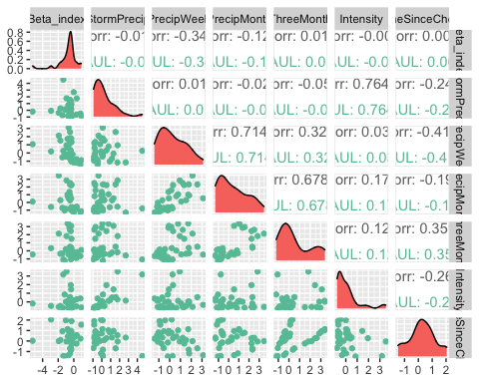

ggsave("fDOM_pairs_BETA_VAUL.pdf",  
 path = here("Output_from_analysis", "09_Antecedent_Conditions_models", "plots"),  
 width = 10, height = 10)

## Warning: Removed 2 rows containing non-finite values (stat_density).  
## Removed 2 rows containing missing values (geom_point).  
## Removed 2 rows containing missing values (geom_point).  
## Removed 2 rows containing missing values (geom_point).  
## Removed 2 rows containing missing values (geom_point).  
## Removed 2 rows containing missing values (geom_point).  
## Removed 2 rows containing missing values (geom_point).

VAUL.model <- lm(Beta_index ~ StormPrecip + PrecipWeek + PrecipMonth + TimeSinceChena, data = HI_FI_fDOM_VAUL)  
  
vif(VAUL.model)

## StormPrecip PrecipWeek PrecipMonth TimeSinceChena   
## 1.085471 2.648138 2.209356 1.385138

plot(VAUL.model)

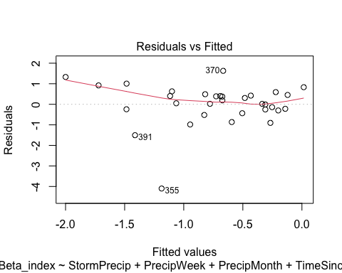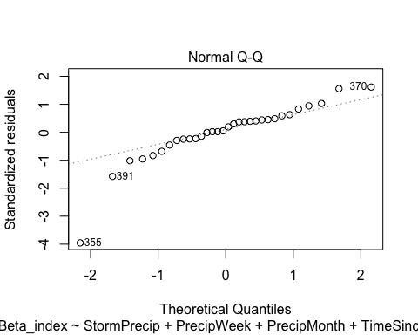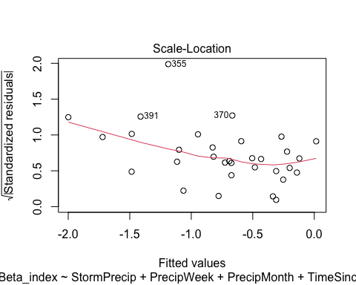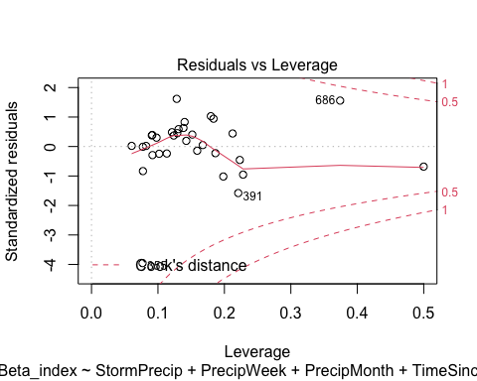

summary(VAUL.model)

##   
## Call:  
## lm(formula = Beta_index ~ StormPrecip + PrecipWeek + PrecipMonth +   
## TimeSinceChena, data = HI_FI_fDOM_VAUL)  
##   
## Residuals:  
## Min 1Q Median 3Q Max   
## -4.0989 -0.2633 0.1203 0.4641 1.6283   
##   
## Coefficients:  
## Estimate Std. Error t value Pr(>|t|)   
## (Intercept) -0.52765 0.22547 -2.340 0.0269 *  
## StormPrecip -0.07666 0.16639 -0.461 0.6487   
## PrecipWeek -0.64805 0.25999 -2.493 0.0191 *  
## PrecipMonth 0.26578 0.20508 1.296 0.2060   
## TimeSinceChena -0.29855 0.23976 -1.245 0.2237   
## ---  
## Signif. codes: 0 '***' 0.001 '**' 0.01 '*' 0.05 '.' 0.1 ' ' 1  
##   
## Residual standard error: 1.079 on 27 degrees of freedom  
## (2 observations deleted due to missingness)  
## Multiple R-squared: 0.2001, Adjusted R-squared: 0.08158   
## F-statistic: 1.688 on 4 and 27 DF, p-value: 0.1817

ggpairs(HI_FI_fDOM_STRT,  
 columns = c("Beta_index", "StormPrecip", "PrecipWeek", "PrecipMonth","ThreeMonth", "Intensity", "TimeSinceChena"),  
 ggplot2::aes(color = site.ID))+  
 scale_color_manual(values = c("#E7298A"))

## Warning in ggally_statistic(data = data, mapping = mapping, na.rm = na.rm, :  
## Removed 2 rows containing missing values  
  
## Warning in ggally_statistic(data = data, mapping = mapping, na.rm = na.rm, :  
## Removed 2 rows containing missing values  
  
## Warning in ggally_statistic(data = data, mapping = mapping, na.rm = na.rm, :  
## Removed 2 rows containing missing values  
  
## Warning in ggally_statistic(data = data, mapping = mapping, na.rm = na.rm, :  
## Removed 2 rows containing missing values  
  
## Warning in ggally_statistic(data = data, mapping = mapping, na.rm = na.rm, :  
## Removed 2 rows containing missing values  
  
## Warning in ggally_statistic(data = data, mapping = mapping, na.rm = na.rm, :  
## Removed 2 rows containing missing values

## Warning: Removed 2 rows containing non-finite values (stat_density).

## Warning: Removed 2 rows containing missing values (geom_point).  
## Removed 2 rows containing missing values (geom_point).  
## Removed 2 rows containing missing values (geom_point).  
## Removed 2 rows containing missing values (geom_point).  
## Removed 2 rows containing missing values (geom_point).  
## Removed 2 rows containing missing values (geom_point).

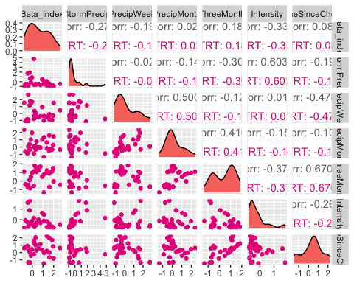

ggsave("fDOM_pairs_BETA_VAUL.pdf",  
 path = here("Output_from_analysis", "09_Antecedent_Conditions_models", "plots"),  
 width = 10, height = 10)

## Warning: Removed 2 rows containing non-finite values (stat_density).  
## Removed 2 rows containing missing values (geom_point).  
## Removed 2 rows containing missing values (geom_point).  
## Removed 2 rows containing missing values (geom_point).  
## Removed 2 rows containing missing values (geom_point).  
## Removed 2 rows containing missing values (geom_point).  
## Removed 2 rows containing missing values (geom_point).

STRT.model <- lm(Beta_index ~ StormPrecip + PrecipWeek + PrecipMonth + TimeSinceChena, data = HI_FI_fDOM_STRT)  
  
vif(STRT.model)

## StormPrecip PrecipWeek PrecipMonth TimeSinceChena   
## 1.079608 1.758827 1.526528 1.275755

plot(STRT.model)

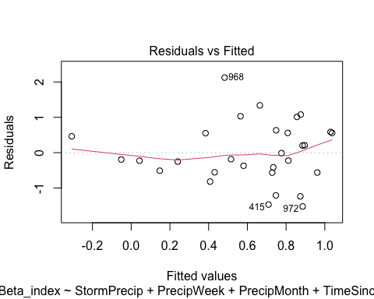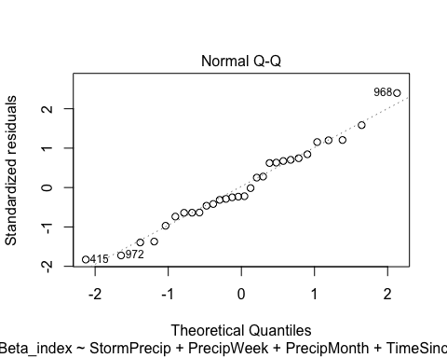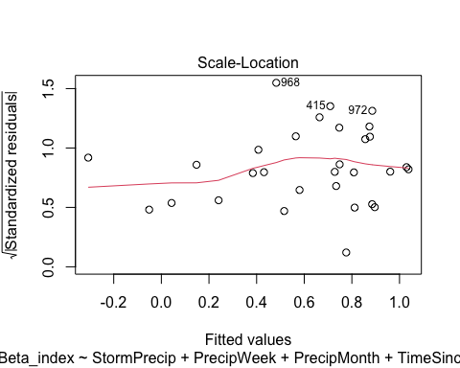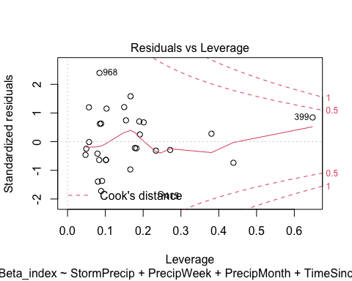

summary(STRT.model)

##   
## Call:  
## lm(formula = Beta_index ~ StormPrecip + PrecipWeek + PrecipMonth +   
## TimeSinceChena, data = HI_FI_fDOM_STRT)  
##   
## Residuals:  
## Min 1Q Median 3Q Max   
## -1.5227 -0.5450 -0.1893 0.5577 2.1237   
##   
## Coefficients:  
## Estimate Std. Error t value Pr(>|t|)   
## (Intercept) 0.60654 0.19292 3.144 0.00426 **  
## StormPrecip -0.21062 0.15073 -1.397 0.17459   
## PrecipWeek -0.27258 0.21762 -1.253 0.22197   
## PrecipMonth 0.15284 0.23446 0.652 0.52042   
## TimeSinceChena -0.06924 0.19738 -0.351 0.72869   
## ---  
## Signif. codes: 0 '***' 0.001 '**' 0.01 '*' 0.05 '.' 0.1 ' ' 1  
##   
## Residual standard error: 0.9254 on 25 degrees of freedom  
## (2 observations deleted due to missingness)  
## Multiple R-squared: 0.1302, Adjusted R-squared: -0.008929   
## F-statistic: 0.9358 on 4 and 25 DF, p-value: 0.4594

Plot_1 <- plot_summs(MOOS.model, FRCH.model,   
 CARI.model, POKE.model,   
 VAUL.model, STRT.model, scale = TRUE,  
 model.names = c("MOOS", "FRCH", "CARI", "POKE", "VAUL", "STRT"),  
 colors = c("#A6761D", "#FF7F00","#3288BD", "#6A3D9A", "#E7298A", "#66C2A5"))

## Loading required namespace: broom.mixed  
## Loading required namespace: broom.mixed  
## Loading required namespace: broom.mixed  
## Loading required namespace: broom.mixed  
## Loading required namespace: broom.mixed  
## Loading required namespace: broom.mixed

fDOM_beta <- Plot_1 +   
 xlab("Coefficient estimate") + ylab("") +  
 geom_vline(xintercept = 0,  
 colour = "grey80",  
 linetype = 1) +  
scale_y_discrete(labels= c("Seasonality",   
 "Precipitation Month",   
 "Precipitation Week",  
 "Storm Precipitation")) +  
 theme_bw()   
  
ggsave("BETA_fDOM.pdf",  
 path = here("plots", "Coefficient_Plots", "HI"),  
 width = 7, height = 7)

### SPC

# correlation   
SPC_data <- HI_FI_SPC[,c("Beta_index", "site.ID", "StormPrecip", "PrecipWeek", "PrecipMonth", "ThreeMonth", "Intensity", "TimeSinceChena", "pf", "burn", "year")]  
SPC_data <- na.omit(SPC_data) # 244 to 236 rows   
  
HI_FI_SPC$logBETA <- log(abs(HI_FI_SPC$Beta_index))  
ggpairs(SPC_data,  
 columns = c("Beta_index", "StormPrecip", "PrecipWeek", "PrecipMonth","ThreeMonth", "Intensity", "TimeSinceChena"),  
 ggplot2::aes(color = site.ID))+  
 scale_color_manual(values = c("#3288BD", "#FF7F00","#A6761D", "#6A3D9A", "#66C2A5", "#E7298A"))

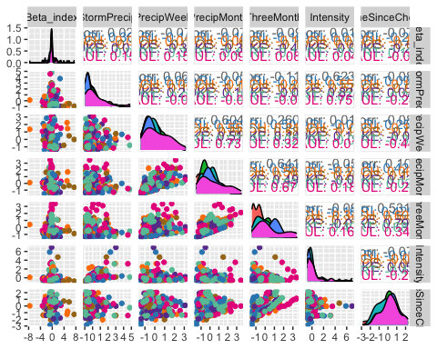

ggsave("SPC_pairs_BETA.pdf",  
 path = here("Output_from_analysis", "09_Antecedent_Conditions_models", "plots"),  
 width = 10, height = 10)

HI_FI_SPC_MOOS <- subset(HI_FI_SPC, site.ID == "MOOS")  
HI_FI_SPC_FRCH <- subset(HI_FI_SPC, site.ID == "FRCH")  
HI_FI_SPC_CARI <- subset(HI_FI_SPC, site.ID == "CARI")  
HI_FI_SPC_POKE <- subset(HI_FI_SPC, site.ID == "POKE")  
HI_FI_SPC_VAUL <- subset(HI_FI_SPC, site.ID == "VAUL")  
HI_FI_SPC_STRT <- subset(HI_FI_SPC, site.ID == "STRT")

ggpairs(HI_FI_SPC_MOOS,  
 columns = c("Beta_index", "StormPrecip", "PrecipWeek", "PrecipMonth","ThreeMonth", "Intensity", "TimeSinceChena"),  
 ggplot2::aes(color = site.ID))+  
 scale_color_manual(values = c("#A6761D"))

## Warning in ggally_statistic(data = data, mapping = mapping, na.rm = na.rm, :  
## Removing 1 row that contained a missing value  
  
## Warning in ggally_statistic(data = data, mapping = mapping, na.rm = na.rm, :  
## Removing 1 row that contained a missing value  
  
## Warning in ggally_statistic(data = data, mapping = mapping, na.rm = na.rm, :  
## Removing 1 row that contained a missing value  
  
## Warning in ggally_statistic(data = data, mapping = mapping, na.rm = na.rm, :  
## Removing 1 row that contained a missing value  
  
## Warning in ggally_statistic(data = data, mapping = mapping, na.rm = na.rm, :  
## Removing 1 row that contained a missing value  
  
## Warning in ggally_statistic(data = data, mapping = mapping, na.rm = na.rm, :  
## Removing 1 row that contained a missing value

## Warning: Removed 1 rows containing non-finite values (stat_density).

## Warning: Removed 1 rows containing missing values (geom_point).  
## Removed 1 rows containing missing values (geom_point).  
## Removed 1 rows containing missing values (geom_point).  
## Removed 1 rows containing missing values (geom_point).  
## Removed 1 rows containing missing values (geom_point).  
## Removed 1 rows containing missing values (geom_point).

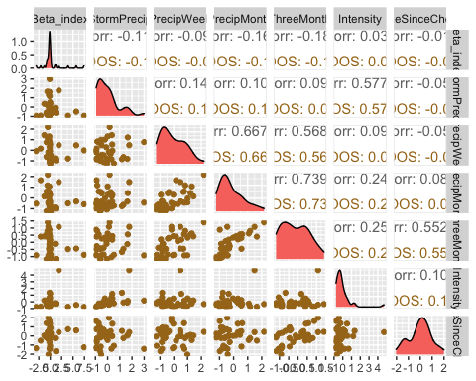

ggsave("SPC_pairs_BETA_MOOS.pdf",  
 path = here("Output_from_analysis", "09_Antecedent_Conditions_models", "plots"),  
 width = 10, height = 10)

## Warning: Removed 1 rows containing non-finite values (stat_density).  
## Removed 1 rows containing missing values (geom_point).  
## Removed 1 rows containing missing values (geom_point).  
## Removed 1 rows containing missing values (geom_point).  
## Removed 1 rows containing missing values (geom_point).  
## Removed 1 rows containing missing values (geom_point).  
## Removed 1 rows containing missing values (geom_point).

MOOS.model <- lm(Beta_index ~ StormPrecip + PrecipWeek + PrecipMonth + TimeSinceChena, data = HI_FI_SPC_MOOS)  
  
vif(MOOS.model)

## StormPrecip PrecipWeek PrecipMonth TimeSinceChena   
## 1.034303 1.821559 1.832019 1.041046

plot(MOOS.model)

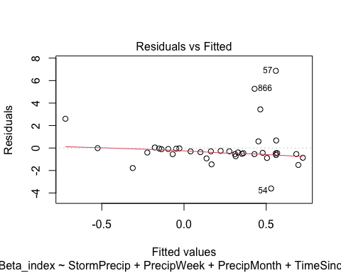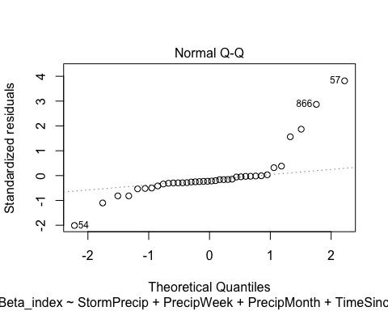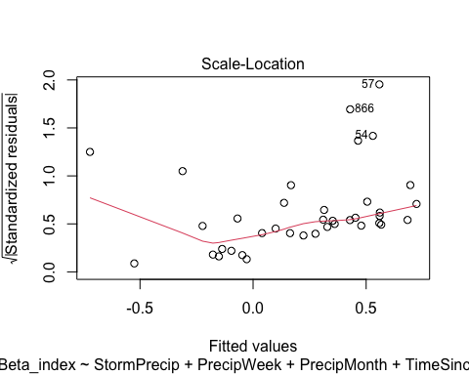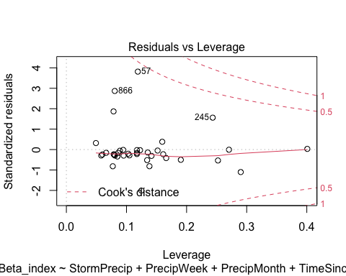 Lets log transform

MOOS.model.log <- lm(logBETA ~ StormPrecip + PrecipWeek + PrecipMonth + TimeSinceChena, data = HI_FI_SPC_MOOS)  
  
vif(MOOS.model.log)

## StormPrecip PrecipWeek PrecipMonth TimeSinceChena   
## 1.034303 1.821559 1.832019 1.041046

plot(MOOS.model.log)

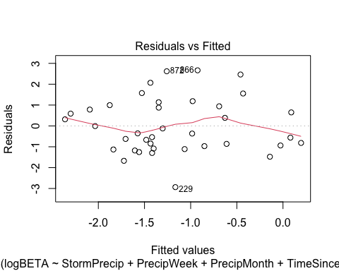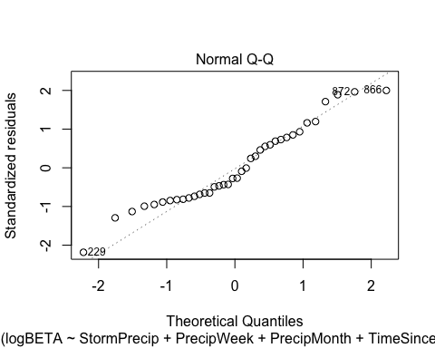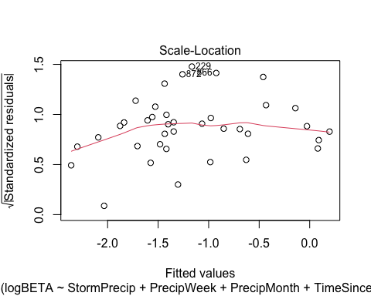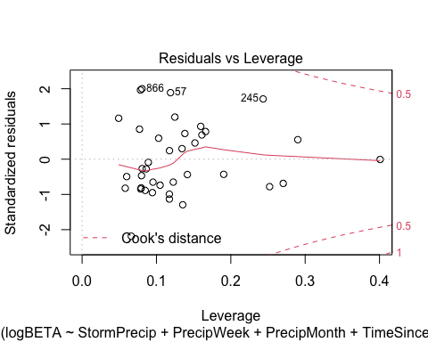

summary(MOOS.model.log)

##   
## Call:  
## lm(formula = logBETA ~ StormPrecip + PrecipWeek + PrecipMonth +   
## TimeSinceChena, data = HI_FI_SPC_MOOS)  
##   
## Residuals:  
## Min 1Q Median 3Q Max   
## -2.9351 -0.9613 -0.3611 0.9250 2.6660   
##   
## Coefficients:  
## Estimate Std. Error t value Pr(>|t|)   
## (Intercept) -1.0766 0.2319 -4.643 5.26e-05 ***  
## StormPrecip -0.4984 0.2544 -1.959 0.0586 .   
## PrecipWeek 0.3669 0.3542 1.036 0.3077   
## PrecipMonth 0.3116 0.3687 0.845 0.4041   
## TimeSinceChena -0.2701 0.2516 -1.074 0.2908   
## ---  
## Signif. codes: 0 '***' 0.001 '**' 0.01 '*' 0.05 '.' 0.1 ' ' 1  
##   
## Residual standard error: 1.39 on 33 degrees of freedom  
## (1 observation deleted due to missingness)  
## Multiple R-squared: 0.2052, Adjusted R-squared: 0.1088   
## F-statistic: 2.129 on 4 and 33 DF, p-value: 0.09923

i dont know if this is better

ggpairs(HI_FI_SPC_FRCH,  
 columns = c("Beta_index", "StormPrecip", "PrecipWeek", "PrecipMonth","ThreeMonth", "Intensity", "TimeSinceChena"),  
 ggplot2::aes(color = site.ID))+  
 scale_color_manual(values = c("#FF7F00"))

## Warning in ggally_statistic(data = data, mapping = mapping, na.rm = na.rm, :  
## Removing 1 row that contained a missing value  
  
## Warning in ggally_statistic(data = data, mapping = mapping, na.rm = na.rm, :  
## Removing 1 row that contained a missing value  
  
## Warning in ggally_statistic(data = data, mapping = mapping, na.rm = na.rm, :  
## Removing 1 row that contained a missing value  
  
## Warning in ggally_statistic(data = data, mapping = mapping, na.rm = na.rm, :  
## Removing 1 row that contained a missing value

## Warning in ggally_statistic(data = data, mapping = mapping, na.rm = na.rm, :  
## Removed 2 rows containing missing values

## Warning in ggally_statistic(data = data, mapping = mapping, na.rm = na.rm, :  
## Removing 1 row that contained a missing value  
  
## Warning in ggally_statistic(data = data, mapping = mapping, na.rm = na.rm, :  
## Removing 1 row that contained a missing value  
  
## Warning in ggally_statistic(data = data, mapping = mapping, na.rm = na.rm, :  
## Removing 1 row that contained a missing value  
  
## Warning in ggally_statistic(data = data, mapping = mapping, na.rm = na.rm, :  
## Removing 1 row that contained a missing value  
  
## Warning in ggally_statistic(data = data, mapping = mapping, na.rm = na.rm, :  
## Removing 1 row that contained a missing value  
  
## Warning in ggally_statistic(data = data, mapping = mapping, na.rm = na.rm, :  
## Removing 1 row that contained a missing value

## Warning: Removed 1 rows containing non-finite values (stat_density).

## Warning: Removed 1 rows containing missing values (geom_point).  
## Removed 1 rows containing missing values (geom_point).  
## Removed 1 rows containing missing values (geom_point).  
## Removed 1 rows containing missing values (geom_point).

## Warning: Removed 2 rows containing missing values (geom_point).

## Warning: Removed 1 rows containing missing values (geom_point).  
## Removed 1 rows containing missing values (geom_point).  
## Removed 1 rows containing missing values (geom_point).  
## Removed 1 rows containing missing values (geom_point).

## Warning: Removed 1 rows containing non-finite values (stat_density).

## Warning: Removed 1 rows containing missing values (geom_point).  
## Removed 1 rows containing missing values (geom_point).

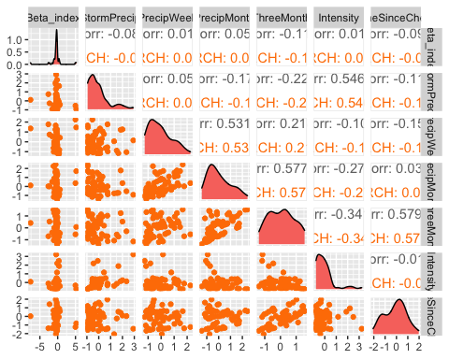

ggsave("SPC_pairs_BETA_FRCH.pdf",  
 path = here("Output_from_analysis", "09_Antecedent_Conditions_models", "plots"),  
 width = 10, height = 10)

## Warning: Removed 1 rows containing non-finite values (stat_density).  
## Removed 1 rows containing missing values (geom_point).  
## Removed 1 rows containing missing values (geom_point).  
## Removed 1 rows containing missing values (geom_point).  
## Removed 1 rows containing missing values (geom_point).

## Warning: Removed 2 rows containing missing values (geom_point).

## Warning: Removed 1 rows containing missing values (geom_point).  
## Removed 1 rows containing missing values (geom_point).  
## Removed 1 rows containing missing values (geom_point).  
## Removed 1 rows containing missing values (geom_point).

## Warning: Removed 1 rows containing non-finite values (stat_density).

## Warning: Removed 1 rows containing missing values (geom_point).  
## Removed 1 rows containing missing values (geom_point).

FRCH.model <- lm(Beta_index ~ StormPrecip + PrecipWeek + PrecipMonth + TimeSinceChena, data = HI_FI_SPC_FRCH)  
  
vif(FRCH.model)

## StormPrecip PrecipWeek PrecipMonth TimeSinceChena   
## 1.065346 1.560563 1.564752 1.061908

plot(FRCH.model)

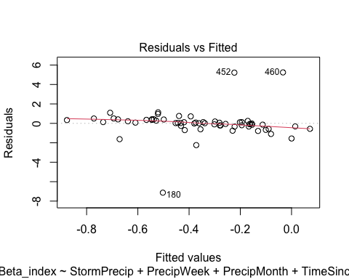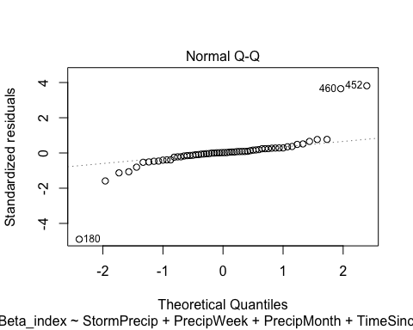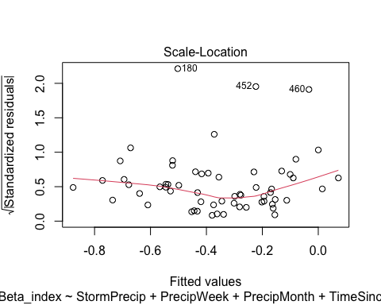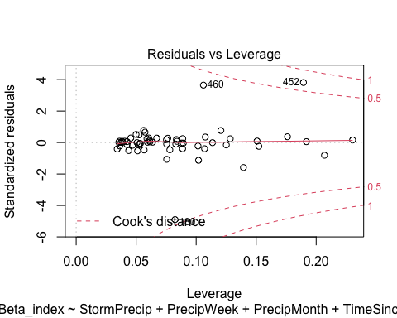

summary(FRCH.model)

##   
## Call:  
## lm(formula = Beta_index ~ StormPrecip + PrecipWeek + PrecipMonth +   
## TimeSinceChena, data = HI_FI_SPC_FRCH)  
##   
## Residuals:  
## Min 1Q Median 3Q Max   
## -7.1305 -0.2697 0.0290 0.3435 5.2437   
##   
## Coefficients:  
## Estimate Std. Error t value Pr(>|t|)   
## (Intercept) -0.39044 0.19914 -1.961 0.055 .  
## StormPrecip -0.13550 0.23089 -0.587 0.560   
## PrecipWeek -0.07772 0.28214 -0.275 0.784   
## PrecipMonth 0.11550 0.26193 0.441 0.661   
## TimeSinceChena -0.18394 0.21867 -0.841 0.404   
## ---  
## Signif. codes: 0 '***' 0.001 '**' 0.01 '*' 0.05 '.' 0.1 ' ' 1  
##   
## Residual standard error: 1.519 on 55 degrees of freedom  
## (1 observation deleted due to missingness)  
## Multiple R-squared: 0.02124, Adjusted R-squared: -0.04994   
## F-statistic: 0.2984 on 4 and 55 DF, p-value: 0.8778

ggpairs(HI_FI_SPC_CARI,  
 columns = c("Beta_index", "StormPrecip", "PrecipWeek", "PrecipMonth","ThreeMonth", "Intensity", "TimeSinceChena"),  
 ggplot2::aes(color = site.ID))+  
 scale_color_manual(values = c("#3288BD"))

## Warning in ggally_statistic(data = data, mapping = mapping, na.rm = na.rm, :  
## Removing 1 row that contained a missing value  
  
## Warning in ggally_statistic(data = data, mapping = mapping, na.rm = na.rm, :  
## Removing 1 row that contained a missing value  
  
## Warning in ggally_statistic(data = data, mapping = mapping, na.rm = na.rm, :  
## Removing 1 row that contained a missing value  
  
## Warning in ggally_statistic(data = data, mapping = mapping, na.rm = na.rm, :  
## Removing 1 row that contained a missing value  
  
## Warning in ggally_statistic(data = data, mapping = mapping, na.rm = na.rm, :  
## Removing 1 row that contained a missing value  
  
## Warning in ggally_statistic(data = data, mapping = mapping, na.rm = na.rm, :  
## Removing 1 row that contained a missing value

## Warning: Removed 1 rows containing non-finite values (stat_density).

## Warning: Removed 1 rows containing missing values (geom_point).  
## Removed 1 rows containing missing values (geom_point).  
## Removed 1 rows containing missing values (geom_point).  
## Removed 1 rows containing missing values (geom_point).  
## Removed 1 rows containing missing values (geom_point).  
## Removed 1 rows containing missing values (geom_point).

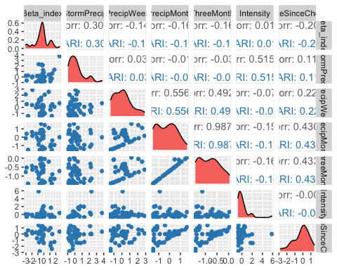

ggsave("SPC_pairs_BETA_CARI.pdf",  
 path = here("Output_from_analysis", "09_Antecedent_Conditions_models", "plots"),  
 width = 10, height = 10)

## Warning: Removed 1 rows containing non-finite values (stat_density).  
## Removed 1 rows containing missing values (geom_point).  
## Removed 1 rows containing missing values (geom_point).  
## Removed 1 rows containing missing values (geom_point).  
## Removed 1 rows containing missing values (geom_point).  
## Removed 1 rows containing missing values (geom_point).  
## Removed 1 rows containing missing values (geom_point).

CARI.model <- lm(Beta_index ~ StormPrecip + PrecipWeek + PrecipMonth + TimeSinceChena, data = HI_FI_SPC_CARI)  
  
vif(CARI.model)

## StormPrecip PrecipWeek PrecipMonth TimeSinceChena   
## 1.019998 1.487969 1.711128 1.240433

plot(CARI.model)

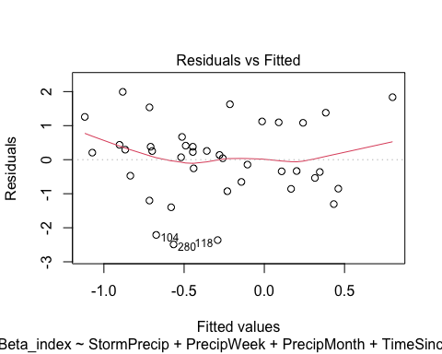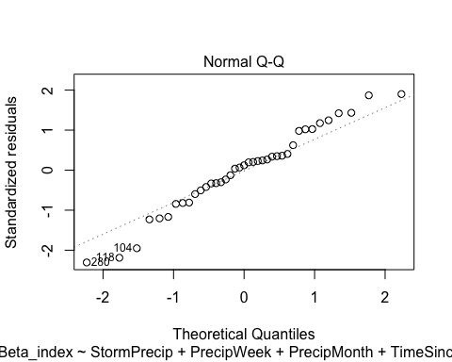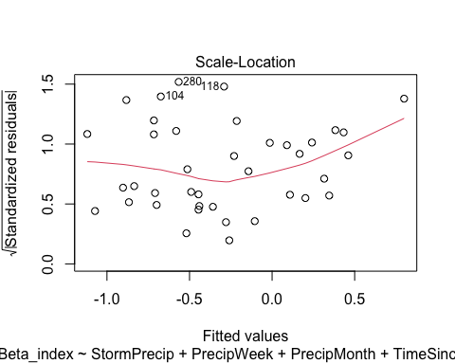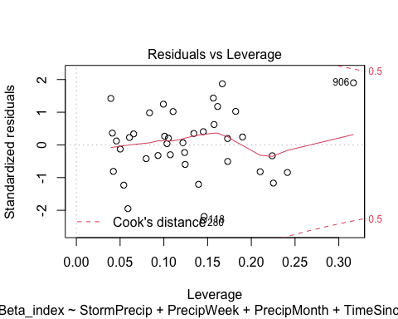

summary(CARI.model)

##   
## Call:  
## lm(formula = Beta_index ~ StormPrecip + PrecipWeek + PrecipMonth +   
## TimeSinceChena, data = HI_FI_SPC_CARI)  
##   
## Residuals:  
## Min 1Q Median 3Q Max   
## -2.4900 -0.5952 0.1383 0.5527 1.9925   
##   
## Coefficients:  
## Estimate Std. Error t value Pr(>|t|)   
## (Intercept) -0.42130 0.20548 -2.050 0.0481 *  
## StormPrecip 0.36796 0.17873 2.059 0.0472 *  
## PrecipWeek -0.10440 0.20581 -0.507 0.6152   
## PrecipMonth -0.01959 0.26762 -0.073 0.9421   
## TimeSinceChena -0.24439 0.21488 -1.137 0.2633   
## ---  
## Signif. codes: 0 '***' 0.001 '**' 0.01 '*' 0.05 '.' 0.1 ' ' 1  
##   
## Residual standard error: 1.168 on 34 degrees of freedom  
## (1 observation deleted due to missingness)  
## Multiple R-squared: 0.1558, Adjusted R-squared: 0.05653   
## F-statistic: 1.569 on 4 and 34 DF, p-value: 0.2049

ggpairs(HI_FI_SPC_POKE,  
 columns = c("Beta_index", "StormPrecip", "PrecipWeek", "PrecipMonth","ThreeMonth", "Intensity", "TimeSinceChena"),  
 ggplot2::aes(color = site.ID))+  
 scale_color_manual(values = c("#6A3D9A"))

## Warning in ggally_statistic(data = data, mapping = mapping, na.rm = na.rm, :  
## Removed 5 rows containing missing values  
  
## Warning in ggally_statistic(data = data, mapping = mapping, na.rm = na.rm, :  
## Removed 5 rows containing missing values  
  
## Warning in ggally_statistic(data = data, mapping = mapping, na.rm = na.rm, :  
## Removed 5 rows containing missing values  
  
## Warning in ggally_statistic(data = data, mapping = mapping, na.rm = na.rm, :  
## Removed 5 rows containing missing values

## Warning in ggally_statistic(data = data, mapping = mapping, na.rm = na.rm, :  
## Removed 6 rows containing missing values

## Warning in ggally_statistic(data = data, mapping = mapping, na.rm = na.rm, :  
## Removing 1 row that contained a missing value  
  
## Warning in ggally_statistic(data = data, mapping = mapping, na.rm = na.rm, :  
## Removing 1 row that contained a missing value  
  
## Warning in ggally_statistic(data = data, mapping = mapping, na.rm = na.rm, :  
## Removing 1 row that contained a missing value  
  
## Warning in ggally_statistic(data = data, mapping = mapping, na.rm = na.rm, :  
## Removing 1 row that contained a missing value

## Warning in ggally_statistic(data = data, mapping = mapping, na.rm = na.rm, :  
## Removed 5 rows containing missing values

## Warning in ggally_statistic(data = data, mapping = mapping, na.rm = na.rm, :  
## Removing 1 row that contained a missing value

## Warning: Removed 5 rows containing non-finite values (stat_density).

## Warning: Removed 5 rows containing missing values (geom_point).  
## Removed 5 rows containing missing values (geom_point).  
## Removed 5 rows containing missing values (geom_point).  
## Removed 5 rows containing missing values (geom_point).

## Warning: Removed 6 rows containing missing values (geom_point).

## Warning: Removed 1 rows containing missing values (geom_point).  
## Removed 1 rows containing missing values (geom_point).  
## Removed 1 rows containing missing values (geom_point).  
## Removed 1 rows containing missing values (geom_point).

## Warning: Removed 1 rows containing non-finite values (stat_density).

## Warning: Removed 5 rows containing missing values (geom_point).

## Warning: Removed 1 rows containing missing values (geom_point).

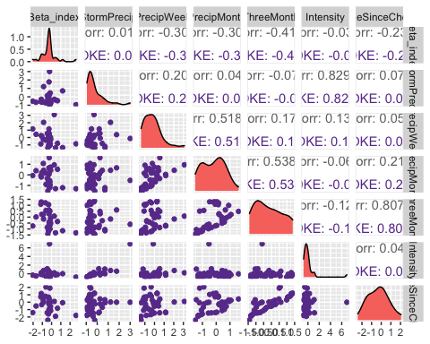

ggsave("SPC_pairs_BETA_POKE.pdf",  
 path = here("Output_from_analysis", "09_Antecedent_Conditions_models", "plots"),  
 width = 10, height = 10)

## Warning: Removed 5 rows containing non-finite values (stat_density).

## Warning: Removed 5 rows containing missing values (geom_point).  
## Removed 5 rows containing missing values (geom_point).  
## Removed 5 rows containing missing values (geom_point).  
## Removed 5 rows containing missing values (geom_point).

## Warning: Removed 6 rows containing missing values (geom_point).

## Warning: Removed 1 rows containing missing values (geom_point).  
## Removed 1 rows containing missing values (geom_point).  
## Removed 1 rows containing missing values (geom_point).  
## Removed 1 rows containing missing values (geom_point).

## Warning: Removed 1 rows containing non-finite values (stat_density).

## Warning: Removed 5 rows containing missing values (geom_point).

## Warning: Removed 1 rows containing missing values (geom_point).

POKE.model <- lm(Beta_index ~ StormPrecip + PrecipWeek + PrecipMonth + TimeSinceChena, data = HI_FI_SPC_POKE)  
  
vif(POKE.model)

## StormPrecip PrecipWeek PrecipMonth TimeSinceChena   
## 1.058856 1.502576 1.505587 1.059268

plot(POKE.model)

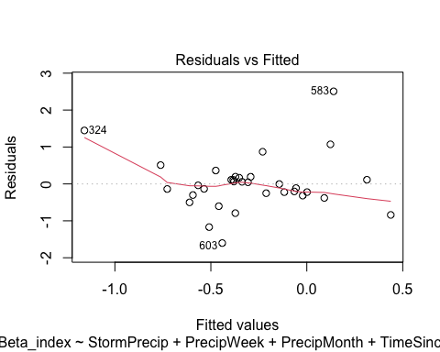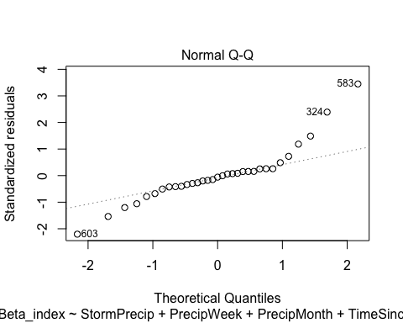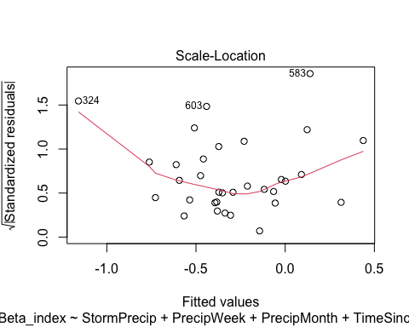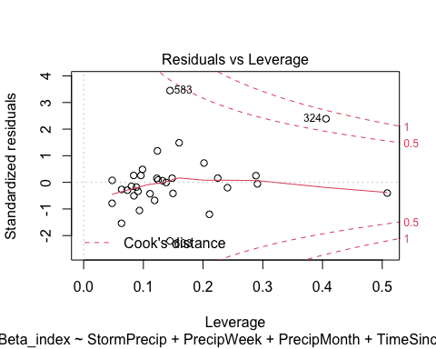

ggpairs(HI_FI_SPC_VAUL,  
 columns = c("Beta_index", "StormPrecip", "PrecipWeek", "PrecipMonth","ThreeMonth", "Intensity", "TimeSinceChena"),  
 ggplot2::aes(color = site.ID))+  
 scale_color_manual(values = c("#E7298A"))

## Warning in ggally_statistic(data = data, mapping = mapping, na.rm = na.rm, :  
## Removed 2 rows containing missing values  
  
## Warning in ggally_statistic(data = data, mapping = mapping, na.rm = na.rm, :  
## Removed 2 rows containing missing values  
  
## Warning in ggally_statistic(data = data, mapping = mapping, na.rm = na.rm, :  
## Removed 2 rows containing missing values  
  
## Warning in ggally_statistic(data = data, mapping = mapping, na.rm = na.rm, :  
## Removed 2 rows containing missing values  
  
## Warning in ggally_statistic(data = data, mapping = mapping, na.rm = na.rm, :  
## Removed 2 rows containing missing values  
  
## Warning in ggally_statistic(data = data, mapping = mapping, na.rm = na.rm, :  
## Removed 2 rows containing missing values

## Warning: Removed 2 rows containing non-finite values (stat_density).

## Warning: Removed 2 rows containing missing values (geom_point).  
## Removed 2 rows containing missing values (geom_point).  
## Removed 2 rows containing missing values (geom_point).  
## Removed 2 rows containing missing values (geom_point).  
## Removed 2 rows containing missing values (geom_point).  
## Removed 2 rows containing missing values (geom_point).

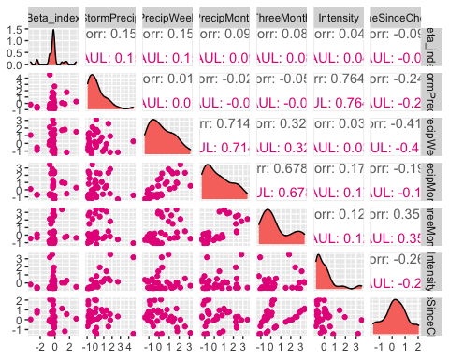

ggsave("SPC_pairs_BETA_VAUL.pdf",  
 path = here("Output_from_analysis", "09_Antecedent_Conditions_models", "plots"),  
 width = 10, height = 10)

## Warning: Removed 2 rows containing non-finite values (stat_density).  
## Removed 2 rows containing missing values (geom_point).  
## Removed 2 rows containing missing values (geom_point).  
## Removed 2 rows containing missing values (geom_point).  
## Removed 2 rows containing missing values (geom_point).  
## Removed 2 rows containing missing values (geom_point).  
## Removed 2 rows containing missing values (geom_point).

VAUL.model <- lm(Beta_index ~ StormPrecip + PrecipWeek + PrecipMonth + TimeSinceChena, data = HI_FI_SPC_VAUL)  
  
vif(VAUL.model)

## StormPrecip PrecipWeek PrecipMonth TimeSinceChena   
## 1.085471 2.648138 2.209356 1.385138

plot(VAUL.model)

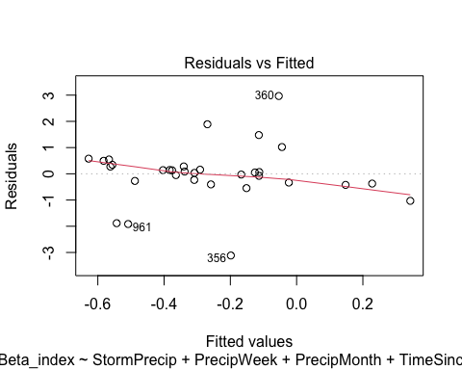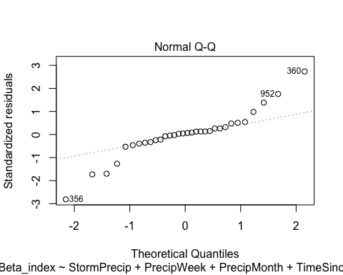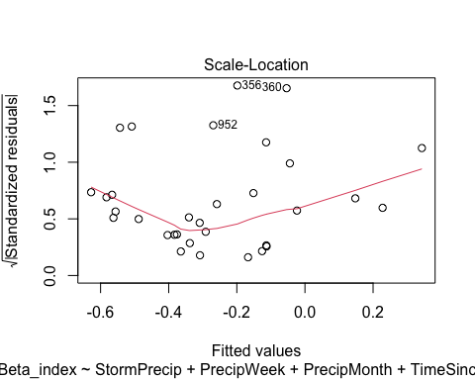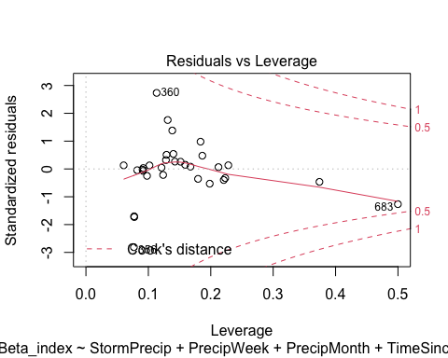 lets log transform

VAUL.model.log <- lm(logBETA ~ StormPrecip + PrecipWeek + PrecipMonth + TimeSinceChena, data = HI_FI_SPC_VAUL)  
  
vif(VAUL.model.log)

## StormPrecip PrecipWeek PrecipMonth TimeSinceChena   
## 1.085471 2.648138 2.209356 1.385138

plot(VAUL.model.log)

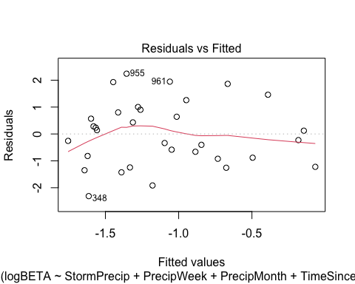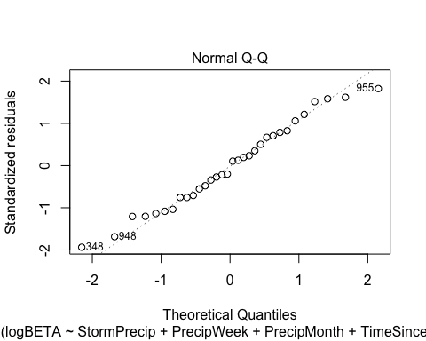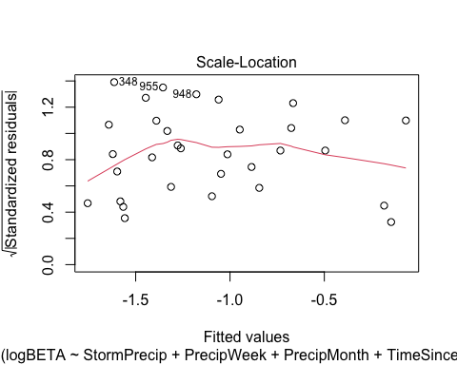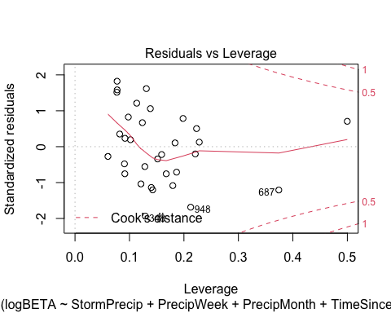

summary(VAUL.model.log)

##   
## Call:  
## lm(formula = logBETA ~ StormPrecip + PrecipWeek + PrecipMonth +   
## TimeSinceChena, data = HI_FI_SPC_VAUL)  
##   
## Residuals:  
## Min 1Q Median 3Q Max   
## -2.31141 -0.89264 -0.05331 0.82582 2.24186   
##   
## Coefficients:  
## Estimate Std. Error t value Pr(>|t|)   
## (Intercept) -1.28214 0.26751 -4.793 5.31e-05 ***  
## StormPrecip 0.08135 0.19741 0.412 0.6835   
## PrecipWeek 0.61661 0.30846 1.999 0.0558 .   
## PrecipMonth -0.35998 0.24332 -1.479 0.1506   
## TimeSinceChena 0.37940 0.28446 1.334 0.1934   
## ---  
## Signif. codes: 0 '***' 0.001 '**' 0.01 '*' 0.05 '.' 0.1 ' ' 1  
##   
## Residual standard error: 1.28 on 27 degrees of freedom  
## (2 observations deleted due to missingness)  
## Multiple R-squared: 0.1371, Adjusted R-squared: 0.00929   
## F-statistic: 1.073 on 4 and 27 DF, p-value: 0.3893

much better

ggpairs(HI_FI_SPC_STRT,  
 columns = c("Beta_index", "StormPrecip", "PrecipWeek", "PrecipMonth","ThreeMonth", "Intensity", "TimeSinceChena"),  
 ggplot2::aes(color = site.ID))+  
 scale_color_manual(values = c("#66C2A5"))

## Warning in ggally_statistic(data = data, mapping = mapping, na.rm = na.rm, :  
## Removed 3 rows containing missing values  
  
## Warning in ggally_statistic(data = data, mapping = mapping, na.rm = na.rm, :  
## Removed 3 rows containing missing values

## Warning in ggally_statistic(data = data, mapping = mapping, na.rm = na.rm, :  
## Removing 1 row that contained a missing value

## Warning in ggally_statistic(data = data, mapping = mapping, na.rm = na.rm, :  
## Removed 3 rows containing missing values

## Warning in ggally_statistic(data = data, mapping = mapping, na.rm = na.rm, :  
## Removing 1 row that contained a missing value  
  
## Warning in ggally_statistic(data = data, mapping = mapping, na.rm = na.rm, :  
## Removing 1 row that contained a missing value

## Warning in ggally_statistic(data = data, mapping = mapping, na.rm = na.rm, :  
## Removed 3 rows containing missing values

## Warning in ggally_statistic(data = data, mapping = mapping, na.rm = na.rm, :  
## Removing 1 row that contained a missing value  
  
## Warning in ggally_statistic(data = data, mapping = mapping, na.rm = na.rm, :  
## Removing 1 row that contained a missing value  
  
## Warning in ggally_statistic(data = data, mapping = mapping, na.rm = na.rm, :  
## Removing 1 row that contained a missing value

## Warning in ggally_statistic(data = data, mapping = mapping, na.rm = na.rm, :  
## Removed 3 rows containing missing values

## Warning in ggally_statistic(data = data, mapping = mapping, na.rm = na.rm, :  
## Removing 1 row that contained a missing value  
  
## Warning in ggally_statistic(data = data, mapping = mapping, na.rm = na.rm, :  
## Removing 1 row that contained a missing value  
  
## Warning in ggally_statistic(data = data, mapping = mapping, na.rm = na.rm, :  
## Removing 1 row that contained a missing value  
  
## Warning in ggally_statistic(data = data, mapping = mapping, na.rm = na.rm, :  
## Removing 1 row that contained a missing value

## Warning in ggally_statistic(data = data, mapping = mapping, na.rm = na.rm, :  
## Removed 3 rows containing missing values

## Warning in ggally_statistic(data = data, mapping = mapping, na.rm = na.rm, :  
## Removing 1 row that contained a missing value  
  
## Warning in ggally_statistic(data = data, mapping = mapping, na.rm = na.rm, :  
## Removing 1 row that contained a missing value  
  
## Warning in ggally_statistic(data = data, mapping = mapping, na.rm = na.rm, :  
## Removing 1 row that contained a missing value  
  
## Warning in ggally_statistic(data = data, mapping = mapping, na.rm = na.rm, :  
## Removing 1 row that contained a missing value  
  
## Warning in ggally_statistic(data = data, mapping = mapping, na.rm = na.rm, :  
## Removing 1 row that contained a missing value

## Warning: Removed 2 rows containing non-finite values (stat_density).

## Warning: Removed 3 rows containing missing values (geom_point).

## Warning: Removed 1 rows containing non-finite values (stat_density).

## Warning: Removed 3 rows containing missing values (geom_point).

## Warning: Removed 1 rows containing missing values (geom_point).

## Warning: Removed 1 rows containing non-finite values (stat_density).

## Warning: Removed 3 rows containing missing values (geom_point).

## Warning: Removed 1 rows containing missing values (geom_point).  
## Removed 1 rows containing missing values (geom_point).

## Warning: Removed 1 rows containing non-finite values (stat_density).

## Warning: Removed 3 rows containing missing values (geom_point).

## Warning: Removed 1 rows containing missing values (geom_point).  
## Removed 1 rows containing missing values (geom_point).  
## Removed 1 rows containing missing values (geom_point).

## Warning: Removed 1 rows containing non-finite values (stat_density).

## Warning: Removed 3 rows containing missing values (geom_point).

## Warning: Removed 1 rows containing missing values (geom_point).  
## Removed 1 rows containing missing values (geom_point).  
## Removed 1 rows containing missing values (geom_point).  
## Removed 1 rows containing missing values (geom_point).

## Warning: Removed 1 rows containing non-finite values (stat_density).

## Warning: Removed 3 rows containing missing values (geom_point).

## Warning: Removed 1 rows containing missing values (geom_point).  
## Removed 1 rows containing missing values (geom_point).  
## Removed 1 rows containing missing values (geom_point).  
## Removed 1 rows containing missing values (geom_point).  
## Removed 1 rows containing missing values (geom_point).

## Warning: Removed 1 rows containing non-finite values (stat_density).

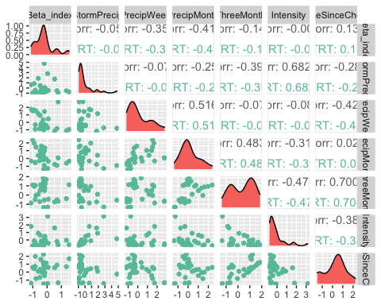

ggsave("SPC_pairs_BETA_VAUL.pdf",  
 path = here("Output_from_analysis", "09_Antecedent_Conditions_models", "plots"),  
 width = 10, height = 10)

## Warning: Removed 2 rows containing non-finite values (stat_density).

## Warning: Removed 3 rows containing missing values (geom_point).

## Warning: Removed 1 rows containing non-finite values (stat_density).

## Warning: Removed 3 rows containing missing values (geom_point).

## Warning: Removed 1 rows containing missing values (geom_point).

## Warning: Removed 1 rows containing non-finite values (stat_density).

## Warning: Removed 3 rows containing missing values (geom_point).

## Warning: Removed 1 rows containing missing values (geom_point).  
## Removed 1 rows containing missing values (geom_point).

## Warning: Removed 1 rows containing non-finite values (stat_density).

## Warning: Removed 3 rows containing missing values (geom_point).

## Warning: Removed 1 rows containing missing values (geom_point).  
## Removed 1 rows containing missing values (geom_point).  
## Removed 1 rows containing missing values (geom_point).

## Warning: Removed 1 rows containing non-finite values (stat_density).

## Warning: Removed 3 rows containing missing values (geom_point).

## Warning: Removed 1 rows containing missing values (geom_point).  
## Removed 1 rows containing missing values (geom_point).  
## Removed 1 rows containing missing values (geom_point).  
## Removed 1 rows containing missing values (geom_point).

## Warning: Removed 1 rows containing non-finite values (stat_density).

## Warning: Removed 3 rows containing missing values (geom_point).

## Warning: Removed 1 rows containing missing values (geom_point).  
## Removed 1 rows containing missing values (geom_point).  
## Removed 1 rows containing missing values (geom_point).  
## Removed 1 rows containing missing values (geom_point).  
## Removed 1 rows containing missing values (geom_point).

## Warning: Removed 1 rows containing non-finite values (stat_density).

STRT.model <- lm(Beta_index ~ StormPrecip + PrecipWeek + PrecipMonth + TimeSinceChena, data = HI_FI_SPC_STRT)  
  
vif(STRT.model)

## StormPrecip PrecipWeek PrecipMonth TimeSinceChena   
## 1.188571 1.860383 1.690349 1.362419

plot(STRT.model)

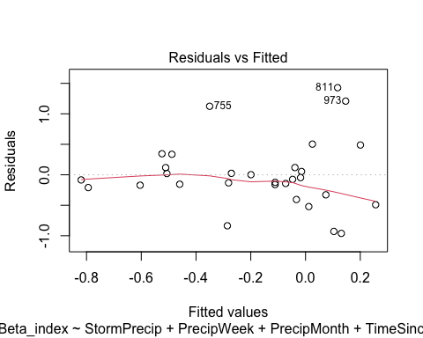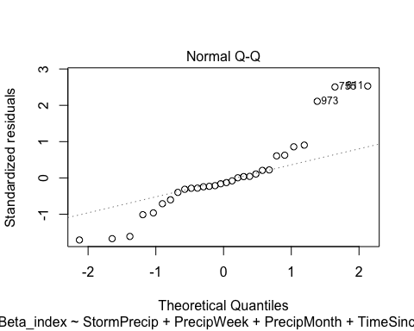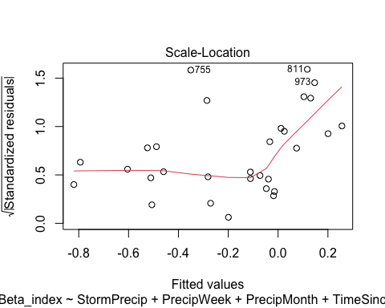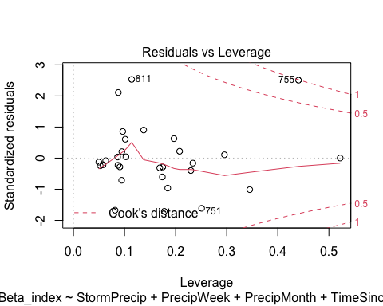

lets log transform

STRT.model.log <- lm(logBETA ~ StormPrecip + PrecipWeek + PrecipMonth + TimeSinceChena, data = HI_FI_SPC_STRT)  
  
vif(STRT.model.log)

## StormPrecip PrecipWeek PrecipMonth TimeSinceChena   
## 1.188571 1.860383 1.690349 1.362419

plot(STRT.model.log)

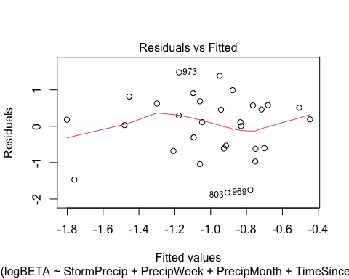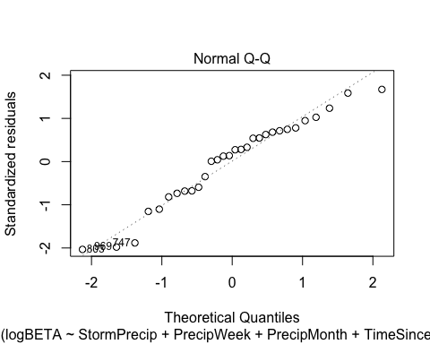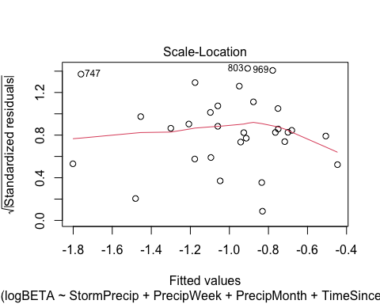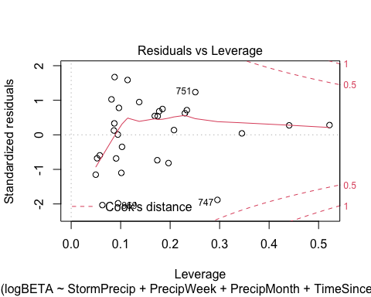

summary(STRT.model.log)

##   
## Call:  
## lm(formula = logBETA ~ StormPrecip + PrecipWeek + PrecipMonth +   
## TimeSinceChena, data = HI_FI_SPC_STRT)  
##   
## Residuals:  
## Min 1Q Median 3Q Max   
## -1.8246 -0.6097 0.1471 0.5776 1.4800   
##   
## Coefficients:  
## Estimate Std. Error t value Pr(>|t|)   
## (Intercept) -1.05825 0.18301 -5.783 5e-06 ***  
## StormPrecip -0.10703 0.14479 -0.739 0.467   
## PrecipWeek 0.26813 0.22211 1.207 0.239   
## PrecipMonth -0.02412 0.23830 -0.101 0.920   
## TimeSinceChena 0.16165 0.20245 0.798 0.432   
## ---  
## Signif. codes: 0 '***' 0.001 '**' 0.01 '*' 0.05 '.' 0.1 ' ' 1  
##   
## Residual standard error: 0.9271 on 25 degrees of freedom  
## (3 observations deleted due to missingness)  
## Multiple R-squared: 0.1236, Adjusted R-squared: -0.01661   
## F-statistic: 0.8816 on 4 and 25 DF, p-value: 0.4891

Plot_1 <- plot_summs(MOOS.model, FRCH.model,   
 CARI.model, POKE.model,   
 VAUL.model, STRT.model, scale = TRUE,  
 model.names = c("MOOS", "FRCH", "CARI", "POKE", "VAUL", "STRT"),  
 colors = c("#A6761D", "#FF7F00","#3288BD", "#6A3D9A", "#E7298A", "#66C2A5"))

## Loading required namespace: broom.mixed  
## Loading required namespace: broom.mixed  
## Loading required namespace: broom.mixed  
## Loading required namespace: broom.mixed  
## Loading required namespace: broom.mixed  
## Loading required namespace: broom.mixed

SPC_beta <- Plot_1 +   
 xlab("Coefficient estimate") + ylab("") +  
 geom_vline(xintercept = 0,  
 colour = "grey80",  
 linetype = 1) +  
scale_y_discrete(labels= c("Seasonality",   
 "Precipitation Month",   
 "Precipitation Week",  
 "Storm Precipitation")) +  
 theme_bw()   
  
ggsave("BETA_SPC.pdf",  
 path = here("plots", "Coefficient_Plots", "HI"),  
 width = 7, height = 7)

### turb

# correlation   
turb_data <- HI_FI_turb[,c("Beta_index", "site.ID", "StormPrecip", "PrecipWeek", "PrecipMonth", "ThreeMonth", "Intensity", "TimeSinceChena", "pf", "burn", "year")]  
turb_data <- na.omit(turb_data) # 244 to 236 rows   
  
HI_FI_turb$logBETA <- log(abs(HI_FI_turb$Beta_index))  
  
ggpairs(turb_data,  
 columns = c("Beta_index", "StormPrecip", "PrecipWeek", "PrecipMonth","ThreeMonth", "Intensity", "TimeSinceChena"),  
 ggplot2::aes(color = site.ID))+  
 scale_color_manual(values = c("#3288BD", "#FF7F00","#A6761D", "#6A3D9A", "#66C2A5", "#E7298A"))

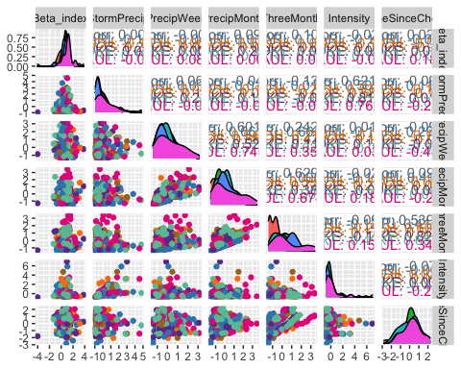

ggsave("turb_pairs_BETA.pdf",  
 path = here("Output_from_analysis", "09_Antecedent_Conditions_models", "plots"),  
 width = 10, height = 10)

HI_FI_turb_MOOS <- subset(HI_FI_turb, site.ID == "MOOS")  
HI_FI_turb_FRCH <- subset(HI_FI_turb, site.ID == "FRCH")  
HI_FI_turb_CARI <- subset(HI_FI_turb, site.ID == "CARI")  
HI_FI_turb_POKE <- subset(HI_FI_turb, site.ID == "POKE")  
HI_FI_turb_VAUL <- subset(HI_FI_turb, site.ID == "VAUL")  
HI_FI_turb_STRT <- subset(HI_FI_turb, site.ID == "STRT")

ggpairs(HI_FI_turb_MOOS,  
 columns = c("Beta_index", "StormPrecip", "PrecipWeek", "PrecipMonth","ThreeMonth", "Intensity", "TimeSinceChena"),  
 ggplot2::aes(color = site.ID))+  
 scale_color_manual(values = c("#A6761D"))

## Warning in ggally_statistic(data = data, mapping = mapping, na.rm = na.rm, :  
## Removing 1 row that contained a missing value  
  
## Warning in ggally_statistic(data = data, mapping = mapping, na.rm = na.rm, :  
## Removing 1 row that contained a missing value  
  
## Warning in ggally_statistic(data = data, mapping = mapping, na.rm = na.rm, :  
## Removing 1 row that contained a missing value  
  
## Warning in ggally_statistic(data = data, mapping = mapping, na.rm = na.rm, :  
## Removing 1 row that contained a missing value  
  
## Warning in ggally_statistic(data = data, mapping = mapping, na.rm = na.rm, :  
## Removing 1 row that contained a missing value  
  
## Warning in ggally_statistic(data = data, mapping = mapping, na.rm = na.rm, :  
## Removing 1 row that contained a missing value

## Warning: Removed 1 rows containing non-finite values (stat_density).

## Warning: Removed 1 rows containing missing values (geom_point).  
## Removed 1 rows containing missing values (geom_point).  
## Removed 1 rows containing missing values (geom_point).  
## Removed 1 rows containing missing values (geom_point).  
## Removed 1 rows containing missing values (geom_point).  
## Removed 1 rows containing missing values (geom_point).

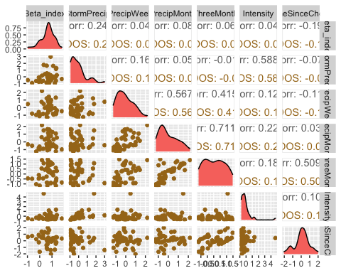

ggsave("turb_pairs_BETA_MOOS.pdf",  
 path = here("Output_from_analysis", "09_Antecedent_Conditions_models", "plots"),  
 width = 10, height = 10)

## Warning: Removed 1 rows containing non-finite values (stat_density).  
## Removed 1 rows containing missing values (geom_point).  
## Removed 1 rows containing missing values (geom_point).  
## Removed 1 rows containing missing values (geom_point).  
## Removed 1 rows containing missing values (geom_point).  
## Removed 1 rows containing missing values (geom_point).  
## Removed 1 rows containing missing values (geom_point).

MOOS.model <- lm(Beta_index ~ StormPrecip + PrecipWeek + PrecipMonth + TimeSinceChena, data = HI_FI_turb_MOOS)  
  
vif(MOOS.model)

## StormPrecip PrecipWeek PrecipMonth TimeSinceChena   
## 1.041982 1.531344 1.488314 1.032331

plot(MOOS.model)

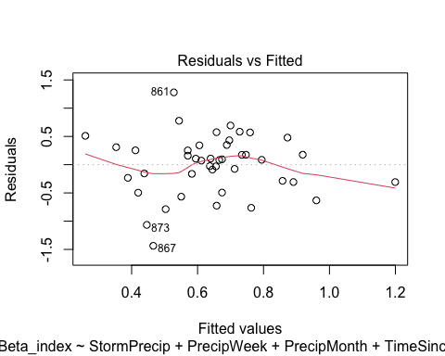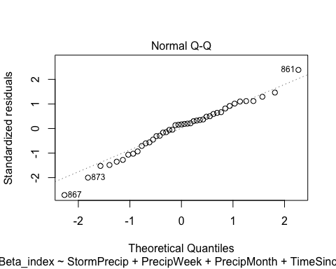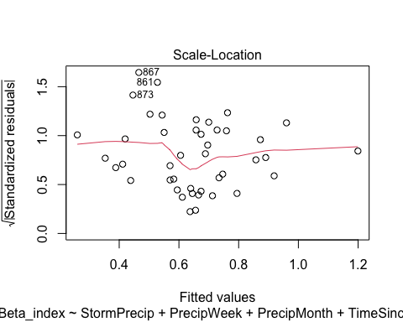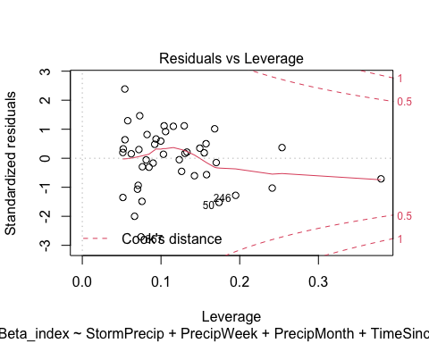

summary(MOOS.model)

##   
## Call:  
## lm(formula = Beta_index ~ StormPrecip + PrecipWeek + PrecipMonth +   
## TimeSinceChena, data = HI_FI_turb_MOOS)  
##   
## Residuals:  
## Min 1Q Median 3Q Max   
## -1.43658 -0.29703 0.08618 0.32580 1.27971   
##   
## Coefficients:  
## Estimate Std. Error t value Pr(>|t|)   
## (Intercept) 0.66473 0.08521 7.801 2.08e-09 ***  
## StormPrecip 0.14655 0.09802 1.495 0.143   
## PrecipWeek -0.05804 0.12926 -0.449 0.656   
## PrecipMonth 0.07709 0.11426 0.675 0.504   
## TimeSinceChena -0.12264 0.10041 -1.221 0.229   
## ---  
## Signif. codes: 0 '***' 0.001 '**' 0.01 '*' 0.05 '.' 0.1 ' ' 1  
##   
## Residual standard error: 0.5515 on 38 degrees of freedom  
## (1 observation deleted due to missingness)  
## Multiple R-squared: 0.1025, Adjusted R-squared: 0.008078   
## F-statistic: 1.086 on 4 and 38 DF, p-value: 0.3774

ggpairs(HI_FI_turb_FRCH,  
 columns = c("Beta_index", "StormPrecip", "PrecipWeek", "PrecipMonth","ThreeMonth", "Intensity", "TimeSinceChena"),  
 ggplot2::aes(color = site.ID))+  
 scale_color_manual(values = c("#FF7F00"))

## Warning in ggally_statistic(data = data, mapping = mapping, na.rm = na.rm, :  
## Removing 1 row that contained a missing value  
  
## Warning in ggally_statistic(data = data, mapping = mapping, na.rm = na.rm, :  
## Removing 1 row that contained a missing value  
  
## Warning in ggally_statistic(data = data, mapping = mapping, na.rm = na.rm, :  
## Removing 1 row that contained a missing value  
  
## Warning in ggally_statistic(data = data, mapping = mapping, na.rm = na.rm, :  
## Removing 1 row that contained a missing value

## Warning in ggally_statistic(data = data, mapping = mapping, na.rm = na.rm, :  
## Removed 2 rows containing missing values

## Warning in ggally_statistic(data = data, mapping = mapping, na.rm = na.rm, :  
## Removing 1 row that contained a missing value  
  
## Warning in ggally_statistic(data = data, mapping = mapping, na.rm = na.rm, :  
## Removing 1 row that contained a missing value  
  
## Warning in ggally_statistic(data = data, mapping = mapping, na.rm = na.rm, :  
## Removing 1 row that contained a missing value  
  
## Warning in ggally_statistic(data = data, mapping = mapping, na.rm = na.rm, :  
## Removing 1 row that contained a missing value  
  
## Warning in ggally_statistic(data = data, mapping = mapping, na.rm = na.rm, :  
## Removing 1 row that contained a missing value  
  
## Warning in ggally_statistic(data = data, mapping = mapping, na.rm = na.rm, :  
## Removing 1 row that contained a missing value

## Warning: Removed 1 rows containing non-finite values (stat_density).

## Warning: Removed 1 rows containing missing values (geom_point).  
## Removed 1 rows containing missing values (geom_point).  
## Removed 1 rows containing missing values (geom_point).  
## Removed 1 rows containing missing values (geom_point).

## Warning: Removed 2 rows containing missing values (geom_point).

## Warning: Removed 1 rows containing missing values (geom_point).  
## Removed 1 rows containing missing values (geom_point).  
## Removed 1 rows containing missing values (geom_point).  
## Removed 1 rows containing missing values (geom_point).

## Warning: Removed 1 rows containing non-finite values (stat_density).

## Warning: Removed 1 rows containing missing values (geom_point).  
## Removed 1 rows containing missing values (geom_point).

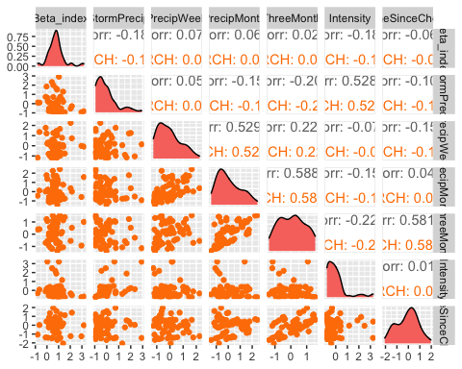

ggsave("turb_pairs_BETA_FRCH.pdf",  
 path = here("Output_from_analysis", "09_Antecedent_Conditions_models", "plots"),  
 width = 10, height = 10)

## Warning: Removed 1 rows containing non-finite values (stat_density).  
## Removed 1 rows containing missing values (geom_point).  
## Removed 1 rows containing missing values (geom_point).  
## Removed 1 rows containing missing values (geom_point).  
## Removed 1 rows containing missing values (geom_point).

## Warning: Removed 2 rows containing missing values (geom_point).

## Warning: Removed 1 rows containing missing values (geom_point).  
## Removed 1 rows containing missing values (geom_point).  
## Removed 1 rows containing missing values (geom_point).  
## Removed 1 rows containing missing values (geom_point).

## Warning: Removed 1 rows containing non-finite values (stat_density).

## Warning: Removed 1 rows containing missing values (geom_point).  
## Removed 1 rows containing missing values (geom_point).

FRCH.model <- lm(Beta_index ~ StormPrecip + PrecipWeek + PrecipMonth + TimeSinceChena, data = HI_FI_turb_FRCH)  
  
vif(FRCH.model)

## StormPrecip PrecipWeek PrecipMonth TimeSinceChena   
## 1.052652 1.551590 1.547921 1.063944

plot(FRCH.model)

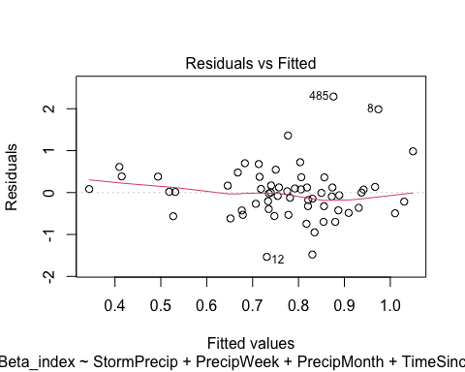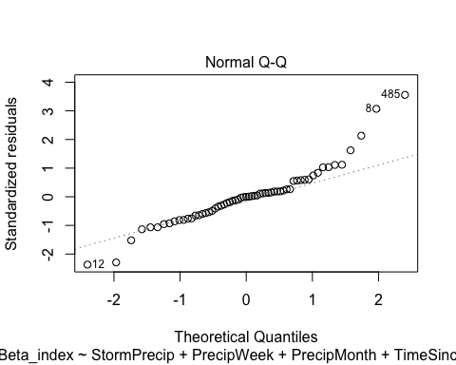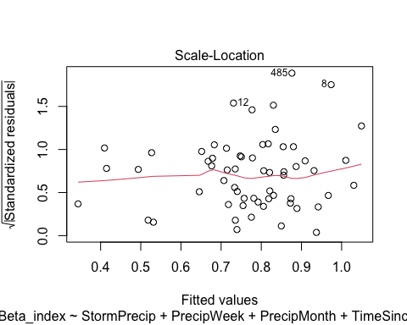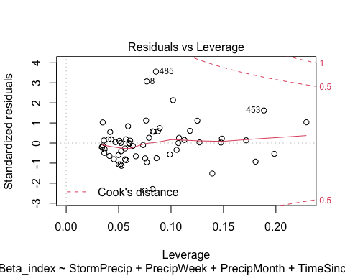 lets loog transform

FRCH.model.log <- lm(logBETA ~ StormPrecip + PrecipWeek + PrecipMonth + TimeSinceChena, data = HI_FI_turb_FRCH)  
  
vif(FRCH.model.log)

## StormPrecip PrecipWeek PrecipMonth TimeSinceChena   
## 1.052652 1.551590 1.547921 1.063944

plot(FRCH.model.log)

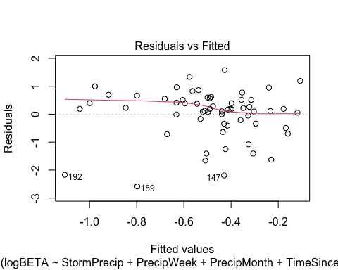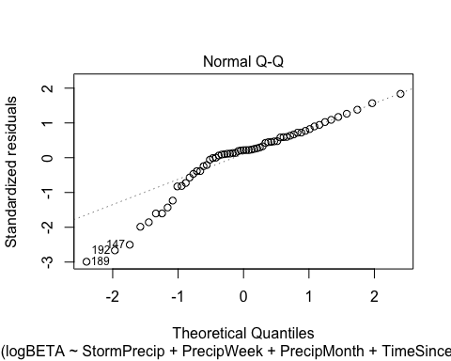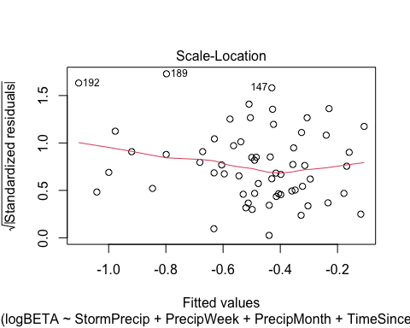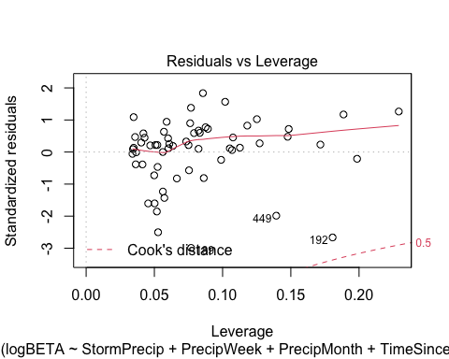 may need further transformation

ggpairs(HI_FI_turb_CARI,  
 columns = c("Beta_index", "StormPrecip", "PrecipWeek", "PrecipMonth","ThreeMonth", "Intensity", "TimeSinceChena"),  
 ggplot2::aes(color = site.ID))+  
 scale_color_manual(values = c("#3288BD"))

## Warning in ggally_statistic(data = data, mapping = mapping, na.rm = na.rm, :  
## Removing 1 row that contained a missing value  
  
## Warning in ggally_statistic(data = data, mapping = mapping, na.rm = na.rm, :  
## Removing 1 row that contained a missing value  
  
## Warning in ggally_statistic(data = data, mapping = mapping, na.rm = na.rm, :  
## Removing 1 row that contained a missing value  
  
## Warning in ggally_statistic(data = data, mapping = mapping, na.rm = na.rm, :  
## Removing 1 row that contained a missing value  
  
## Warning in ggally_statistic(data = data, mapping = mapping, na.rm = na.rm, :  
## Removing 1 row that contained a missing value  
  
## Warning in ggally_statistic(data = data, mapping = mapping, na.rm = na.rm, :  
## Removing 1 row that contained a missing value

## Warning: Removed 1 rows containing non-finite values (stat_density).

## Warning: Removed 1 rows containing missing values (geom_point).  
## Removed 1 rows containing missing values (geom_point).  
## Removed 1 rows containing missing values (geom_point).  
## Removed 1 rows containing missing values (geom_point).  
## Removed 1 rows containing missing values (geom_point).  
## Removed 1 rows containing missing values (geom_point).

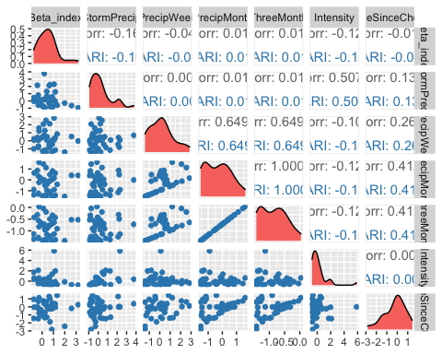

ggsave("turb_pairs_BETA_CARI.pdf",  
 path = here("Output_from_analysis", "09_Antecedent_Conditions_models", "plots"),  
 width = 10, height = 10)

## Warning: Removed 1 rows containing non-finite values (stat_density).  
## Removed 1 rows containing missing values (geom_point).  
## Removed 1 rows containing missing values (geom_point).  
## Removed 1 rows containing missing values (geom_point).  
## Removed 1 rows containing missing values (geom_point).  
## Removed 1 rows containing missing values (geom_point).  
## Removed 1 rows containing missing values (geom_point).

CARI.model <- lm(Beta_index ~ StormPrecip + PrecipWeek + PrecipMonth + TimeSinceChena, data = HI_FI_turb_CARI)  
  
vif(CARI.model)

## StormPrecip PrecipWeek PrecipMonth TimeSinceChena   
## 1.015206 1.777952 1.952014 1.222154

plot(CARI.model)

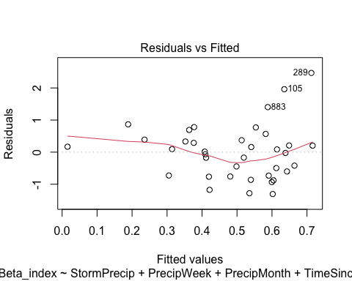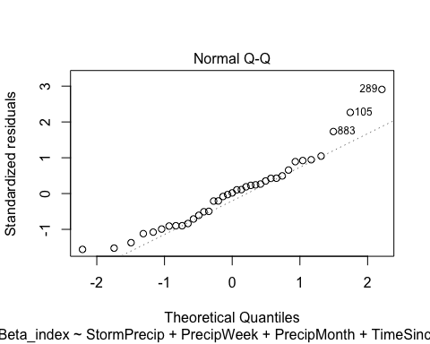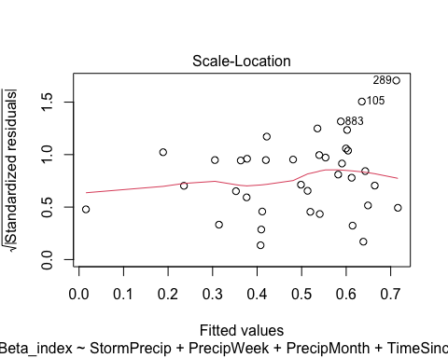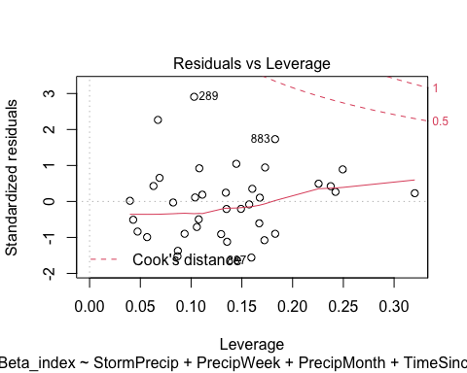

summary(CARI.model)

##   
## Call:  
## lm(formula = Beta_index ~ StormPrecip + PrecipWeek + PrecipMonth +   
## TimeSinceChena, data = HI_FI_turb_CARI)  
##   
## Residuals:  
## Min 1Q Median 3Q Max   
## -1.30556 -0.72801 0.01631 0.37207 2.46866   
##   
## Coefficients:  
## Estimate Std. Error t value Pr(>|t|)   
## (Intercept) 0.558719 0.174882 3.195 0.00314 **  
## StormPrecip -0.131750 0.138482 -0.951 0.34854   
## PrecipWeek -0.068270 0.177250 -0.385 0.70267   
## PrecipMonth 0.067062 0.226150 0.297 0.76873   
## TimeSinceChena 0.001445 0.165301 0.009 0.99308   
## ---  
## Signif. codes: 0 '***' 0.001 '**' 0.01 '*' 0.05 '.' 0.1 ' ' 1  
##   
## Residual standard error: 0.896 on 32 degrees of freedom  
## (1 observation deleted due to missingness)  
## Multiple R-squared: 0.03264, Adjusted R-squared: -0.08828   
## F-statistic: 0.2699 on 4 and 32 DF, p-value: 0.8952

ggpairs(HI_FI_turb_POKE,  
 columns = c("Beta_index", "StormPrecip", "PrecipWeek", "PrecipMonth","ThreeMonth", "Intensity", "TimeSinceChena"),  
 ggplot2::aes(color = site.ID))+  
 scale_color_manual(values = c("#6A3D9A"))

## Warning in ggally_statistic(data = data, mapping = mapping, na.rm = na.rm, :  
## Removed 3 rows containing missing values  
  
## Warning in ggally_statistic(data = data, mapping = mapping, na.rm = na.rm, :  
## Removed 3 rows containing missing values  
  
## Warning in ggally_statistic(data = data, mapping = mapping, na.rm = na.rm, :  
## Removed 3 rows containing missing values  
  
## Warning in ggally_statistic(data = data, mapping = mapping, na.rm = na.rm, :  
## Removed 3 rows containing missing values

## Warning in ggally_statistic(data = data, mapping = mapping, na.rm = na.rm, :  
## Removed 4 rows containing missing values

## Warning in ggally_statistic(data = data, mapping = mapping, na.rm = na.rm, :  
## Removing 1 row that contained a missing value  
  
## Warning in ggally_statistic(data = data, mapping = mapping, na.rm = na.rm, :  
## Removing 1 row that contained a missing value  
  
## Warning in ggally_statistic(data = data, mapping = mapping, na.rm = na.rm, :  
## Removing 1 row that contained a missing value  
  
## Warning in ggally_statistic(data = data, mapping = mapping, na.rm = na.rm, :  
## Removing 1 row that contained a missing value

## Warning in ggally_statistic(data = data, mapping = mapping, na.rm = na.rm, :  
## Removed 3 rows containing missing values

## Warning in ggally_statistic(data = data, mapping = mapping, na.rm = na.rm, :  
## Removing 1 row that contained a missing value

## Warning: Removed 3 rows containing non-finite values (stat_density).

## Warning: Removed 3 rows containing missing values (geom_point).  
## Removed 3 rows containing missing values (geom_point).  
## Removed 3 rows containing missing values (geom_point).  
## Removed 3 rows containing missing values (geom_point).

## Warning: Removed 4 rows containing missing values (geom_point).

## Warning: Removed 1 rows containing missing values (geom_point).  
## Removed 1 rows containing missing values (geom_point).  
## Removed 1 rows containing missing values (geom_point).  
## Removed 1 rows containing missing values (geom_point).

## Warning: Removed 1 rows containing non-finite values (stat_density).

## Warning: Removed 3 rows containing missing values (geom_point).

## Warning: Removed 1 rows containing missing values (geom_point).

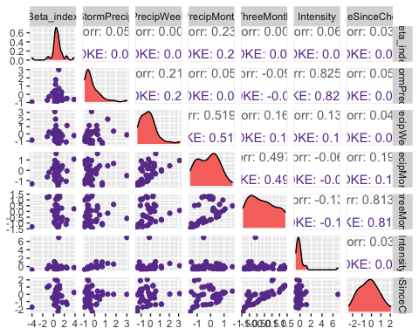

ggsave("turb_pairs_BETA_POKE.pdf",  
 path = here("Output_from_analysis", "09_Antecedent_Conditions_models", "plots"),  
 width = 10, height = 10)

## Warning: Removed 3 rows containing non-finite values (stat_density).

## Warning: Removed 3 rows containing missing values (geom_point).  
## Removed 3 rows containing missing values (geom_point).  
## Removed 3 rows containing missing values (geom_point).  
## Removed 3 rows containing missing values (geom_point).

## Warning: Removed 4 rows containing missing values (geom_point).

## Warning: Removed 1 rows containing missing values (geom_point).  
## Removed 1 rows containing missing values (geom_point).  
## Removed 1 rows containing missing values (geom_point).  
## Removed 1 rows containing missing values (geom_point).

## Warning: Removed 1 rows containing non-finite values (stat_density).

## Warning: Removed 3 rows containing missing values (geom_point).

## Warning: Removed 1 rows containing missing values (geom_point).

POKE.model <- lm(Beta_index ~ StormPrecip + PrecipWeek + PrecipMonth + TimeSinceChena, data = HI_FI_turb_POKE)  
  
vif(POKE.model)

## StormPrecip PrecipWeek PrecipMonth TimeSinceChena   
## 1.057505 1.503184 1.481290 1.032551

plot(POKE.model)

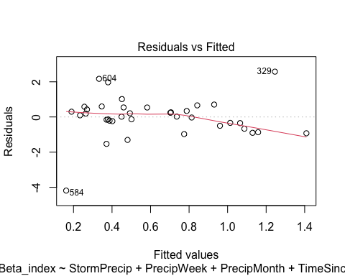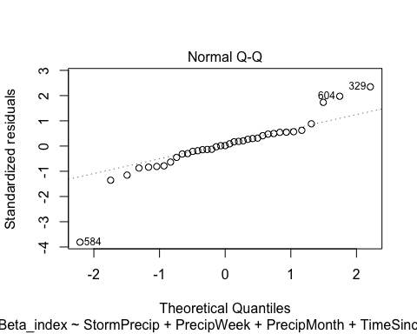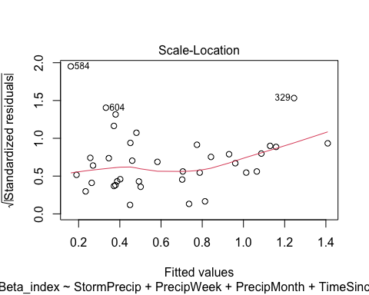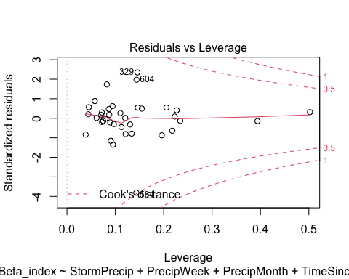 log transform

POKE.model.log <- lm(logBETA ~ StormPrecip + PrecipWeek + PrecipMonth + TimeSinceChena, data = HI_FI_turb_POKE)  
  
vif(POKE.model.log)

## StormPrecip PrecipWeek PrecipMonth TimeSinceChena   
## 1.057505 1.503184 1.481290 1.032551

plot(POKE.model.log)

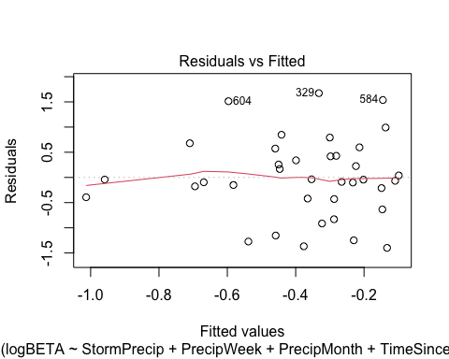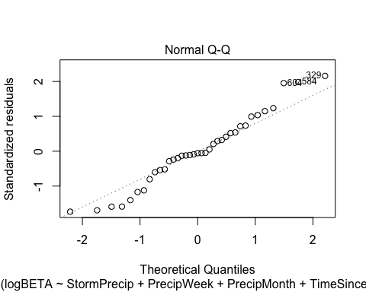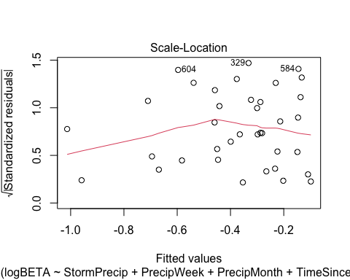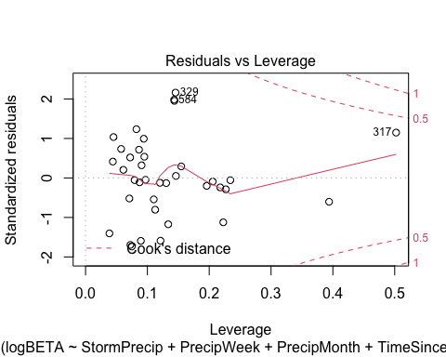

summary(POKE.model.log)

##   
## Call:  
## lm(formula = logBETA ~ StormPrecip + PrecipWeek + PrecipMonth +   
## TimeSinceChena, data = HI_FI_turb_POKE)  
##   
## Residuals:  
## Min 1Q Median 3Q Max   
## -1.39926 -0.41967 -0.04391 0.42886 1.67344   
##   
## Coefficients:  
## Estimate Std. Error t value Pr(>|t|)   
## (Intercept) -0.428627 0.147806 -2.900 0.00669 **  
## StormPrecip -0.103865 0.178015 -0.583 0.56367   
## PrecipWeek -0.194601 0.182363 -1.067 0.29391   
## PrecipMonth -0.011484 0.221078 -0.052 0.95890   
## TimeSinceChena -0.003078 0.132368 -0.023 0.98159   
## ---  
## Signif. codes: 0 '***' 0.001 '**' 0.01 '*' 0.05 '.' 0.1 ' ' 1  
##   
## Residual standard error: 0.838 on 32 degrees of freedom  
## (3 observations deleted due to missingness)  
## Multiple R-squared: 0.07376, Adjusted R-squared: -0.04202   
## F-statistic: 0.6371 on 4 and 32 DF, p-value: 0.6398

ggpairs(HI_FI_turb_VAUL,  
 columns = c("Beta_index", "StormPrecip", "PrecipWeek", "PrecipMonth","ThreeMonth", "Intensity", "TimeSinceChena"),  
 ggplot2::aes(color = site.ID))+  
 scale_color_manual(values = c("#E7298A"))

## Warning in ggally_statistic(data = data, mapping = mapping, na.rm = na.rm, :  
## Removed 2 rows containing missing values  
  
## Warning in ggally_statistic(data = data, mapping = mapping, na.rm = na.rm, :  
## Removed 2 rows containing missing values  
  
## Warning in ggally_statistic(data = data, mapping = mapping, na.rm = na.rm, :  
## Removed 2 rows containing missing values  
  
## Warning in ggally_statistic(data = data, mapping = mapping, na.rm = na.rm, :  
## Removed 2 rows containing missing values  
  
## Warning in ggally_statistic(data = data, mapping = mapping, na.rm = na.rm, :  
## Removed 2 rows containing missing values  
  
## Warning in ggally_statistic(data = data, mapping = mapping, na.rm = na.rm, :  
## Removed 2 rows containing missing values

## Warning: Removed 2 rows containing non-finite values (stat_density).

## Warning: Removed 2 rows containing missing values (geom_point).  
## Removed 2 rows containing missing values (geom_point).  
## Removed 2 rows containing missing values (geom_point).  
## Removed 2 rows containing missing values (geom_point).  
## Removed 2 rows containing missing values (geom_point).  
## Removed 2 rows containing missing values (geom_point).

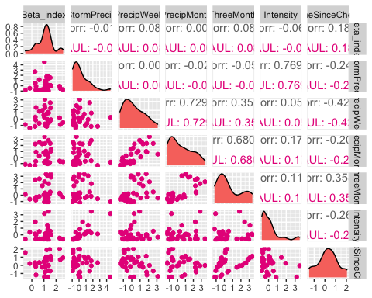

ggsave("turb_pairs_BETA_VAUL.pdf",  
 path = here("Output_from_analysis", "09_Antecedent_Conditions_models", "plots"),  
 width = 10, height = 10)

## Warning: Removed 2 rows containing non-finite values (stat_density).  
## Removed 2 rows containing missing values (geom_point).  
## Removed 2 rows containing missing values (geom_point).  
## Removed 2 rows containing missing values (geom_point).  
## Removed 2 rows containing missing values (geom_point).  
## Removed 2 rows containing missing values (geom_point).  
## Removed 2 rows containing missing values (geom_point).

VAUL.model <- lm(Beta_index ~ StormPrecip + PrecipWeek + PrecipMonth + TimeSinceChena, data = HI_FI_turb_VAUL)  
  
vif(VAUL.model)

## StormPrecip PrecipWeek PrecipMonth TimeSinceChena   
## 1.086667 2.796671 2.327722 1.397647

plot(VAUL.model)

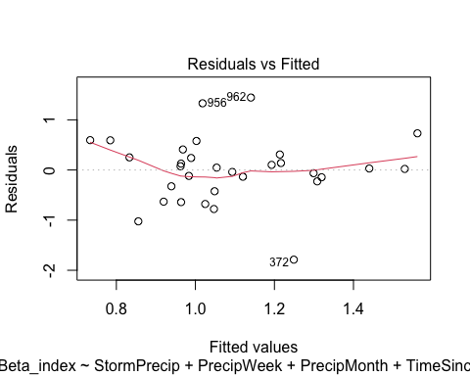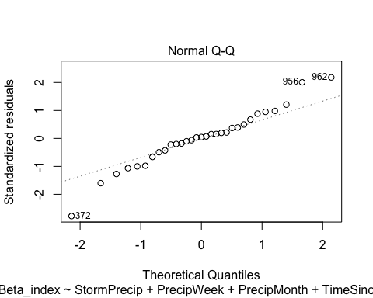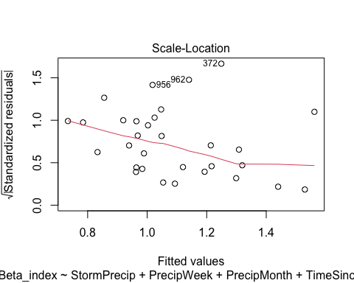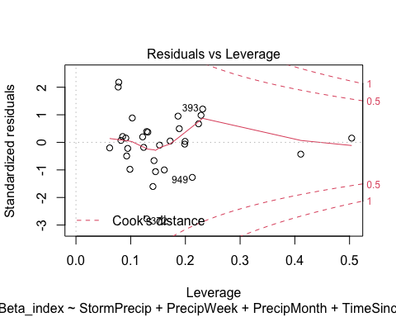

summary(VAUL.model)

##   
## Call:  
## lm(formula = Beta_index ~ StormPrecip + PrecipWeek + PrecipMonth +   
## TimeSinceChena, data = HI_FI_turb_VAUL)  
##   
## Residuals:  
## Min 1Q Median 3Q Max   
## -1.78773 -0.27593 0.02972 0.27993 1.44412   
##   
## Coefficients:  
## Estimate Std. Error t value Pr(>|t|)   
## (Intercept) 0.99710 0.14481 6.885 2.61e-07 ***  
## StormPrecip 0.03464 0.10649 0.325 0.748   
## PrecipWeek 0.21585 0.17371 1.243 0.225   
## PrecipMonth -0.09968 0.13465 -0.740 0.466   
## TimeSinceChena 0.22819 0.15412 1.481 0.151   
## ---  
## Signif. codes: 0 '***' 0.001 '**' 0.01 '*' 0.05 '.' 0.1 ' ' 1  
##   
## Residual standard error: 0.6901 on 26 degrees of freedom  
## (2 observations deleted due to missingness)  
## Multiple R-squared: 0.09187, Adjusted R-squared: -0.04784   
## F-statistic: 0.6576 on 4 and 26 DF, p-value: 0.6269

log transform

VAUL.model.log <- lm(logBETA ~ StormPrecip + PrecipWeek + PrecipMonth + TimeSinceChena, data = HI_FI_turb_POKE)  
  
vif(VAUL.model.log)

## StormPrecip PrecipWeek PrecipMonth TimeSinceChena   
## 1.057505 1.503184 1.481290 1.032551

plot(VAUL.model.log)

 looks worse

ggpairs(HI_FI_turb_STRT,  
 columns = c("Beta_index", "StormPrecip", "PrecipWeek", "PrecipMonth","ThreeMonth", "Intensity", "TimeSinceChena"),  
 ggplot2::aes(color = site.ID))+  
 scale_color_manual(values = c("#66C2A5"))

## Warning in ggally_statistic(data = data, mapping = mapping, na.rm = na.rm, :  
## Removed 3 rows containing missing values  
  
## Warning in ggally_statistic(data = data, mapping = mapping, na.rm = na.rm, :  
## Removed 3 rows containing missing values

## Warning in ggally_statistic(data = data, mapping = mapping, na.rm = na.rm, :  
## Removing 1 row that contained a missing value

## Warning in ggally_statistic(data = data, mapping = mapping, na.rm = na.rm, :  
## Removed 3 rows containing missing values

## Warning in ggally_statistic(data = data, mapping = mapping, na.rm = na.rm, :  
## Removing 1 row that contained a missing value  
  
## Warning in ggally_statistic(data = data, mapping = mapping, na.rm = na.rm, :  
## Removing 1 row that contained a missing value

## Warning in ggally_statistic(data = data, mapping = mapping, na.rm = na.rm, :  
## Removed 3 rows containing missing values

## Warning in ggally_statistic(data = data, mapping = mapping, na.rm = na.rm, :  
## Removing 1 row that contained a missing value  
  
## Warning in ggally_statistic(data = data, mapping = mapping, na.rm = na.rm, :  
## Removing 1 row that contained a missing value  
  
## Warning in ggally_statistic(data = data, mapping = mapping, na.rm = na.rm, :  
## Removing 1 row that contained a missing value

## Warning in ggally_statistic(data = data, mapping = mapping, na.rm = na.rm, :  
## Removed 3 rows containing missing values

## Warning in ggally_statistic(data = data, mapping = mapping, na.rm = na.rm, :  
## Removing 1 row that contained a missing value  
  
## Warning in ggally_statistic(data = data, mapping = mapping, na.rm = na.rm, :  
## Removing 1 row that contained a missing value  
  
## Warning in ggally_statistic(data = data, mapping = mapping, na.rm = na.rm, :  
## Removing 1 row that contained a missing value  
  
## Warning in ggally_statistic(data = data, mapping = mapping, na.rm = na.rm, :  
## Removing 1 row that contained a missing value

## Warning in ggally_statistic(data = data, mapping = mapping, na.rm = na.rm, :  
## Removed 3 rows containing missing values

## Warning in ggally_statistic(data = data, mapping = mapping, na.rm = na.rm, :  
## Removing 1 row that contained a missing value  
  
## Warning in ggally_statistic(data = data, mapping = mapping, na.rm = na.rm, :  
## Removing 1 row that contained a missing value  
  
## Warning in ggally_statistic(data = data, mapping = mapping, na.rm = na.rm, :  
## Removing 1 row that contained a missing value  
  
## Warning in ggally_statistic(data = data, mapping = mapping, na.rm = na.rm, :  
## Removing 1 row that contained a missing value  
  
## Warning in ggally_statistic(data = data, mapping = mapping, na.rm = na.rm, :  
## Removing 1 row that contained a missing value

## Warning: Removed 2 rows containing non-finite values (stat_density).

## Warning: Removed 3 rows containing missing values (geom_point).

## Warning: Removed 1 rows containing non-finite values (stat_density).

## Warning: Removed 3 rows containing missing values (geom_point).

## Warning: Removed 1 rows containing missing values (geom_point).

## Warning: Removed 1 rows containing non-finite values (stat_density).

## Warning: Removed 3 rows containing missing values (geom_point).

## Warning: Removed 1 rows containing missing values (geom_point).  
## Removed 1 rows containing missing values (geom_point).

## Warning: Removed 1 rows containing non-finite values (stat_density).

## Warning: Removed 3 rows containing missing values (geom_point).

## Warning: Removed 1 rows containing missing values (geom_point).  
## Removed 1 rows containing missing values (geom_point).  
## Removed 1 rows containing missing values (geom_point).

## Warning: Removed 1 rows containing non-finite values (stat_density).

## Warning: Removed 3 rows containing missing values (geom_point).

## Warning: Removed 1 rows containing missing values (geom_point).  
## Removed 1 rows containing missing values (geom_point).  
## Removed 1 rows containing missing values (geom_point).  
## Removed 1 rows containing missing values (geom_point).

## Warning: Removed 1 rows containing non-finite values (stat_density).

## Warning: Removed 3 rows containing missing values (geom_point).

## Warning: Removed 1 rows containing missing values (geom_point).  
## Removed 1 rows containing missing values (geom_point).  
## Removed 1 rows containing missing values (geom_point).  
## Removed 1 rows containing missing values (geom_point).  
## Removed 1 rows containing missing values (geom_point).

## Warning: Removed 1 rows containing non-finite values (stat_density).

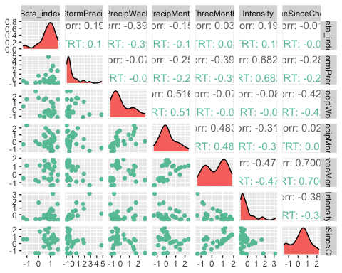

ggsave("turb_pairs_BETA_VAUL.pdf",  
 path = here("Output_from_analysis", "09_Antecedent_Conditions_models", "plots"),  
 width = 10, height = 10)

## Warning: Removed 2 rows containing non-finite values (stat_density).

## Warning: Removed 3 rows containing missing values (geom_point).

## Warning: Removed 1 rows containing non-finite values (stat_density).

## Warning: Removed 3 rows containing missing values (geom_point).

## Warning: Removed 1 rows containing missing values (geom_point).

## Warning: Removed 1 rows containing non-finite values (stat_density).

## Warning: Removed 3 rows containing missing values (geom_point).

## Warning: Removed 1 rows containing missing values (geom_point).  
## Removed 1 rows containing missing values (geom_point).

## Warning: Removed 1 rows containing non-finite values (stat_density).

## Warning: Removed 3 rows containing missing values (geom_point).

## Warning: Removed 1 rows containing missing values (geom_point).  
## Removed 1 rows containing missing values (geom_point).  
## Removed 1 rows containing missing values (geom_point).

## Warning: Removed 1 rows containing non-finite values (stat_density).

## Warning: Removed 3 rows containing missing values (geom_point).

## Warning: Removed 1 rows containing missing values (geom_point).  
## Removed 1 rows containing missing values (geom_point).  
## Removed 1 rows containing missing values (geom_point).  
## Removed 1 rows containing missing values (geom_point).

## Warning: Removed 1 rows containing non-finite values (stat_density).

## Warning: Removed 3 rows containing missing values (geom_point).

## Warning: Removed 1 rows containing missing values (geom_point).  
## Removed 1 rows containing missing values (geom_point).  
## Removed 1 rows containing missing values (geom_point).  
## Removed 1 rows containing missing values (geom_point).  
## Removed 1 rows containing missing values (geom_point).

## Warning: Removed 1 rows containing non-finite values (stat_density).

STRT.model <- lm(Beta_index ~ StormPrecip + PrecipWeek + PrecipMonth + TimeSinceChena, data = HI_FI_turb_STRT)  
  
vif(STRT.model)

## StormPrecip PrecipWeek PrecipMonth TimeSinceChena   
## 1.188571 1.860383 1.690349 1.362419

plot(STRT.model)

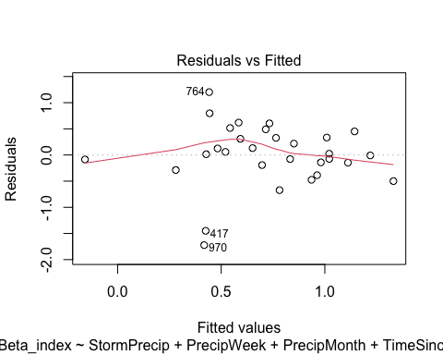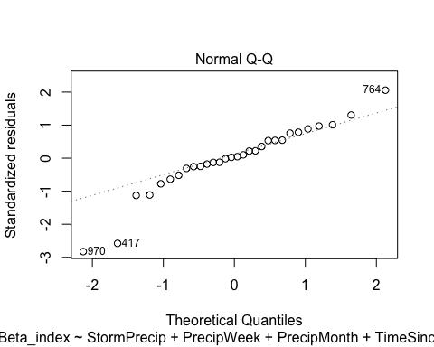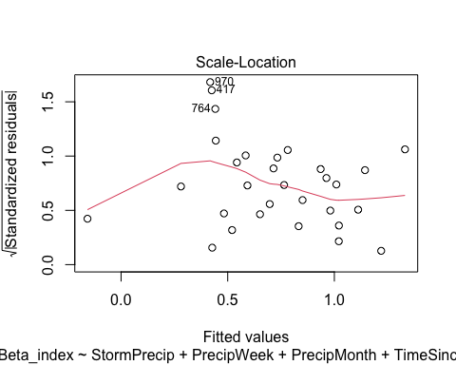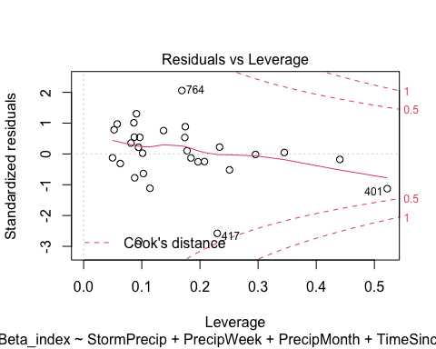

summary(STRT.model)

##   
## Call:  
## lm(formula = Beta_index ~ StormPrecip + PrecipWeek + PrecipMonth +   
## TimeSinceChena, data = HI_FI_turb_STRT)  
##   
## Residuals:  
## Min 1Q Median 3Q Max   
## -1.72315 -0.18141 0.01942 0.33209 1.20193   
##   
## Coefficients:  
## Estimate Std. Error t value Pr(>|t|)   
## (Intercept) 0.74904 0.12648 5.922 3.51e-06 ***  
## StormPrecip 0.08564 0.10007 0.856 0.4002   
## PrecipWeek -0.36251 0.15350 -2.362 0.0263 *   
## PrecipMonth 0.15982 0.16469 0.970 0.3411   
## TimeSinceChena -0.11363 0.13991 -0.812 0.4243   
## ---  
## Signif. codes: 0 '***' 0.001 '**' 0.01 '*' 0.05 '.' 0.1 ' ' 1  
##   
## Residual standard error: 0.6407 on 25 degrees of freedom  
## (3 observations deleted due to missingness)  
## Multiple R-squared: 0.2249, Adjusted R-squared: 0.1008   
## F-statistic: 1.813 on 4 and 25 DF, p-value: 0.1579

lets log transform

STRT.model.log <- lm(logBETA ~ StormPrecip + PrecipWeek + PrecipMonth + TimeSinceChena, data = HI_FI_turb_STRT)  
  
vif(STRT.model.log)

## StormPrecip PrecipWeek PrecipMonth TimeSinceChena   
## 1.188571 1.860383 1.690349 1.362419

plot(STRT.model.log)

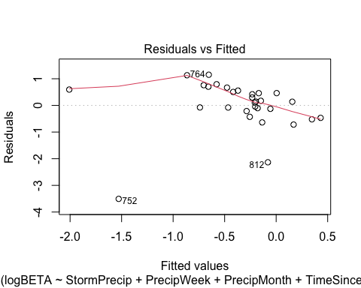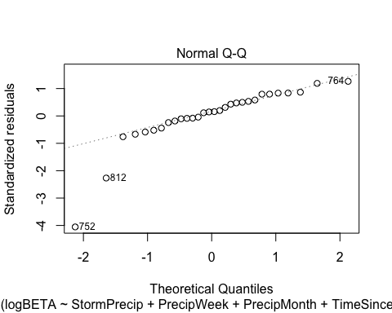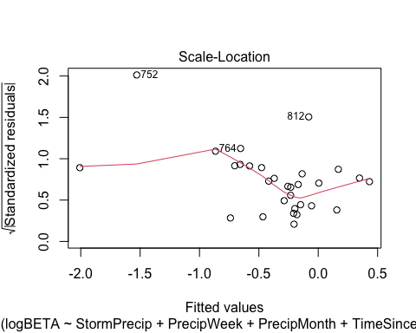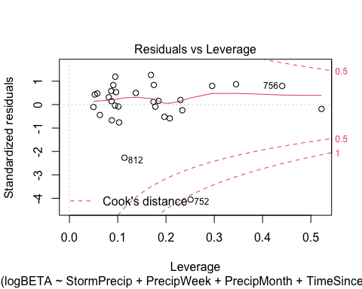

Plot_1 <- plot_summs(MOOS.model, FRCH.model,   
 CARI.model, POKE.model,   
 VAUL.model, STRT.model, scale = TRUE,  
 model.names = c("MOOS", "FRCH", "CARI", "POKE", "VAUL", "STRT"),  
 colors = c("#A6761D", "#FF7F00","#3288BD", "#6A3D9A", "#E7298A", "#66C2A5"))

## Loading required namespace: broom.mixed  
## Loading required namespace: broom.mixed  
## Loading required namespace: broom.mixed  
## Loading required namespace: broom.mixed  
## Loading required namespace: broom.mixed  
## Loading required namespace: broom.mixed

turb_beta <- Plot_1 +   
 xlab("Coefficient estimate") + ylab("") +  
 geom_vline(xintercept = 0,  
 colour = "grey80",  
 linetype = 1) +  
scale_y_discrete(labels= c("Seasonality",   
 "Precipitation Month",   
 "Precipitation Week",  
 "Storm Precipitation")) +  
 theme_bw()   
  
ggsave("BETA_turb.pdf",  
 path = here("plots", "Coefficient_Plots", "HI"),  
 width = 7, height = 7)

# plots for thesis

# ggarrange(no3_hi, fdom_hi,  
# no3_beta, fDOM_beta,  
# ncol = 2, nrow = 2,  
# common.legend = TRUE,  
# labels = c("A)", "B)",  
# "C)", "D)"),  
# legend = "bottom")  
#   
# ggsave("NO3_fDOM.pdf",  
# path = here("plots", "Coefficient_Plots"),  
# width = 10, height = 10)  
#   
# ggarrange(spc_hi, turb_hi,  
# spc_beta, turb_beta,  
# ncol = 2, nrow = 2,  
# common.legend = TRUE,  
# labels = c("A)", "B)",  
# "C)", "D)"),  
# legend = "bottom")  
#   
# ggsave("SPC_turb.pdf",  
# path = here("plots", "Coefficient_Plots"),  
# width = 10, height = 10)  
#   
# # annotate_figure(a,   
# # top = "Column 1 Title, Column 2 Title")